ERP Verification Evidence Pack — [ERP bug-fix] Section title text box needs to be wider
Result: FAIL — FAIL — 1 browser check(s) failed · 1 console error(s) · 1 server-5xx response(s)
When: 20260614T202246Z
Verified URL: http://100.68.36.49:3080/

Runtime Start Checks
No runtime checks were configured.

Notes
- Verification level 2
- ✓ task proof plan L2: 1 task browser check(s), 0 API check(s)
- Task-proof-only mode: Level 1 launch smoke already passed; skipping baseline browser checks.
- Playwright MCP required for level 2+ UI proof; validating worker-declared MCP-backed checks.
- networkidle not reached after login (app polls continuously) — non-fatal; confirming login via login-form disappearance instead.
- Logged in as claude-dev@arcontrols.internal
- Browser flow 'quote-builder-section-title-input-width' started at /; target is /opportunities. Navigation must use visible UI actions from here.
- ✓ quote-builder-section-title-input-width: step 1 navigate
- ✓ quote-builder-section-title-input-width: step 2 input[placeholder="Search opportunities..."]
- ✓ quote-builder-section-title-input-width: step 3 tbody tr[data-testid="opportunity-row"]:first-of-type button[title="Open Quote Builder"]
- ✓ quote-builder-section-title-input-width: step 4 tbody tr[data-testid="opportunity-row"]:first-of-type button[title="Open Quote Builder"]
- ✗ browser check 'quote-builder-section-title-input-width' failed: Page.wait_for_selector: Timeout 30000ms exceeded.
Call log:
- waiting for locator("[data-testid=\"quotation-builder-sections-tab\"]") to be visible

Screenshots
01-landing.png
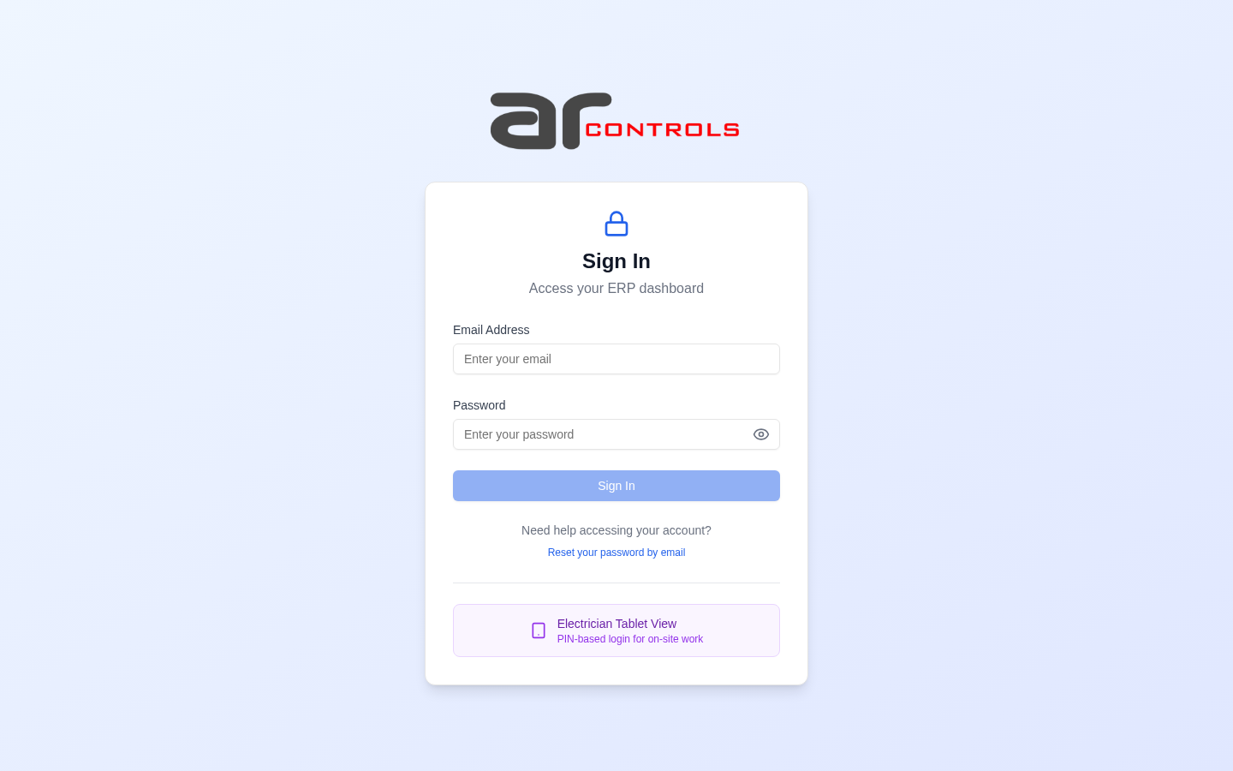
02-post-login.png
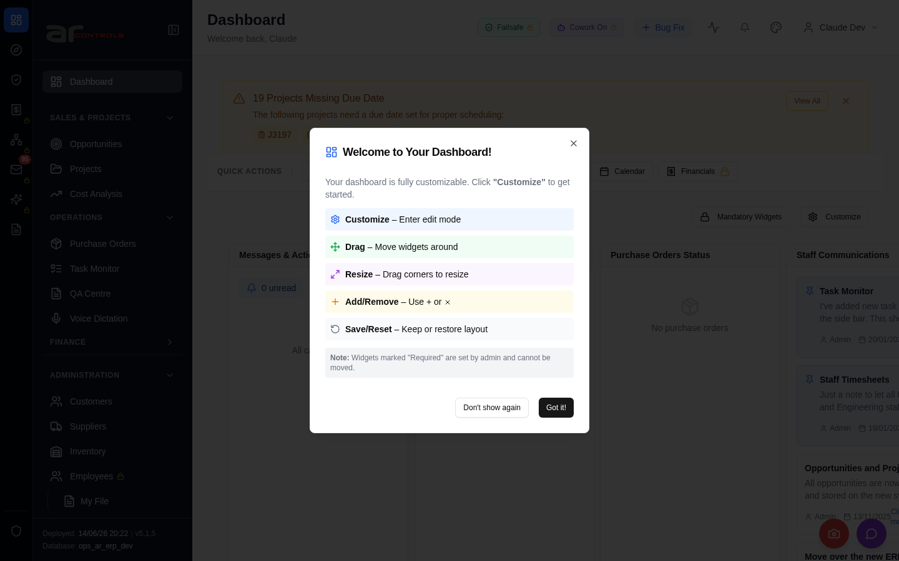
03-quote-builder-section-title-input-width-00-journey-start.png
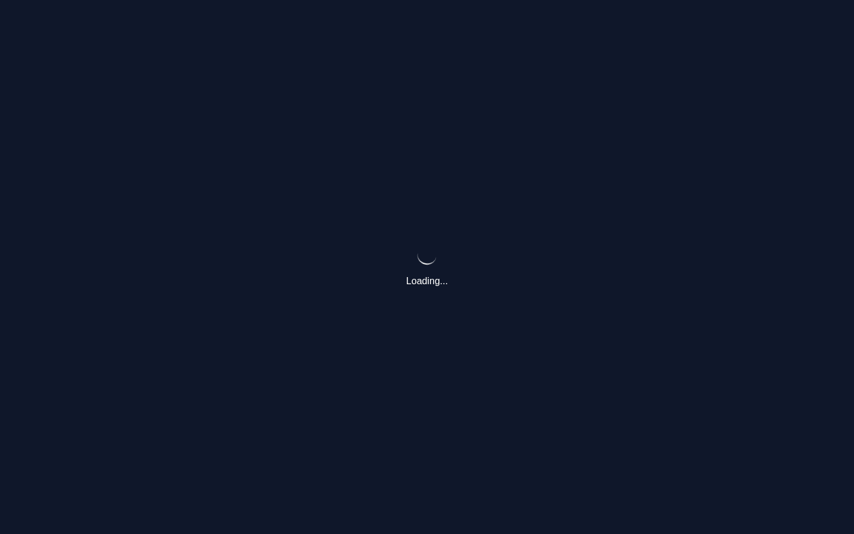
03-quote-builder-section-title-input-width-01-navigate.png
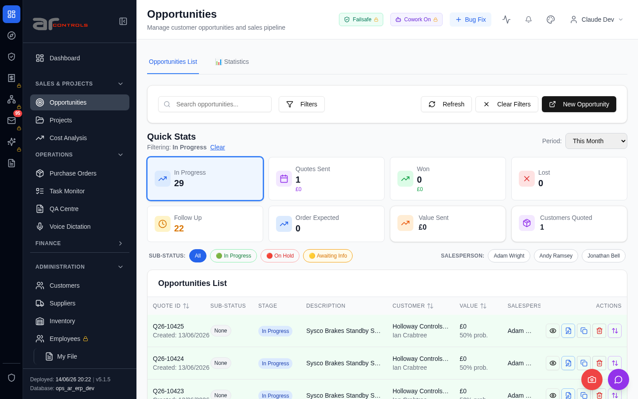
03-quote-builder-section-title-input-width-02-input-placeholder-search-opportunities.png
03-quote-builder-section-title-input-width-02-input-placeholder-search-opportunities-element.png
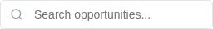
03-quote-builder-section-title-input-width-03-tbody-tr-data-testid-opportunity-row-first-of-type-button-title-open-quote-builder.png
03-quote-builder-section-title-input-width-03-tbody-tr-data-testid-opportunity-row-first-of-type-button-title-open-quote-builder-element.png

03-quote-builder-section-title-input-width-04-tbody-tr-data-testid-opportunity-row-first-of-type-button-title-open-quote-builder.png
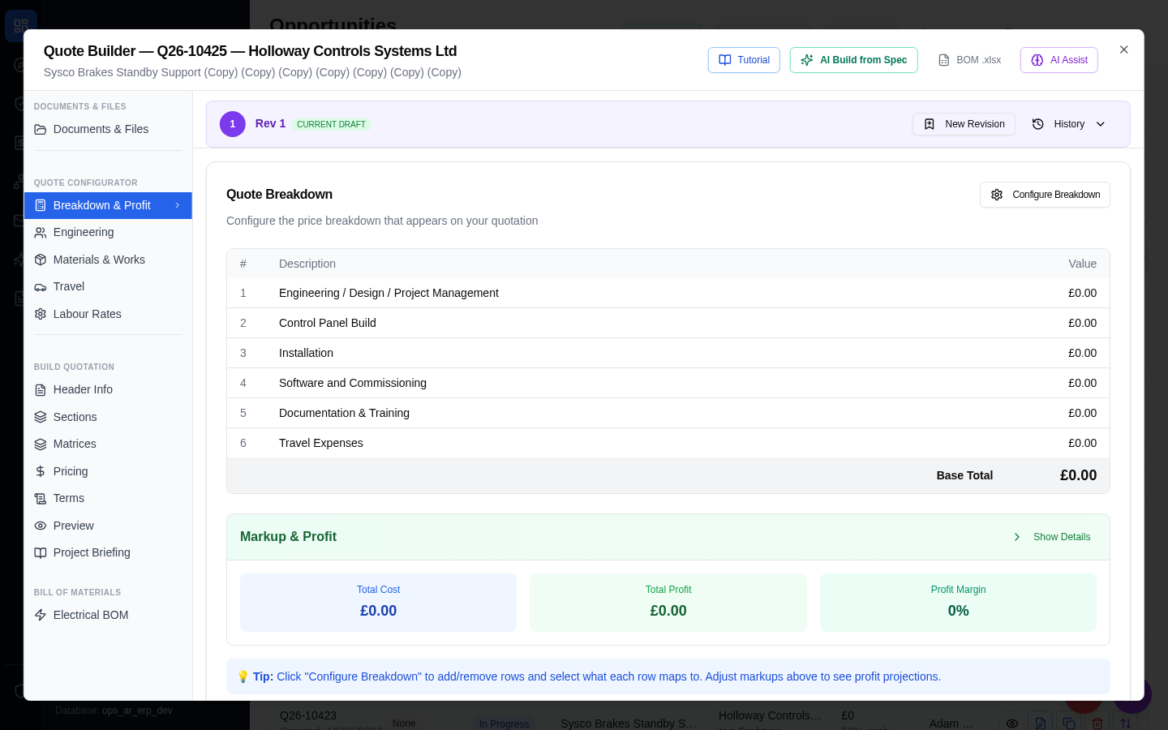
03-quote-builder-section-title-input-width-04-tbody-tr-data-testid-opportunity-row-first-of-type-button-title-open-quote-builder-element.png

03-quote-builder-section-title-input-width-failed.png

Console Errors
- [error] Failed to load resource: the server responded with a status of 500 (Internal Server Error)

Network Issues
- GET http://100.68.36.49:3080/api/notifications/stream?access_token=eyJhbGciOiJIUzI1NiIsInR5cCI6IkpXVCJ9.eyJzdWIiOiJjbGF1ZGUtZGV2QGFyY29udHJvbHMuaW50ZXJuYWwiLCJ1c2VyX2lkIjoiN2NlNDFmZjAtZDBmNy00NzMxLTkzNGIt — net::ERR_ABORTED
- GET http://100.68.36.49:3080/api/notifications/stream?access_token=eyJhbGciOiJIUzI1NiIsInR5cCI6IkpXVCJ9.eyJzdWIiOiJjbGF1ZGUtZGV2QGFyY29udHJvbHMuaW50ZXJuYWwiLCJ1c2VyX2lkIjoiN2NlNDFmZjAtZDBmNy00NzMxLTkzNGIt — net::ERR_ABORTED
- 500 http://100.68.36.49:3080/api/opportunities/3305f58d-f0b7-466b-bb74-16b48b6759f6/revisions

