ERP Verification Evidence Pack — [ERP bug-fix] Error sending invoice from email centre
Result: PASS — PASS — 13 screenshot(s), 0 smoke selector(s), 1 task browser check(s)
When: 20260615T083449Z
Verified URL: http://100.68.36.49:3080/

Runtime Start Checks
No runtime checks were configured.

Notes
- Verification level 2
- ✓ task proof plan L2: 1 task browser check(s), 0 API check(s)
- Task-proof-only mode: Level 1 launch smoke already passed; skipping baseline browser checks.
- Playwright MCP required for level 2+ UI proof; validating worker-declared MCP-backed checks.
- ✓ readiness gate: app ready after 1 probe(s) (status 200)
- networkidle not reached after login (app polls continuously) — non-fatal; confirming login via login-form disappearance instead.
- Logged in as claude-dev@arcontrols.internal
- Browser flow 'invoices-email-centre-send-surface' started at /; target is /invoicing. Navigation must use visible UI actions from here.
- ✓ invoices-email-centre-send-surface: step 1 navigate
- ✓ invoices-email-centre-send-surface: step 2 [data-testid="invoices-open-email-centre-button"]
- ✓ invoices-email-centre-send-surface: step 3 [data-testid="invoices-open-email-centre-button"]
- ✓ invoices-email-centre-send-surface: step 4 [data-testid="email-centre-on-close-button"]
- ✓ invoices-email-centre-send-surface: step 5 Email Centre
- ✓ invoices-email-centre-send-surface: step 6 Financials
- ✓ invoices-email-centre-send-surface: browser flow reached target path /invoicing
- ✓ invoices-email-centre-send-surface: text present: Financials

Screenshots
01-landing.png
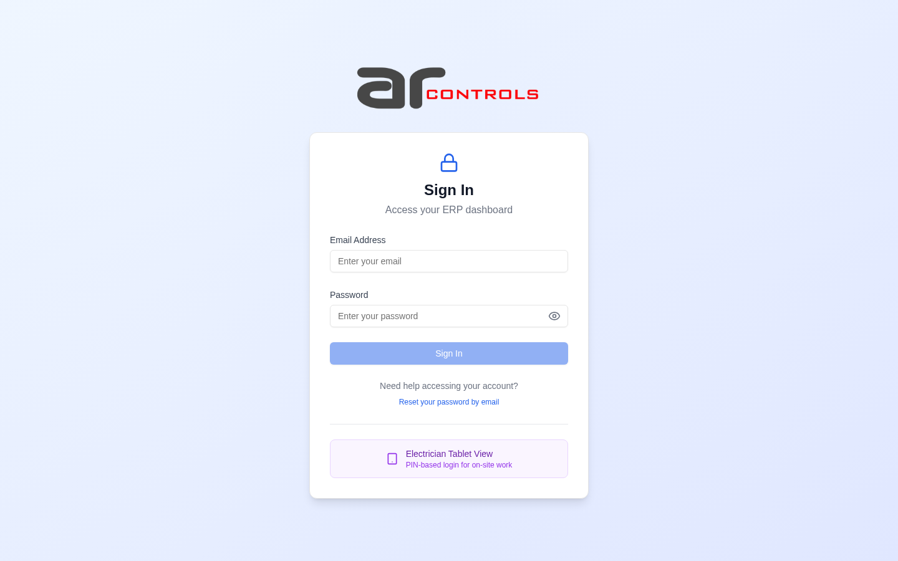
02-post-login.png
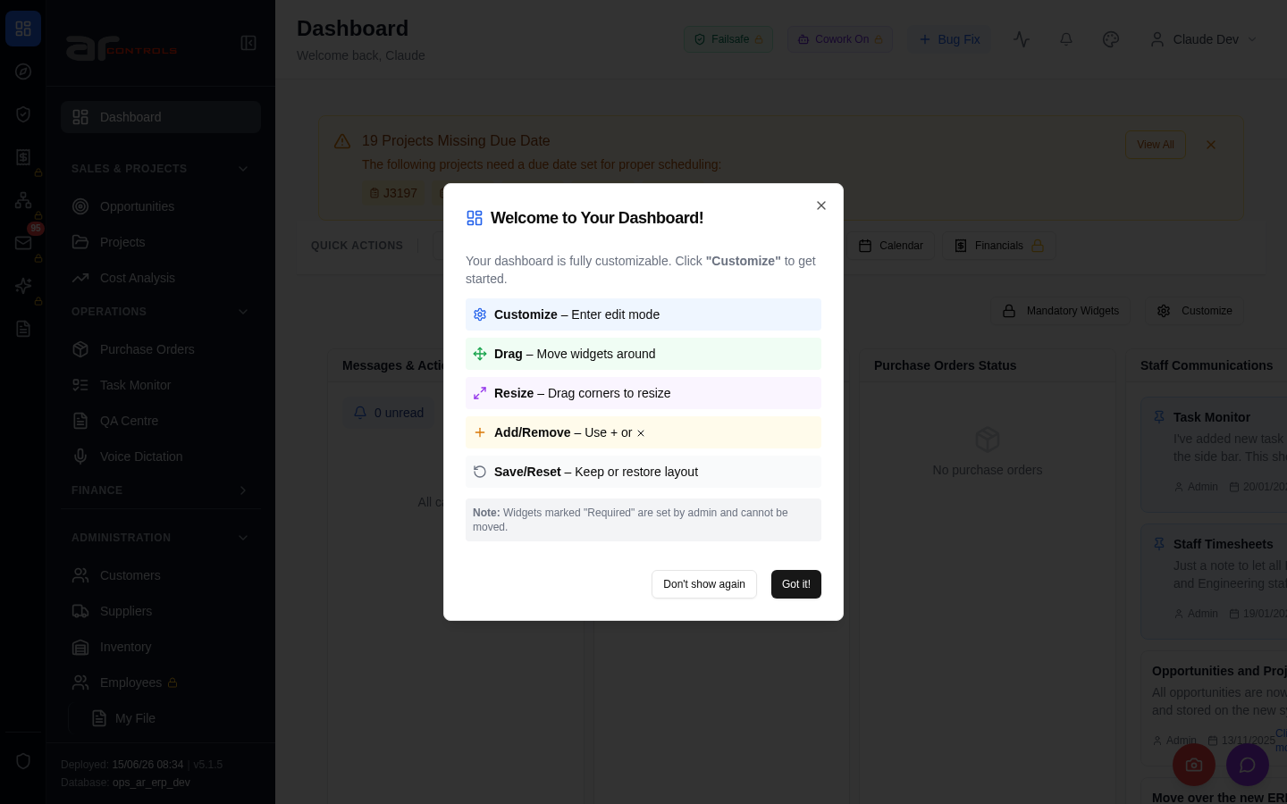
03-invoices-email-centre-send-surface-00-journey-start.png
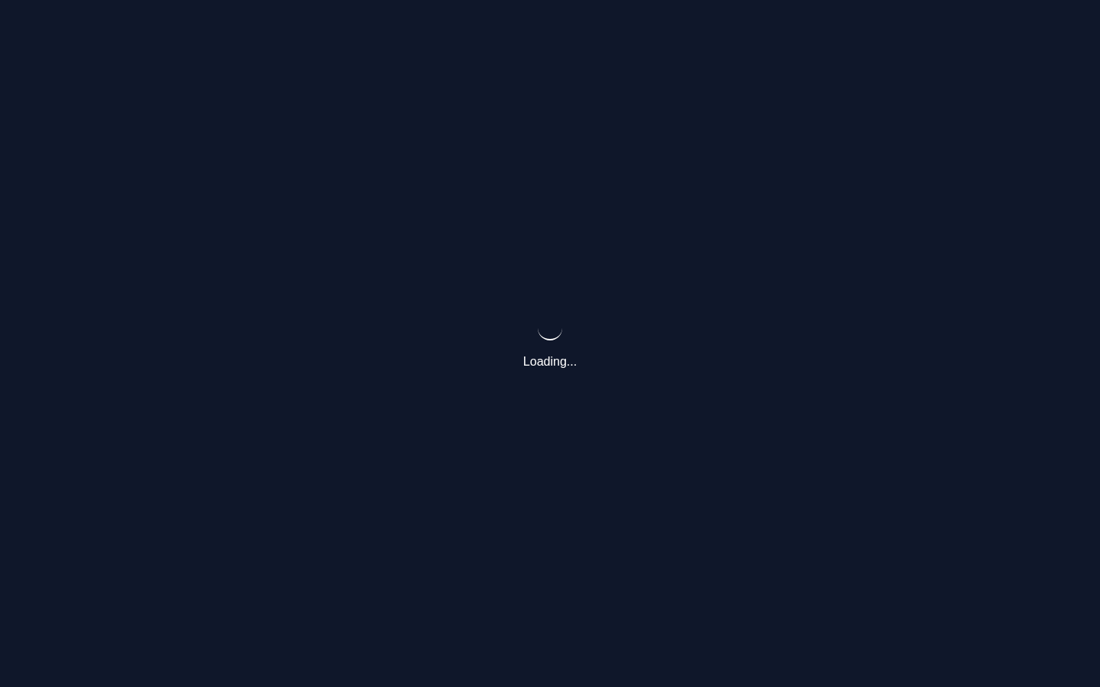
03-invoices-email-centre-send-surface-01-navigate.png
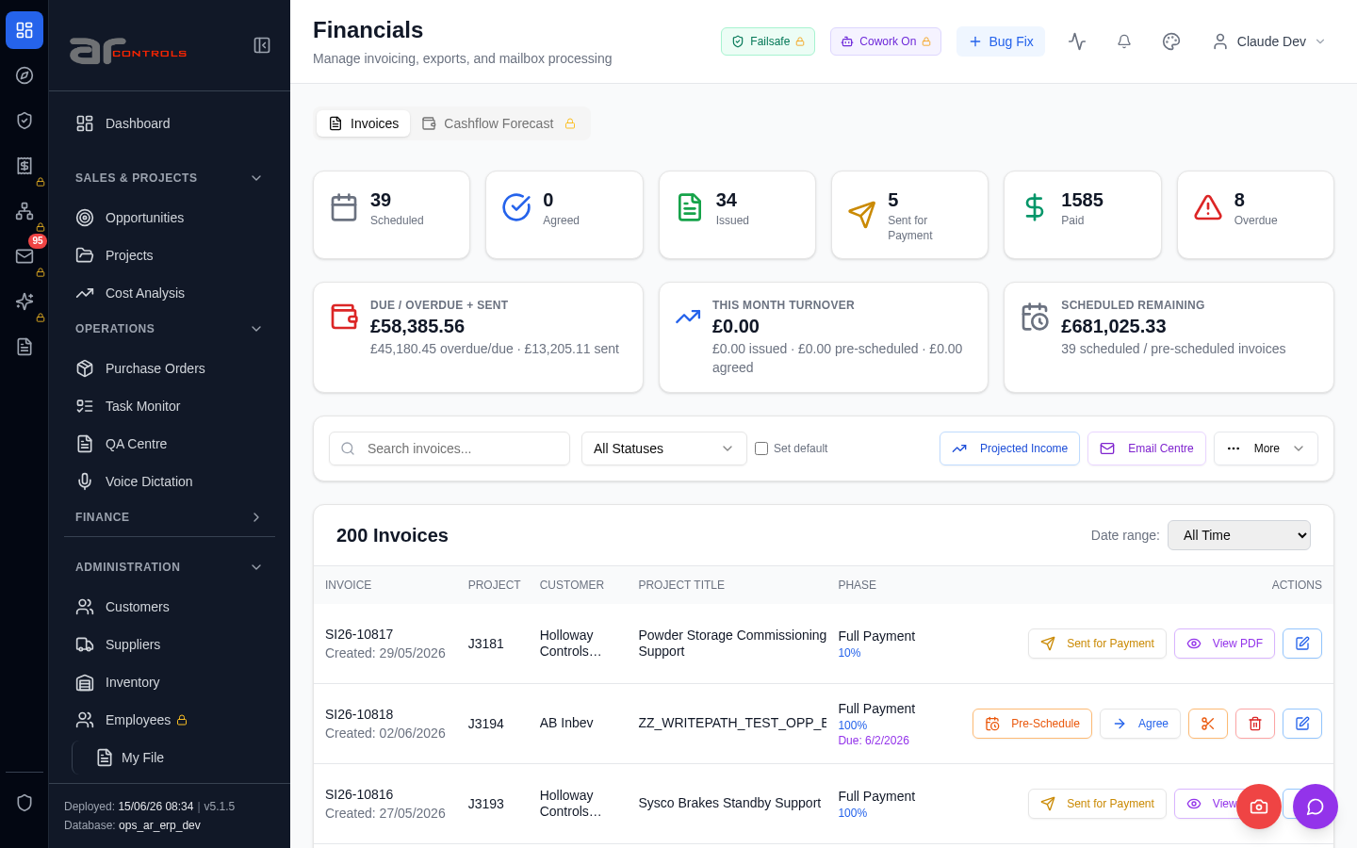
03-invoices-email-centre-send-surface-02-data-testid-invoices-open-email-centre-button.png
03-invoices-email-centre-send-surface-02-data-testid-invoices-open-email-centre-button-element.png

03-invoices-email-centre-send-surface-03-data-testid-invoices-open-email-centre-button.png
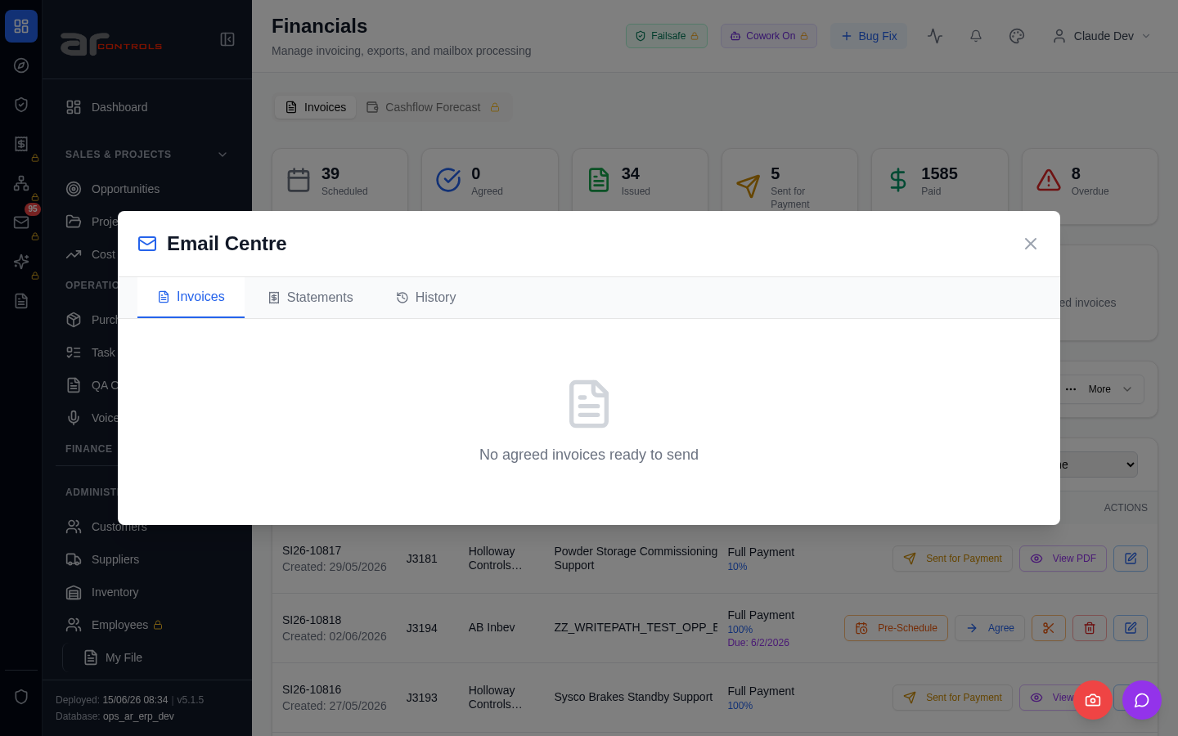
03-invoices-email-centre-send-surface-03-data-testid-invoices-open-email-centre-button-element.png

03-invoices-email-centre-send-surface-04-data-testid-email-centre-on-close-button.png
03-invoices-email-centre-send-surface-04-data-testid-email-centre-on-close-button-element.png
03-invoices-email-centre-send-surface-05-email-centre.png
03-invoices-email-centre-send-surface-06-financials.png
03-invoices-email-centre-send-surface.png

Network Issues
- GET http://100.68.36.49:3080/api/notifications/stream?access_token=eyJhbGciOiJIUzI1NiIsInR5cCI6IkpXVCJ9.eyJzdWIiOiJjbGF1ZGUtZGV2QGFyY29udHJvbHMuaW50ZXJuYWwiLCJ1c2VyX2lkIjoiN2NlNDFmZjAtZDBmNy00NzMxLTkzNGIt — net::ERR_ABORTED
- GET http://100.68.36.49:3080/api/notifications/stream?access_token=eyJhbGciOiJIUzI1NiIsInR5cCI6IkpXVCJ9.eyJzdWIiOiJjbGF1ZGUtZGV2QGFyY29udHJvbHMuaW50ZXJuYWwiLCJ1c2VyX2lkIjoiN2NlNDFmZjAtZDBmNy00NzMxLTkzNGIt — net::ERR_ABORTED

