ERP Verification Evidence Pack — [ERP bug-fix] Timesheet
Result: FAIL — FAIL — 1 browser check(s) failed
When: 20260615T100142Z
Verified URL: http://100.68.36.49:3080/

Runtime Start Checks
No runtime checks were configured.

Notes
- Verification level 2
- ✓ task proof plan L2: 1 task browser check(s), 0 API check(s)
- Task-proof-only mode: Level 1 launch smoke already passed; skipping baseline browser checks.
- Playwright MCP required for level 2+ UI proof; validating worker-declared MCP-backed checks.
- ✓ readiness gate: app ready after 1 probe(s) (status 200)
- networkidle not reached after login (app polls continuously) — non-fatal; confirming login via login-form disappearance instead.
- Logged in as claude-dev@arcontrols.internal
- Browser flow 'my-timesheets-scheduled-tasks-visible-on-approved' started at /resource-manager?tab=timesheets; target is /resource-manager. Navigation must use visible UI actions from here.
- ✓ my-timesheets-scheduled-tasks-visible-on-approved: step 1 navigate
- ✓ my-timesheets-scheduled-tasks-visible-on-approved: step 2 [data-testid="timesheets-control-select"]
- ✓ my-timesheets-scheduled-tasks-visible-on-approved: step 3 [data-testid="timesheets-control-select"]
- ✓ my-timesheets-scheduled-tasks-visible-on-approved: step 4 [data-testid="timesheets-user-id-option"]:has-text("Tom Croft")
- ✓ my-timesheets-scheduled-tasks-visible-on-approved: step 5 h2:has-text("My Weekly Timesheet"), h2:has-text("Timesheet for Tom Croft")
- ✓ my-timesheets-scheduled-tasks-visible-on-approved: step 6 [data-testid="timesheets-previous-button"]
- ✓ my-timesheets-scheduled-tasks-visible-on-approved: step 7 [data-testid="timesheets-previous-button"]
- ✓ my-timesheets-scheduled-tasks-visible-on-approved: step 8 [data-testid="timesheets-previous-button"]
- ✓ my-timesheets-scheduled-tasks-visible-on-approved: step 9 [data-testid="timesheets-previous-button"]
- ✓ my-timesheets-scheduled-tasks-visible-on-approved: step 10 [data-testid="timesheets-previous-button"]
- ✗ browser check 'my-timesheets-scheduled-tasks-visible-on-approved' failed: Page.wait_for_selector: Timeout 30000ms exceeded.
Call log:
- waiting for locator("span:has-text(\"Approved\")") to be visible

Screenshots
01-landing.png
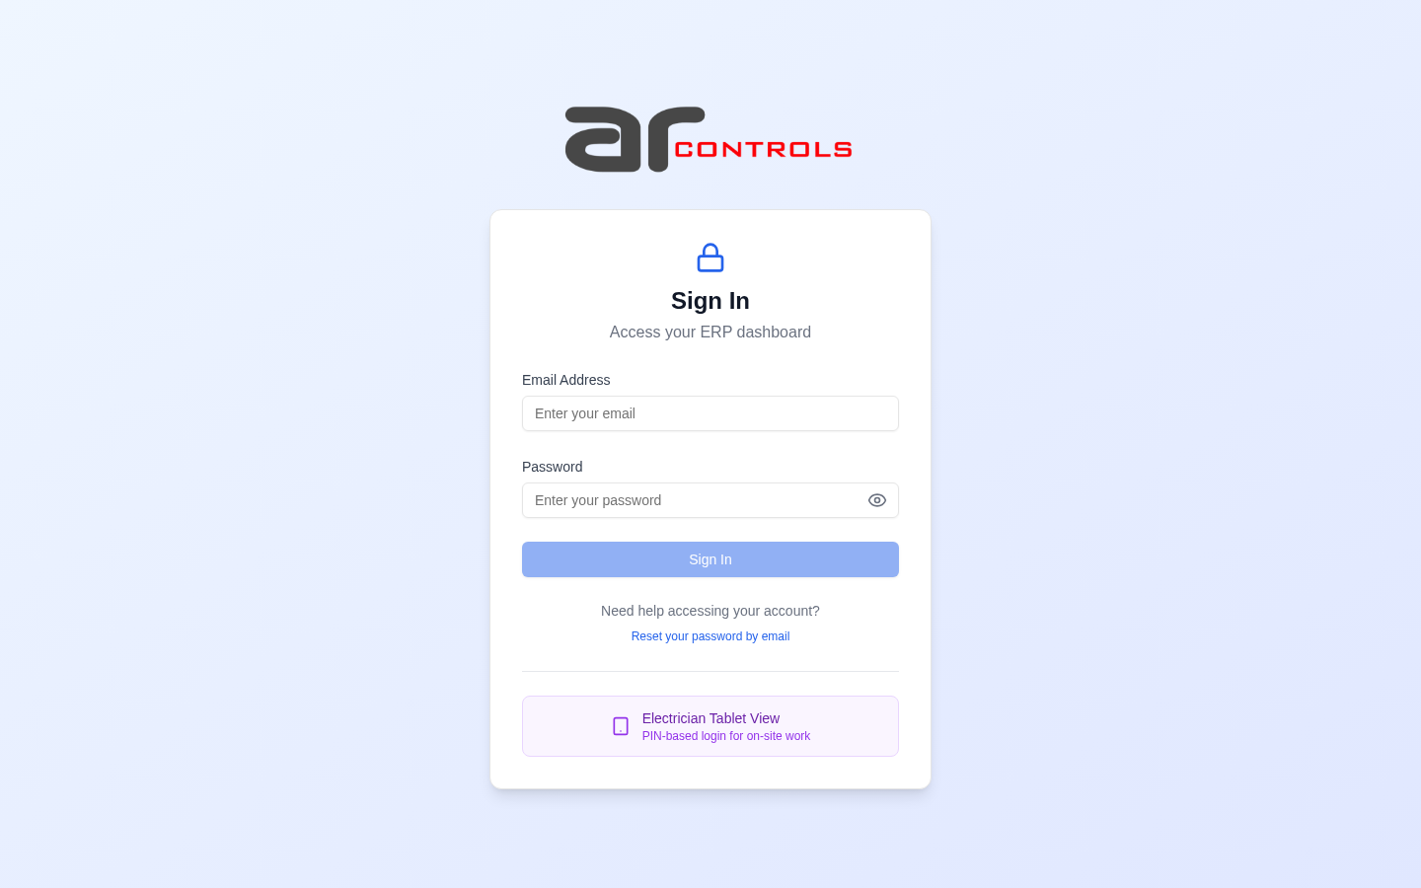
02-post-login.png
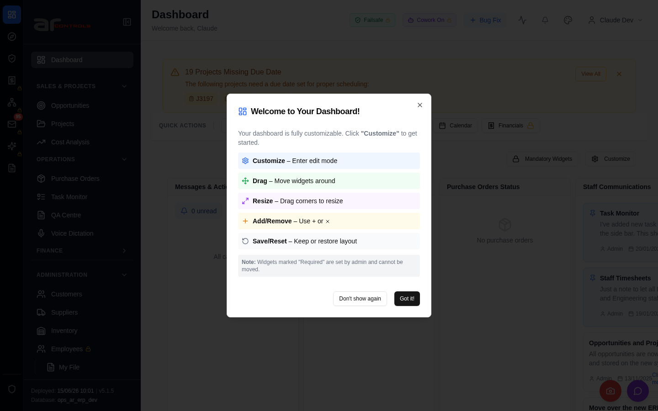
03-my-timesheets-scheduled-tasks-visible-on-approved-00-journey-start.png

03-my-timesheets-scheduled-tasks-visible-on-approved-01-navigate.png
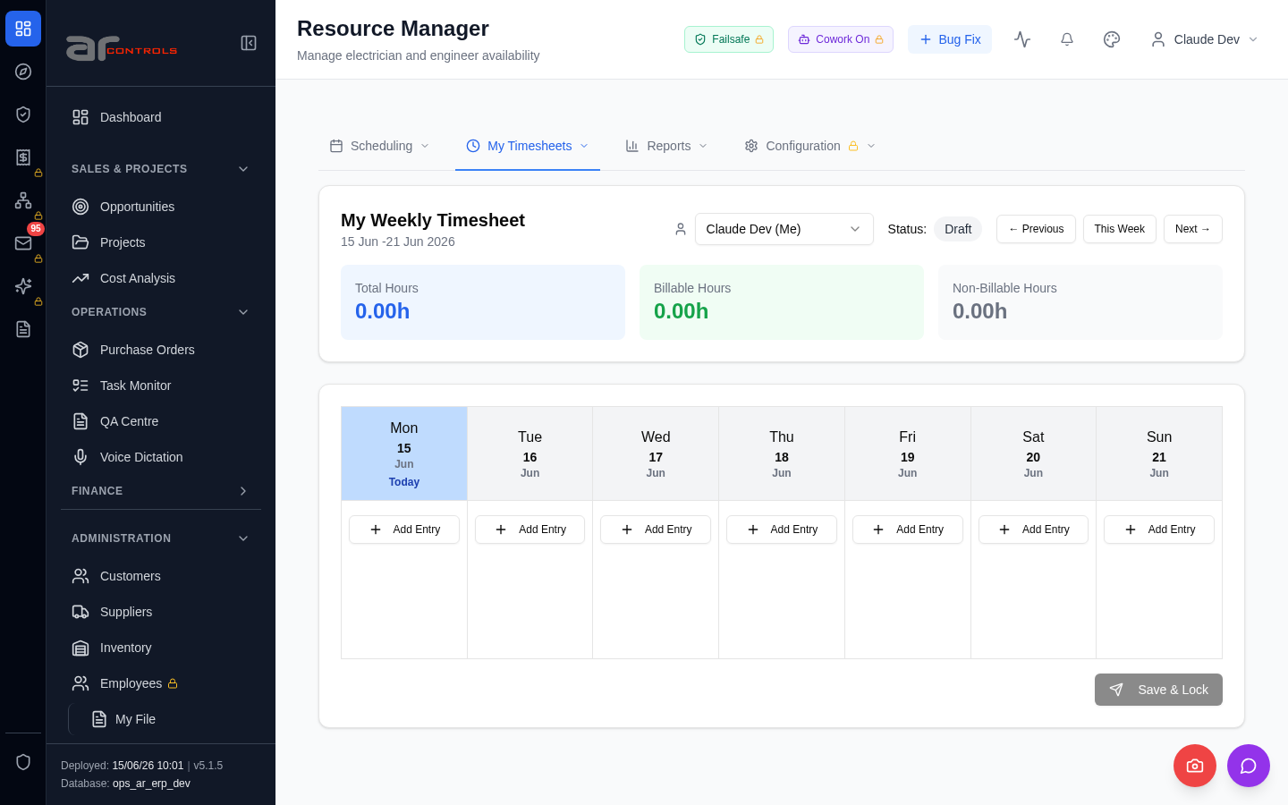
03-my-timesheets-scheduled-tasks-visible-on-approved-02-data-testid-timesheets-control-select.png
03-my-timesheets-scheduled-tasks-visible-on-approved-02-data-testid-timesheets-control-select-element.png

03-my-timesheets-scheduled-tasks-visible-on-approved-03-data-testid-timesheets-control-select.png
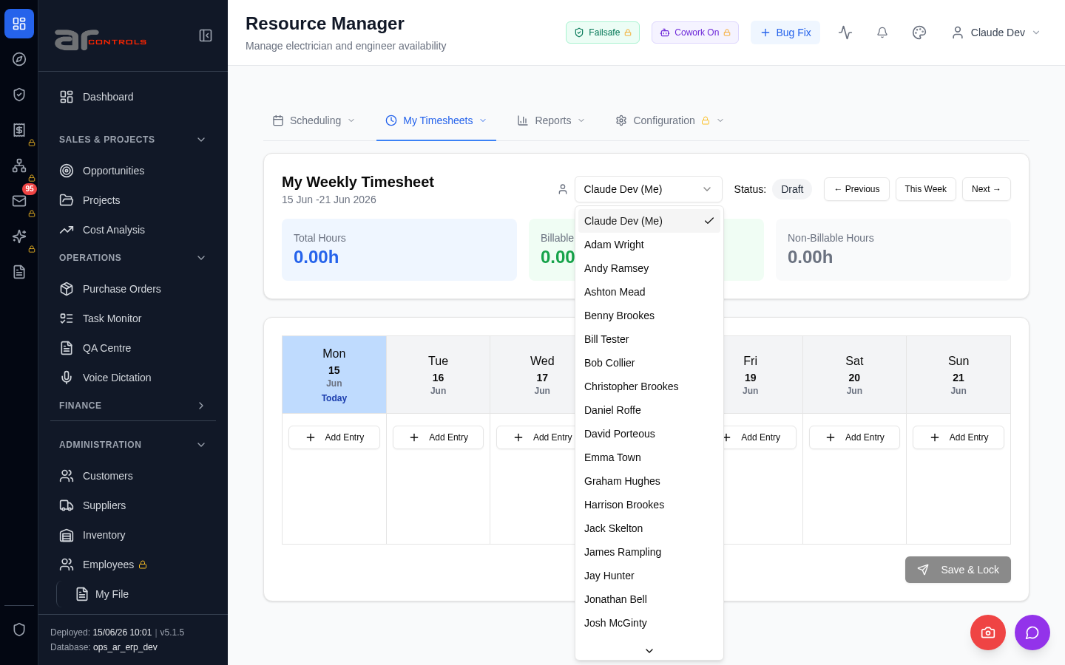
03-my-timesheets-scheduled-tasks-visible-on-approved-03-data-testid-timesheets-control-select-element.png
03-my-timesheets-scheduled-tasks-visible-on-approved-04-data-testid-timesheets-user-id-option-has-text-tom-croft.png
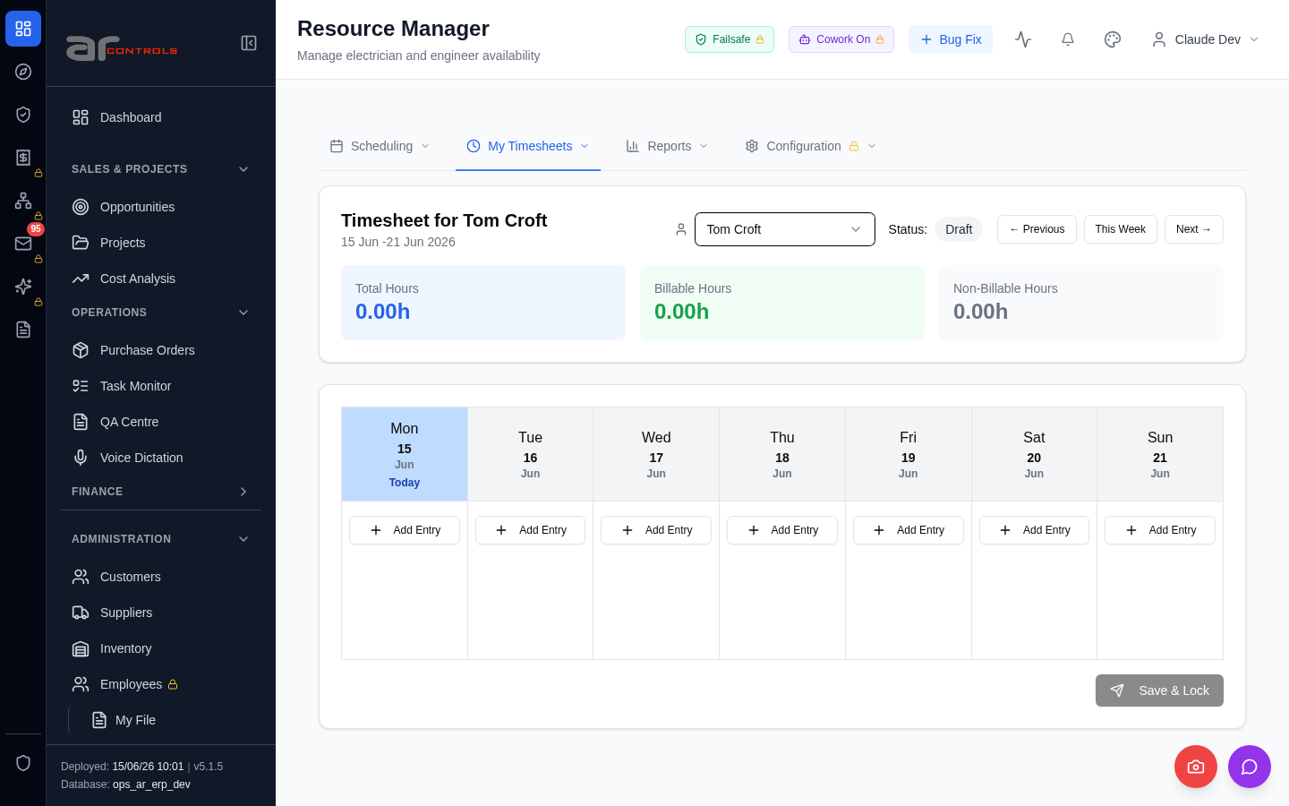
03-my-timesheets-scheduled-tasks-visible-on-approved-05-h2-has-text-my-weekly-timesheet-h2-has-text-timesheet-for-tom-croft.png
03-my-timesheets-scheduled-tasks-visible-on-approved-05-h2-has-text-my-weekly-timesheet-h2-has-text-timesheet-for-tom-croft-element.png
03-my-timesheets-scheduled-tasks-visible-on-approved-06-data-testid-timesheets-previous-button.png
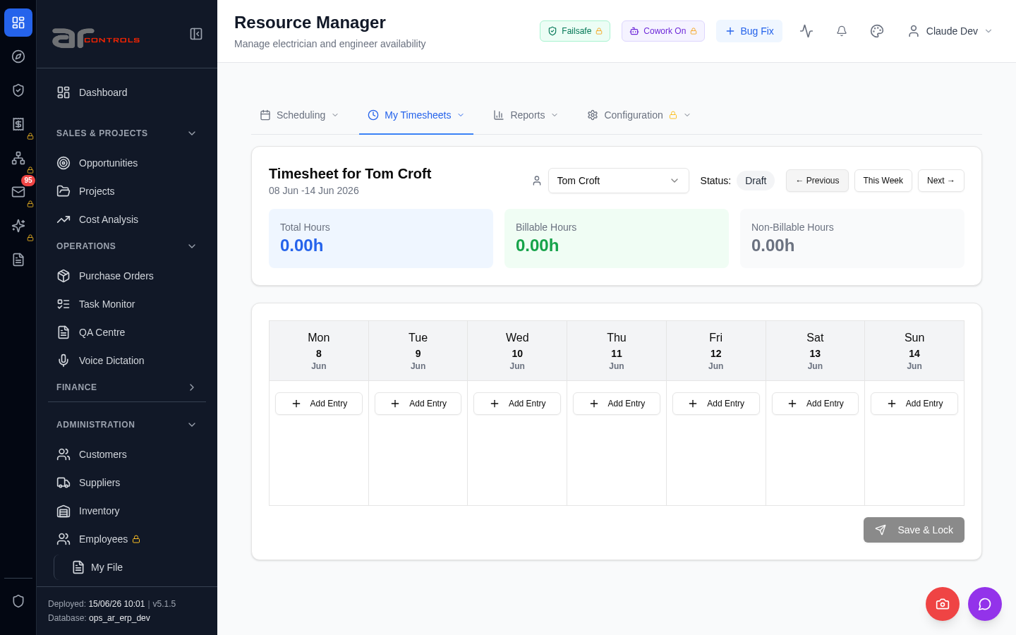
03-my-timesheets-scheduled-tasks-visible-on-approved-06-data-testid-timesheets-previous-button-element.png
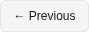
03-my-timesheets-scheduled-tasks-visible-on-approved-07-data-testid-timesheets-previous-button.png
03-my-timesheets-scheduled-tasks-visible-on-approved-07-data-testid-timesheets-previous-button-element.png
03-my-timesheets-scheduled-tasks-visible-on-approved-08-data-testid-timesheets-previous-button.png
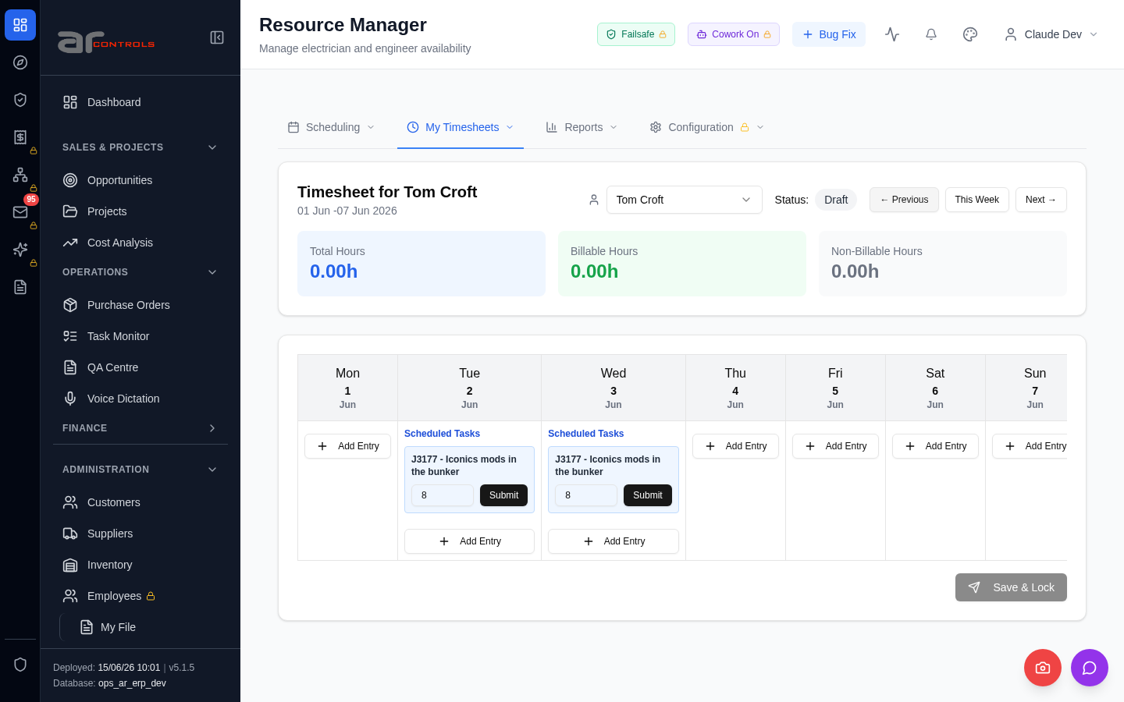
03-my-timesheets-scheduled-tasks-visible-on-approved-08-data-testid-timesheets-previous-button-element.png
03-my-timesheets-scheduled-tasks-visible-on-approved-09-data-testid-timesheets-previous-button.png
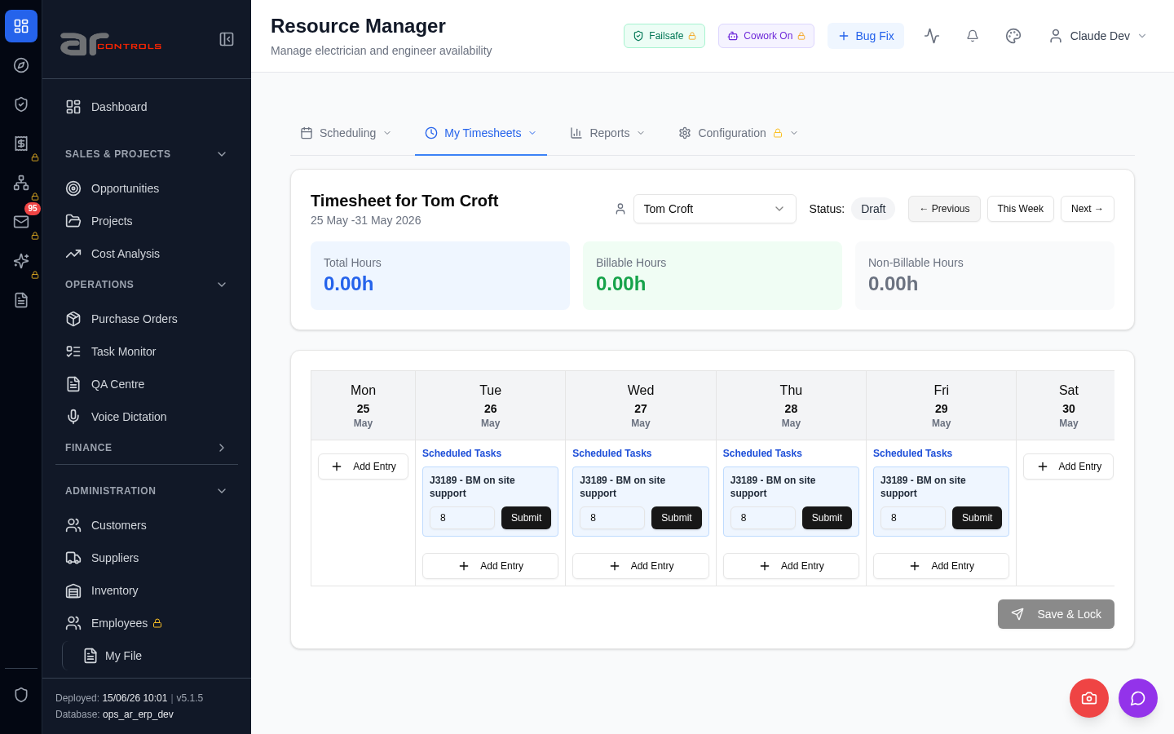
03-my-timesheets-scheduled-tasks-visible-on-approved-09-data-testid-timesheets-previous-button-element.png
03-my-timesheets-scheduled-tasks-visible-on-approved-10-data-testid-timesheets-previous-button.png
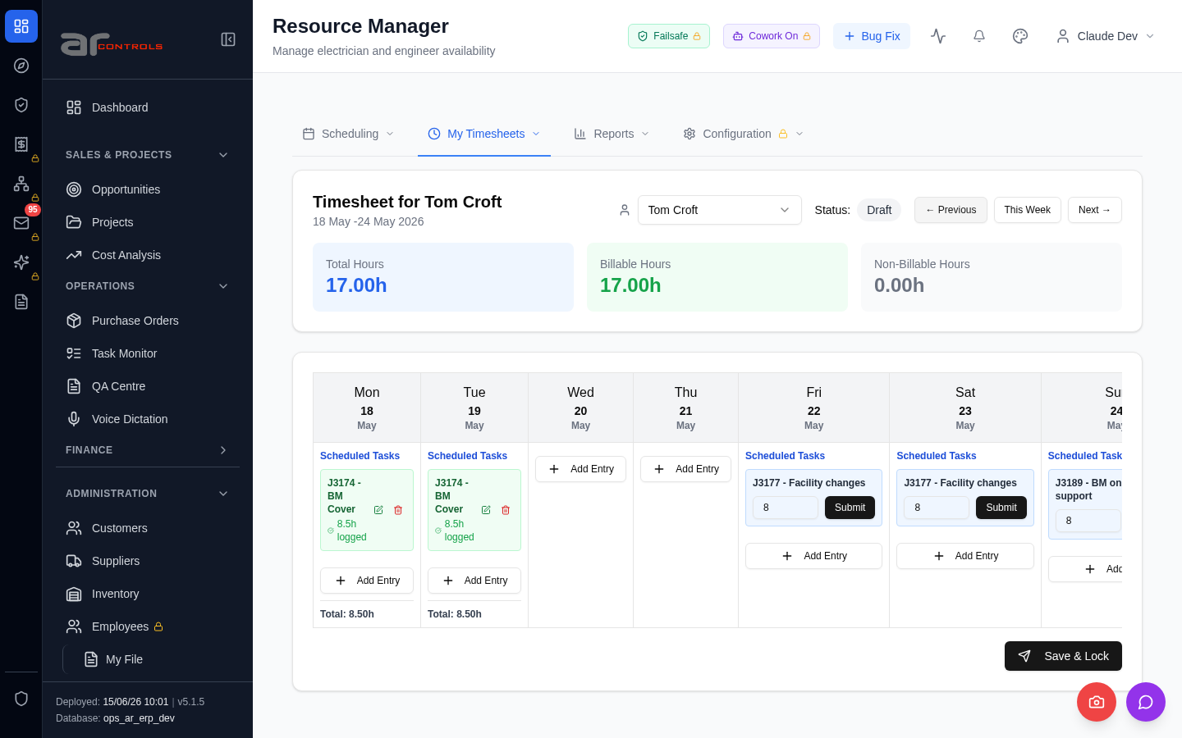
03-my-timesheets-scheduled-tasks-visible-on-approved-10-data-testid-timesheets-previous-button-element.png
03-my-timesheets-scheduled-tasks-visible-on-approved-failed.png

Network Issues
- GET http://100.68.36.49:3080/api/notifications/stream?access_token=eyJhbGciOiJIUzI1NiIsInR5cCI6IkpXVCJ9.eyJzdWIiOiJjbGF1ZGUtZGV2QGFyY29udHJvbHMuaW50ZXJuYWwiLCJ1c2VyX2lkIjoiN2NlNDFmZjAtZDBmNy00NzMxLTkzNGIt — net::ERR_ABORTED
- GET http://100.68.36.49:3080/api/notifications/stream?access_token=eyJhbGciOiJIUzI1NiIsInR5cCI6IkpXVCJ9.eyJzdWIiOiJjbGF1ZGUtZGV2QGFyY29udHJvbHMuaW50ZXJuYWwiLCJ1c2VyX2lkIjoiN2NlNDFmZjAtZDBmNy00NzMxLTkzNGIt — net::ERR_ABORTED
- GET http://100.68.36.49:3080/static/js/213.53220fd4.chunk.js — net::ERR_ABORTED
- GET http://100.68.36.49:3080/static/js/7140.1ca14c86.chunk.js — net::ERR_ABORTED

