ERP Verification Evidence Pack — [ERP bug-fix] Bug from /purchase-orders
Result: FAIL — FAIL — 1 browser check(s) failed
When: 20260616T212951Z
Verified URL: http://100.68.36.49:3080/

Runtime Start Checks
No runtime checks were configured.

Notes
- Verification level 2
- ✓ task proof plan L2: 1 task browser check(s), 0 API check(s)
- Task-proof-only mode: Level 1 launch smoke already passed; skipping baseline browser checks.
- Playwright MCP required for level 2+ UI proof; validating worker-declared MCP-backed checks.
- ✓ readiness gate: app ready after 1 probe(s) (status 200)
- networkidle not reached after login (app polls continuously) — non-fatal; confirming login via login-form disappearance instead.
- Logged in as claude-dev@arcontrols.internal
- Browser flow 'po-toolbar-no-overlap-and-consistent-height-2026-06-16' started at /; target is /purchase-orders. Navigation must use visible UI actions from here.
- ✓ po-toolbar-no-overlap-and-consistent-height-2026-06-16: step 1 navigate
- ✓ po-toolbar-no-overlap-and-consistent-height-2026-06-16: step 2 a[href="/purchase-orders"]
- ✓ po-toolbar-no-overlap-and-consistent-height-2026-06-16: step 3 a[href="/purchase-orders"]
- ✓ po-toolbar-no-overlap-and-consistent-height-2026-06-16: step 4 input[placeholder="Search PO, supplier or project..."]
- ✗ browser check 'po-toolbar-no-overlap-and-consistent-height-2026-06-16' failed: Page.wait_for_selector: Timeout 30000ms exceeded.
Call log:
- waiting for locator("[data-testid=\"po-toolbar-min-h-marker\"]") to be visible
63 × locator resolved to hidden <span aria-hidden="true" class="po-toolbar-min-h-marker" data-testid="po-toolbar-min-h-marker"></span>
- Ignored 18 aborted background fetch console error(s); task browser checks, API checks, and runtime checks decide this proof.

Screenshots
01-landing.png
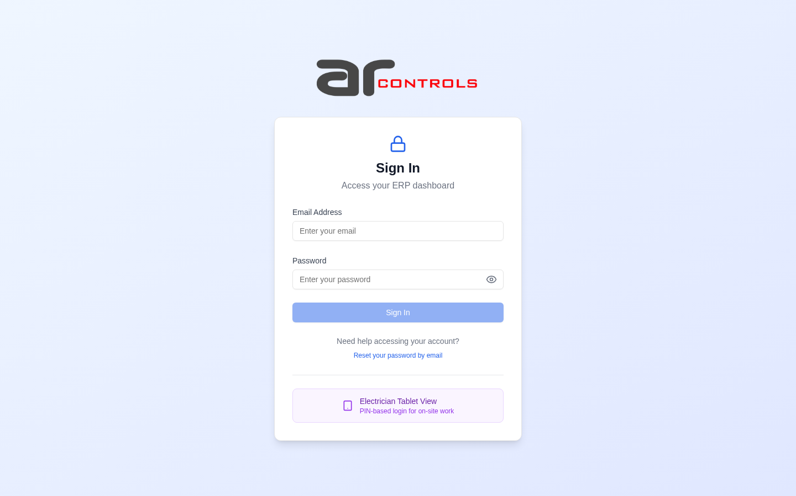
02-post-login.png
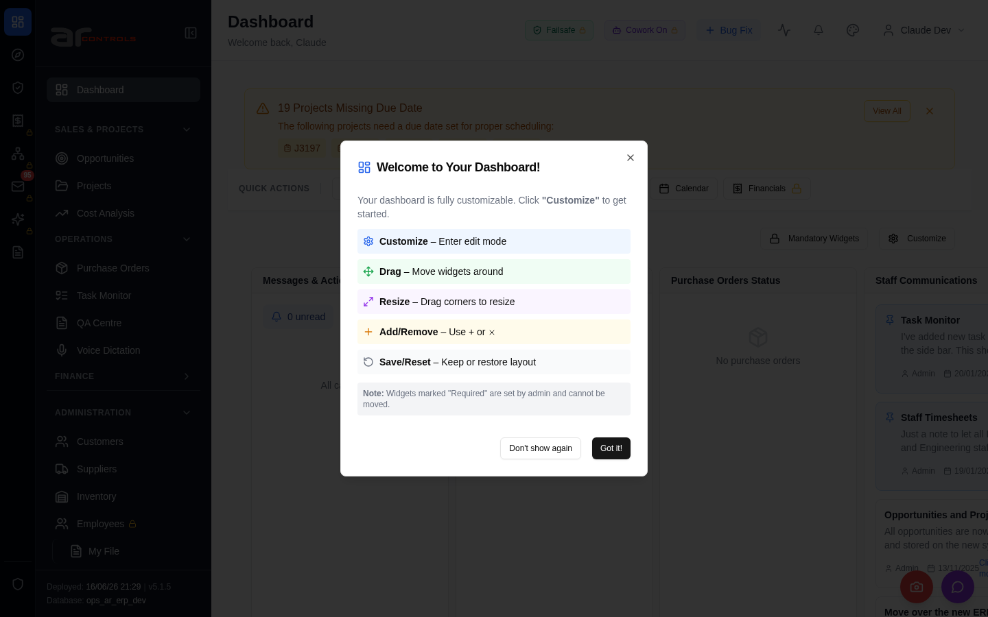
03-po-toolbar-no-overlap-and-consistent-height-2026-06-16-00-journey-start.png
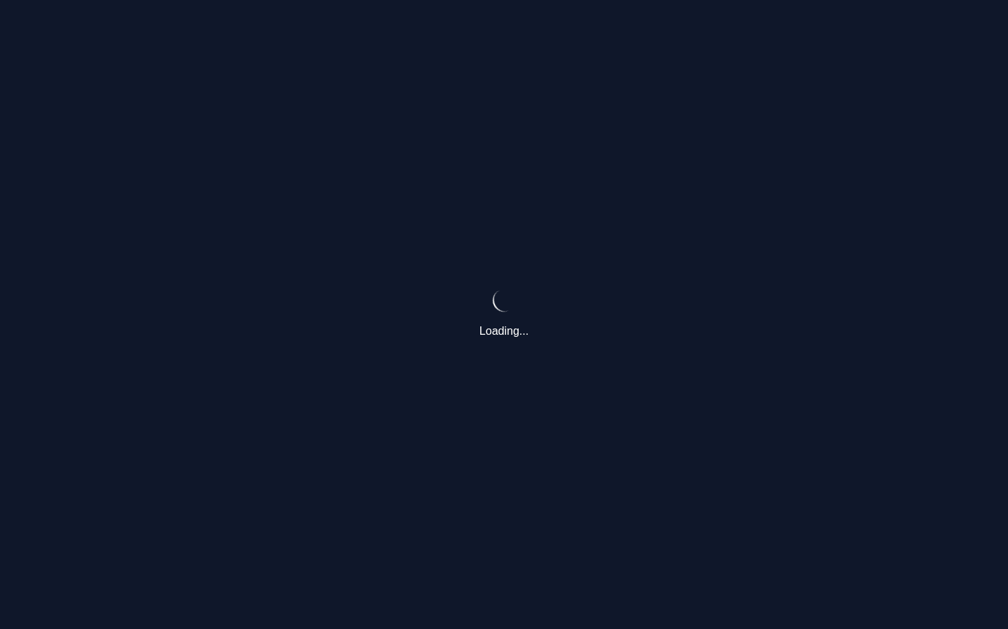
03-po-toolbar-no-overlap-and-consistent-height-2026-06-16-01-navigate.png
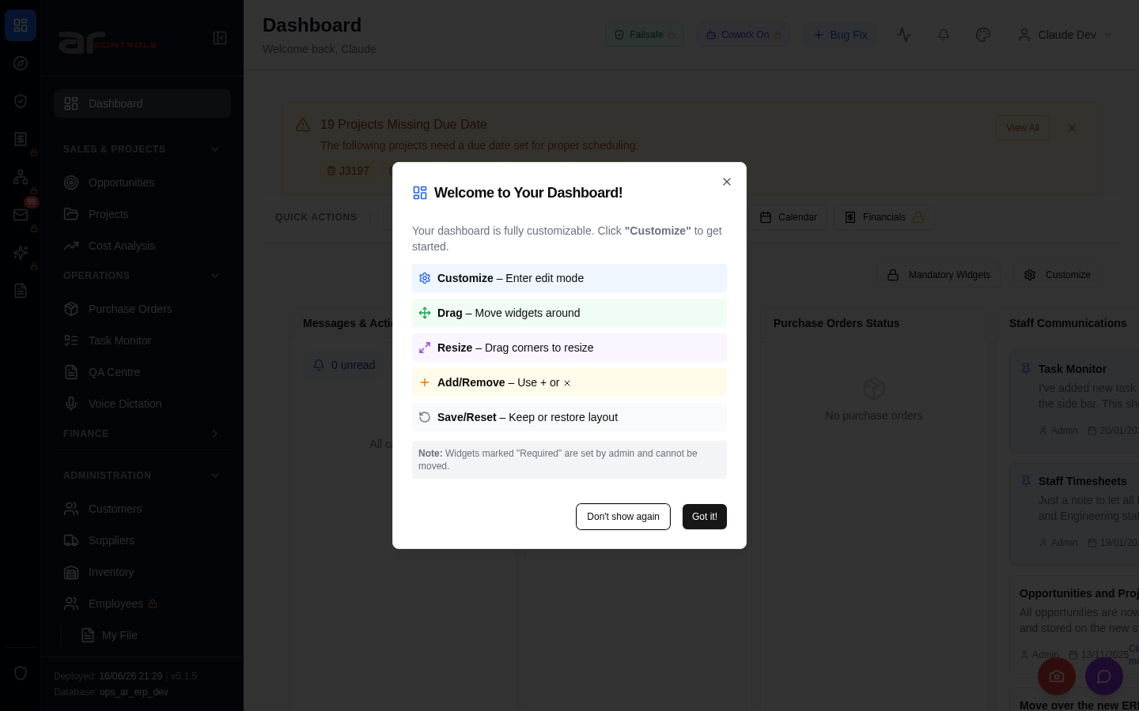
03-po-toolbar-no-overlap-and-consistent-height-2026-06-16-02-a-href-purchase-orders.png
03-po-toolbar-no-overlap-and-consistent-height-2026-06-16-02-a-href-purchase-orders-element.png

03-po-toolbar-no-overlap-and-consistent-height-2026-06-16-03-a-href-purchase-orders.png
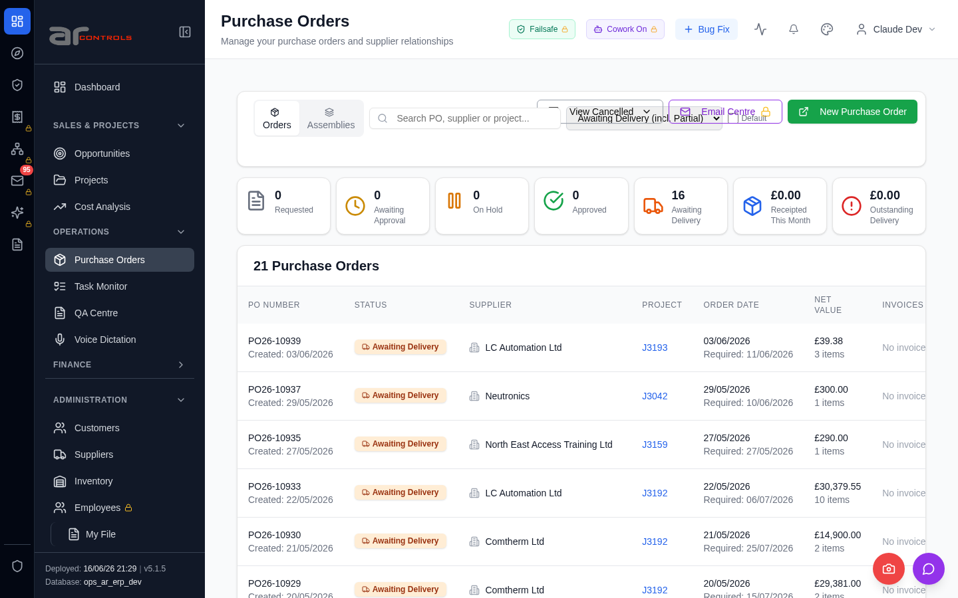
03-po-toolbar-no-overlap-and-consistent-height-2026-06-16-03-a-href-purchase-orders-element.png

03-po-toolbar-no-overlap-and-consistent-height-2026-06-16-04-input-placeholder-search-po-supplier-or-project.png
03-po-toolbar-no-overlap-and-consistent-height-2026-06-16-04-input-placeholder-search-po-supplier-or-project-element.png
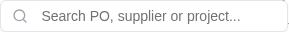
03-po-toolbar-no-overlap-and-consistent-height-2026-06-16-failed.png

Console Errors
- [error] Failed to check for nudges: TypeError: Failed to fetch
at d (http://100.68.36.49:3080/static/js/9627.6c769993.chunk.js:1:20111)
- [error] Error fetching widget types: TypeError: Failed to fetch
at F (http://100.68.36.49:3080/static/js/872.89f56c8c.chunk.js:1:66718)
- [error] Failed to check timesheet compliance: TypeError: Failed to fetch
at u (http://100.68.36.49:3080/static/js/9627.6c769993.chunk.js:1:14135)
- [error] 🔔 NotificationsDropdown: Error fetching notification summary: TypeError: Failed to fetch
at T (http://100.68.36.49:3080/static/js/505.03a7c875.chunk.js:1:76319)
- [error] Error fetching pending QA checks: TypeError: Failed to fetch
at g (http://100.68.36.49:3080/static/js/9627.6c769993.chunk.js:1:17127)
- [error] 🔔 NotificationsDropdown: Error fetching notification summary: TypeError: Failed to fetch
at T (http://100.68.36.49:3080/static/js/505.03a7c875.chunk.js:1:76319)
- [error] Failed to fetch version info: TypeError: Failed to fetch
at http://100.68.36.49:3080/static/js/9627.6c769993.chunk.js:1:1290
at http://100.68.36.49:3080/static/js/9627.6c769993.chunk.js:1:1425
at vs (http://100.68.36.49:3080/static/js/main.06e38c19.js:2:177100)
at tc (http://100.68.3
- [error] Failed to fetch version info: TypeError: Failed to fetch
at http://100.68.36.49:3080/static/js/9627.6c769993.chunk.js:1:1290
at http://100.68.36.49:3080/static/js/9627.6c769993.chunk.js:1:1425
at vs (http://100.68.36.49:3080/static/js/main.06e38c19.js:2:177100)
at tc (http://100.68.3
- [error] Error fetching dashboard config: TypeError: Failed to fetch
at O (http://100.68.36.49:3080/static/js/872.89f56c8c.chunk.js:1:66364)
- [error] Failed to fetch HR settings: TypeError: Failed to fetch
at http://100.68.36.49:3080/static/js/9627.6c769993.chunk.js:1:1868
- [error] Failed to fetch new task count: TypeError: Failed to fetch
at e (http://100.68.36.49:3080/static/js/9627.6c769993.chunk.js:1:1521)
- [error] Failed to fetch HR settings: TypeError: Failed to fetch
at http://100.68.36.49:3080/static/js/9627.6c769993.chunk.js:1:1868
- [error] Error fetching checklist settings: TypeError: Failed to fetch
at h (http://100.68.36.49:3080/static/js/9627.6c769993.chunk.js:1:16839)
- [error] Failed to fetch new task count: TypeError: Failed to fetch
at e (http://100.68.36.49:3080/static/js/9627.6c769993.chunk.js:1:1521)
- [error] Failed to check weekend availability: TypeError: Failed to fetch
at http://100.68.36.49:3080/static/js/872.89f56c8c.chunk.js:1:88958
- [error] Failed to fetch environment info: TypeError: Failed to fetch
at http://100.68.36.49:3080/static/js/9627.6c769993.chunk.js:1:1110
at http://100.68.36.49:3080/static/js/9627.6c769993.chunk.js:1:1258
at vs (http://100.68.36.49:3080/static/js/main.06e38c19.js:2:177100)
at tc (http://100.
- [error] Failed to check projects due date: TypeError: Failed to fetch
at http://100.68.36.49:3080/static/js/872.89f56c8c.chunk.js:1:89576
- [error] Failed to fetch environment info: TypeError: Failed to fetch
at http://100.68.36.49:3080/static/js/9627.6c769993.chunk.js:1:1110
at http://100.68.36.49:3080/static/js/9627.6c769993.chunk.js:1:1258
at vs (http://100.68.36.49:3080/static/js/main.06e38c19.js:2:177100)
at tc (http://100.

Network Issues
- GET http://100.68.36.49:3080/api/notifications/stream?access_token=eyJhbGciOiJIUzI1NiIsInR5cCI6IkpXVCJ9.eyJzdWIiOiJjbGF1ZGUtZGV2QGFyY29udHJvbHMuaW50ZXJuYWwiLCJ1c2VyX2lkIjoiN2NlNDFmZjAtZDBmNy00NzMxLTkzNGIt — net::ERR_ABORTED
- GET http://100.68.36.49:3080/api/notifications/stream?access_token=eyJhbGciOiJIUzI1NiIsInR5cCI6IkpXVCJ9.eyJzdWIiOiJjbGF1ZGUtZGV2QGFyY29udHJvbHMuaW50ZXJuYWwiLCJ1c2VyX2lkIjoiN2NlNDFmZjAtZDBmNy00NzMxLTkzNGIt — net::ERR_ABORTED
- GET http://100.68.36.49:3080/api/resources/nudge/active — net::ERR_ABORTED
- GET http://100.68.36.49:3080/api/dashboard/widget-types — net::ERR_ABORTED
- GET http://100.68.36.49:3080/api/system-settings/ — net::ERR_ABORTED
- GET http://100.68.36.49:3080/api/resources/timesheets/compliance-check — net::ERR_ABORTED
- GET http://100.68.36.49:3080/api/notifications/summary — net::ERR_ABORTED
- GET http://100.68.36.49:3080/api/system-settings/cowork-agent-enabled — net::ERR_ABORTED
- GET http://100.68.36.49:3080/api/qa/my-pending-checks — net::ERR_ABORTED
- GET http://100.68.36.49:3080/api/notifications/summary — net::ERR_ABORTED
- GET http://100.68.36.49:3080/api/version — net::ERR_ABORTED
- GET http://100.68.36.49:3080/api/version — net::ERR_ABORTED
- GET http://100.68.36.49:3080/api/dashboard/config — net::ERR_ABORTED
- GET http://100.68.36.49:3080/api/employees/my-file — net::ERR_ABORTED
- GET http://100.68.36.49:3080/api/tasks/new-count — net::ERR_ABORTED
- GET http://100.68.36.49:3080/api/email-inbox/stats — net::ERR_ABORTED
- GET http://100.68.36.49:3080/api/system-settings/ — net::ERR_ABORTED
- GET http://100.68.36.49:3080/api/server-security/failsafe/status — net::ERR_ABORTED
- GET http://100.68.36.49:3080/api/resources/timesheets/compliance-check — net::ERR_ABORTED
- GET http://100.68.36.49:3080/api/employees/my-file — net::ERR_ABORTED

