ERP Verification Evidence Pack — [ERP bug-fix] Bug from /purchase-orders — proof-only
Result: FAIL — FAIL — wall-clock timeout after 180s · 2 console error(s) · 2 server-5xx response(s)
When: 20260618T235602Z
Verified URL: http://100.121.252.85:3180/

Runtime Start Checks
frontend_http: PASS — http://100.121.252.85:3180/ returned HTTP 200 (text/html; charset=utf-8); body starts '<!doctype html><html lang="en"><head><meta charset="utf-8"/><link rel="icon" href="/favicon.ico"/><link rel="icon" type='
backend_health: PASS — 100.121.252.85 http://127.0.0.1:8002/health returned HTTP 200 (application/json); body starts '{"status":"healthy","service":"backend"}'
pm2_backend-dev: PASS — backend-dev status=online
pm2_frontend-dev: PASS — frontend-dev status=online

Notes
- Verification level 2
- ✓ task proof plan L2: 7 task browser check(s), 0 API check(s)
- Playwright MCP required for level 2+ UI proof; validating worker-declared MCP-backed checks.
- ✓ readiness gate: app ready after 1 probe(s) (status 200)
- networkidle not reached after login (app polls continuously) — non-fatal; confirming login via login-form disappearance instead.
- Logged in as claude-dev@arcontrols.internal
- ✓ selector present: #root > *
- ✓ smoke_text present: Dashboard
- ✓ l2-menu-smoke: step 1 #root *
- ✓ l2-menu-smoke: step 2 menu_sweep: Opportunities, Dashboard, Projects, Cost Analysis, Purchase Orders
- ✗ l2-menu-smoke: no positive assertion — only trivial/generic anchors or absence checks; this proves nothing
- Browser flow 'ERP proof-only navigation smoke L2' started at /; target is /employees/my-file. Navigation must use visible UI actions from here.
- ✓ ERP proof-only navigation smoke L2: step 1 dashboard loaded
- ✓ ERP proof-only navigation smoke L2: step 2 dismiss welcome modal
- ✓ ERP proof-only navigation smoke L2: step 3 open Opportunities
- ✓ ERP proof-only navigation smoke L2: step 4 Opportunities screen visible
- ✓ ERP proof-only navigation smoke L2: step 5 open Projects
- ✓ ERP proof-only navigation smoke L2: step 6 Projects screen visible
- ✗ ERP proof-only navigation smoke L2: step 7 open Resource Manager: Locator.click: Timeout 30000ms exceeded.
Call log:
- waiting for locator("a[href=\"/resource-manager\"]:visible")
| DIAGNOSIS: selector 'a[href="/resource-manager"]:visible' matched 0 elements; the row/control may not exist in dev. Seed a fixture id and target it, or verify the selector against the rendered page.
- ✗ ERP proof-only navigation smoke L2: step 8 Resource Manager screen visible: text missing: Resource Manager
- ✓ ERP proof-only navigation smoke L2: step 9 open Cost Analysis
- ✓ ERP proof-only navigation smoke L2: step 10 Cost Analysis screen visible
- ✗ ERP proof-only navigation smoke L2: step 11 open Email Inbox: Locator.click: Timeout 30000ms exceeded.
Call log:
- waiting for locator("a[href=\"/email-inbox\"]:visible")
| DIAGNOSIS: selector 'a[href="/email-inbox"]:visible' matched 0 elements; the row/control may not exist in dev. Seed a fixture id and target it, or verify the selector against the rendered page.
- ✗ Playwright verification exceeded wall-clock timeout
- Runtime start checks passed: 4

Screenshots
01-landing.png
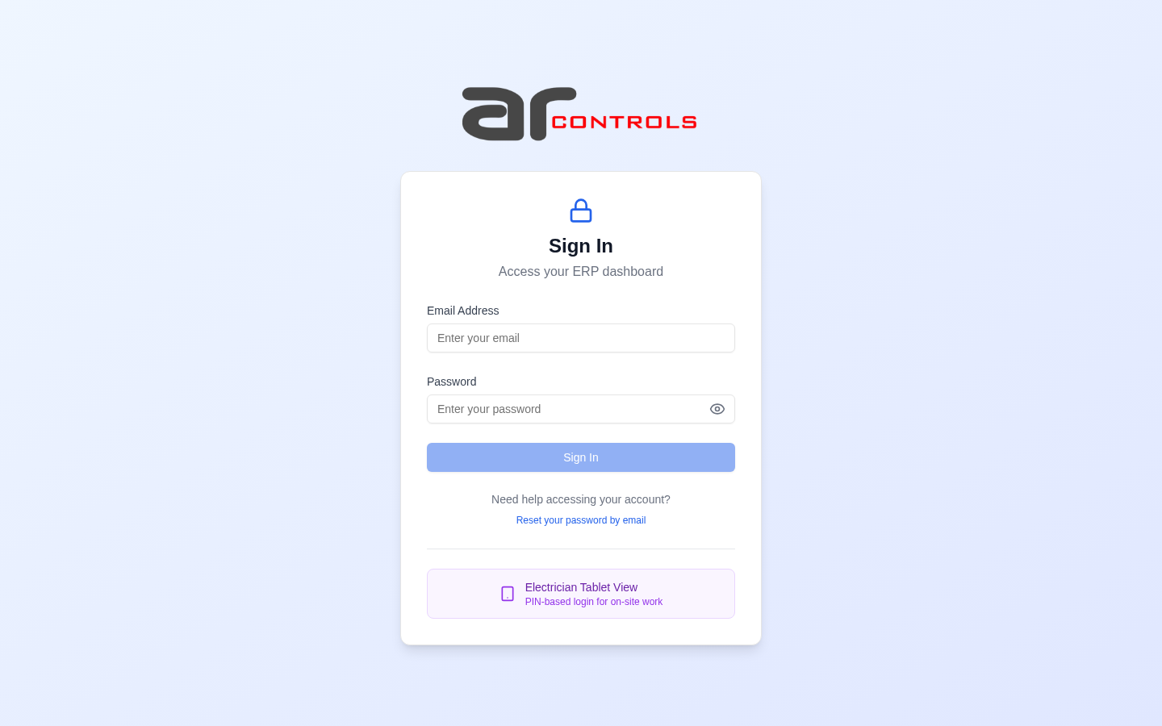
02-post-login.png
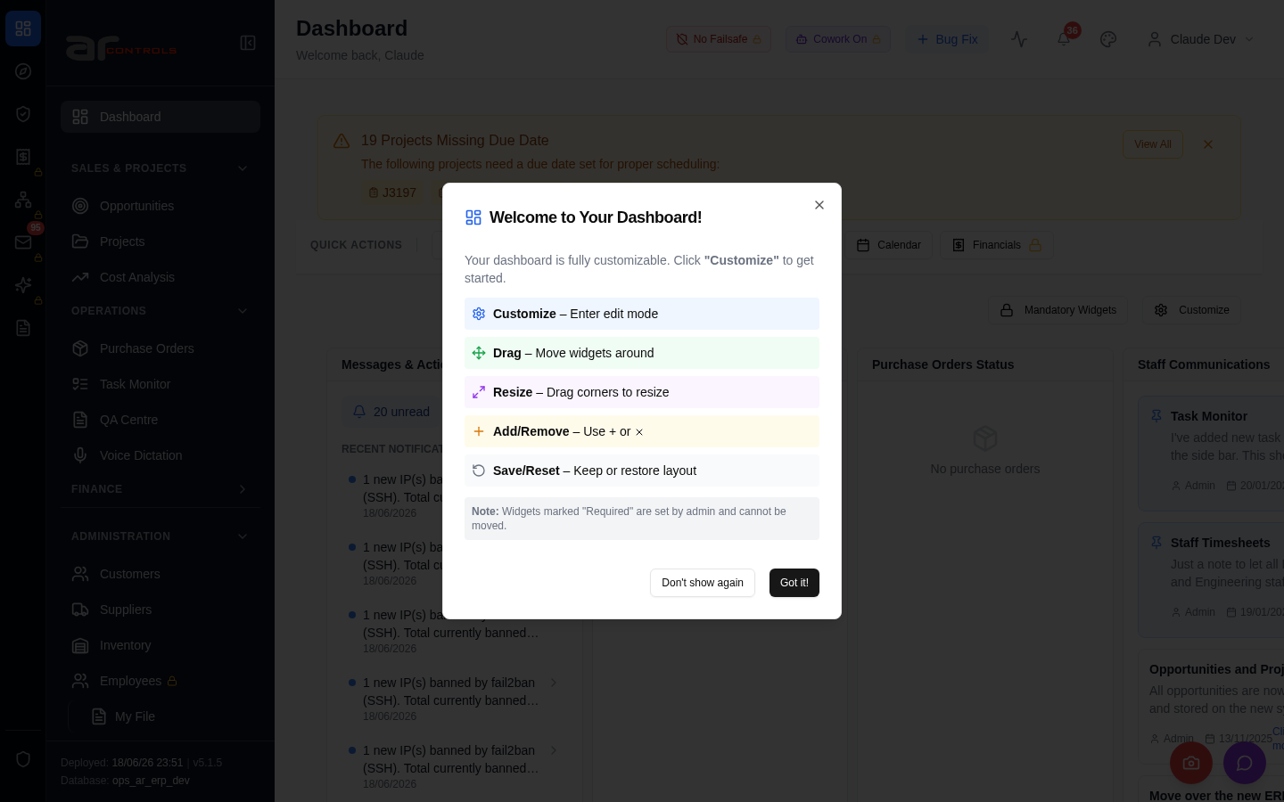
03-l2-menu-smoke-01-root.png
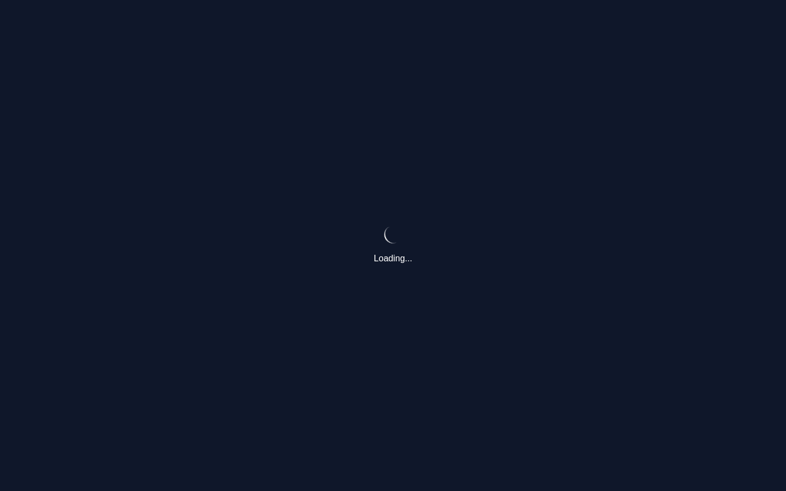
03-l2-menu-smoke-01-root-element.png
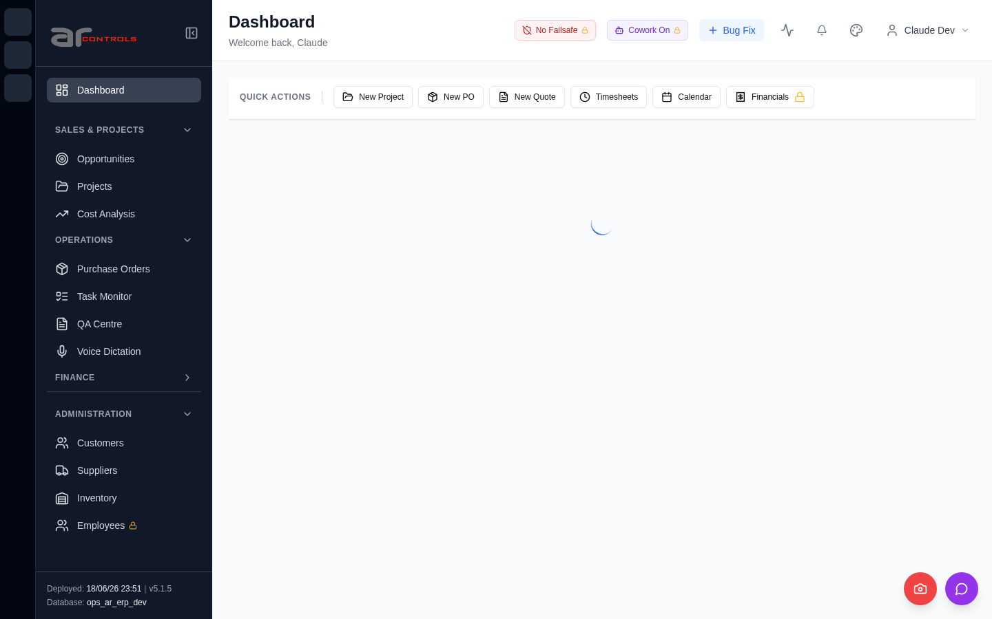
03-l2-menu-smoke-02-menu-sweep-opportunities-dashboard-projects-cost-analysis-purchase-orders.png
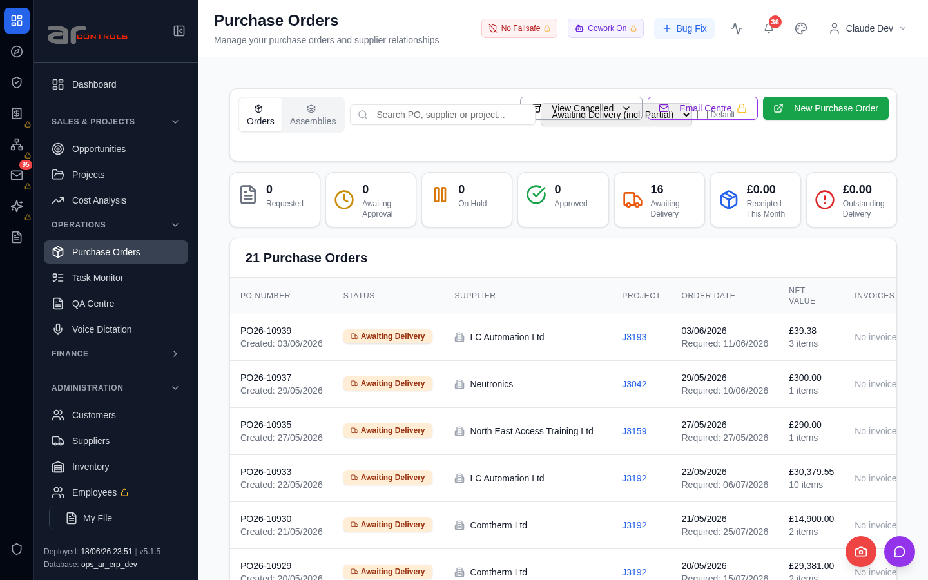
03-l2-menu-smoke.png
04-erp-proof-only-navigation-smoke-l2-00-journey-start.png
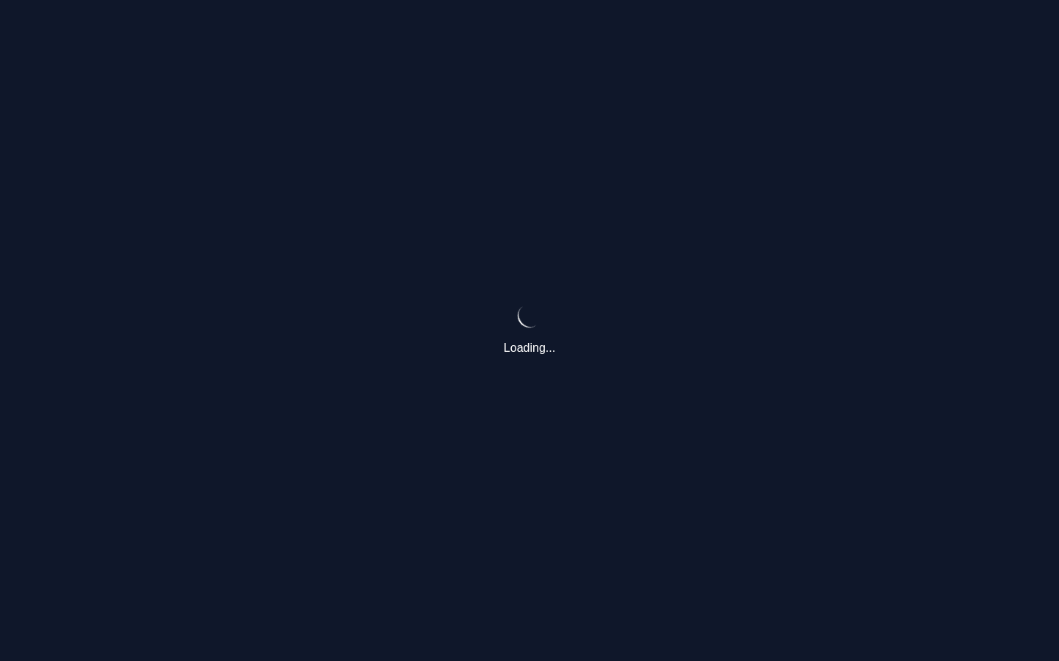
04-erp-proof-only-navigation-smoke-l2-01-dashboard-loaded.png
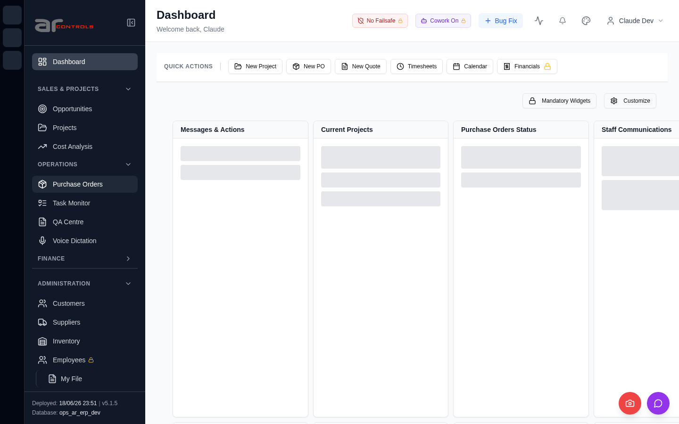
04-erp-proof-only-navigation-smoke-l2-02-dismiss-welcome-modal.png
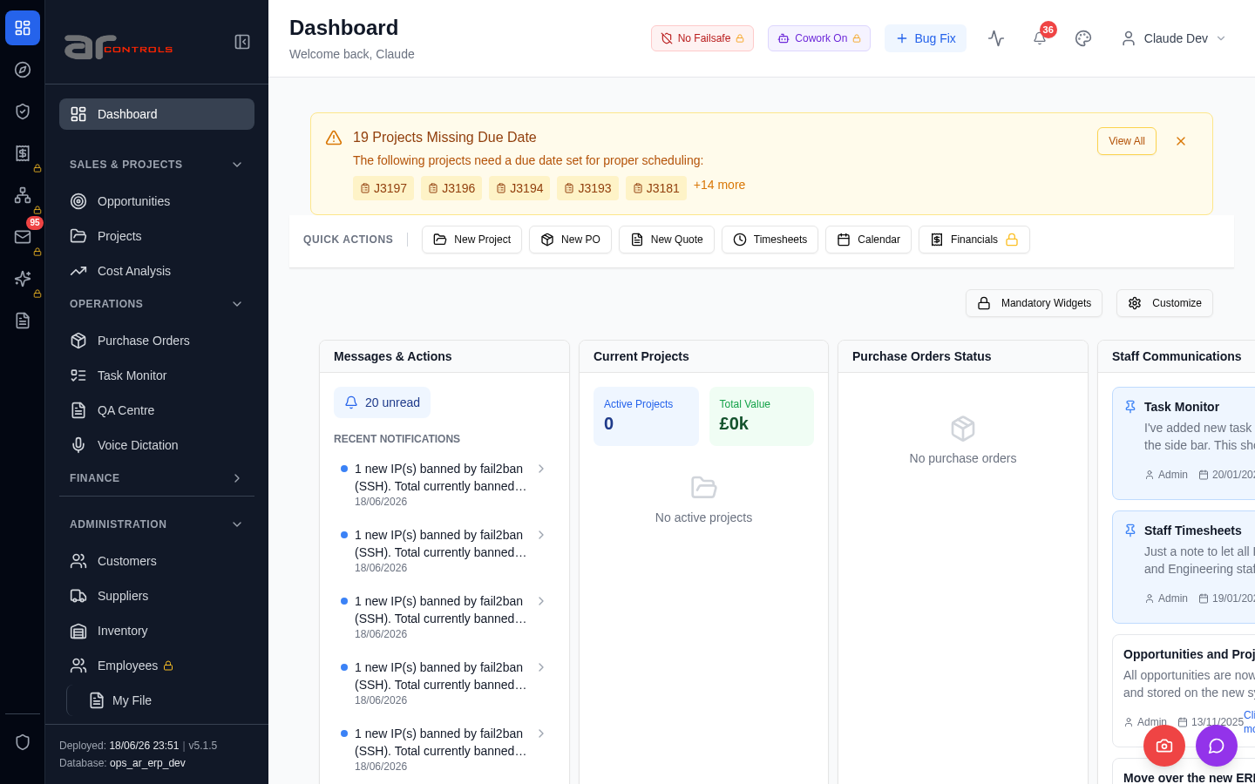
04-erp-proof-only-navigation-smoke-l2-03-open-opportunities.png
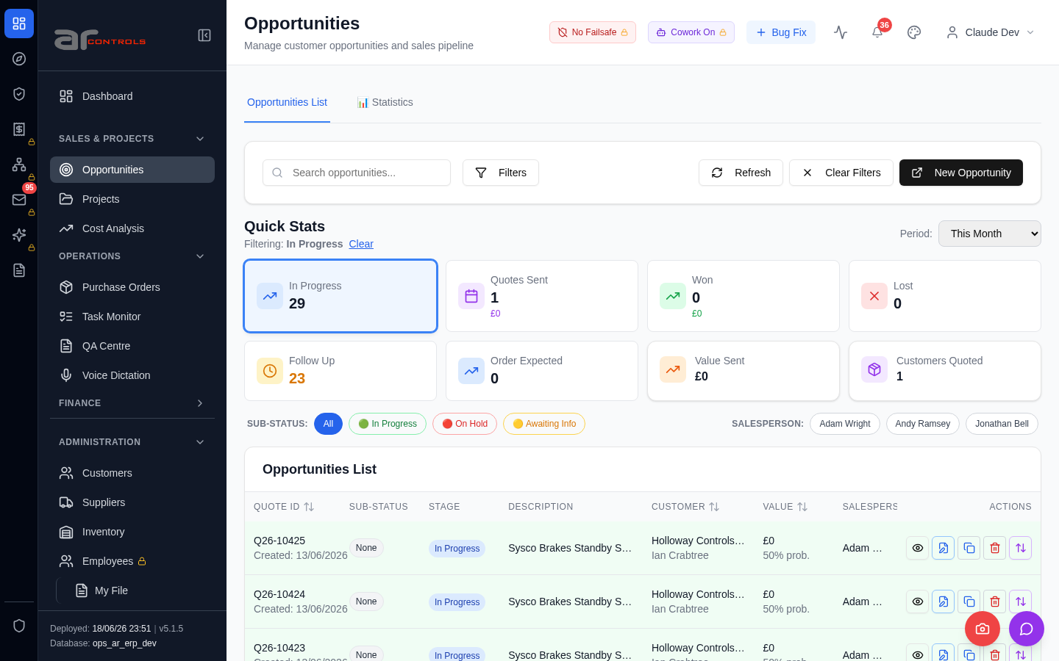
04-erp-proof-only-navigation-smoke-l2-03-open-opportunities-element.png

04-erp-proof-only-navigation-smoke-l2-04-opportunities-screen-visible.png
04-erp-proof-only-navigation-smoke-l2-05-open-projects.png
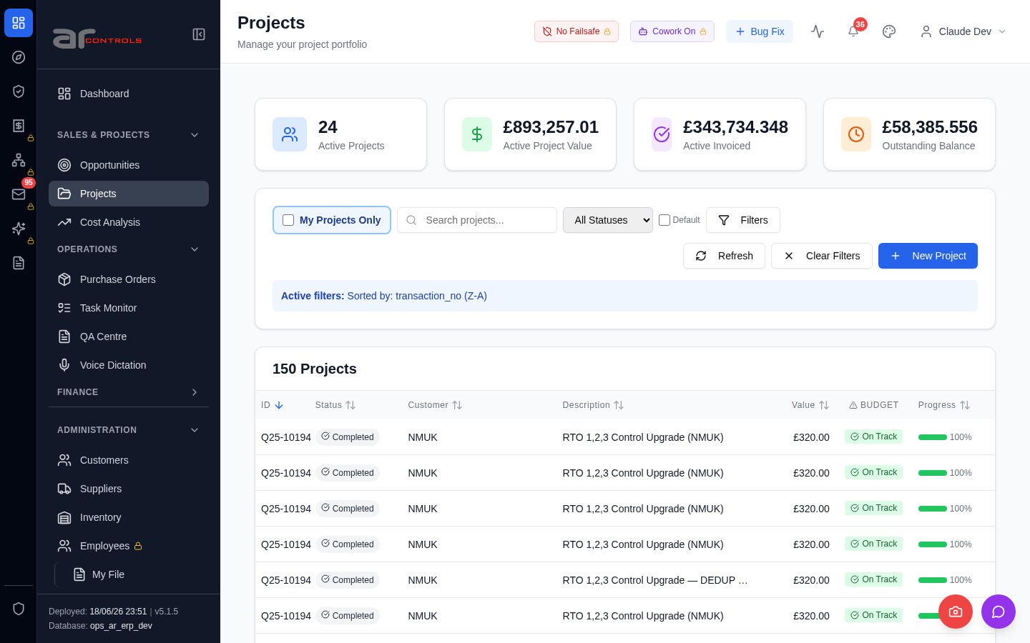
04-erp-proof-only-navigation-smoke-l2-05-open-projects-element.png

04-erp-proof-only-navigation-smoke-l2-06-projects-screen-visible.png
04-erp-proof-only-navigation-smoke-l2-07-open-resource-manager.png
04-erp-proof-only-navigation-smoke-l2-08-resource-manager-screen-visible.png
04-erp-proof-only-navigation-smoke-l2-09-open-cost-analysis.png
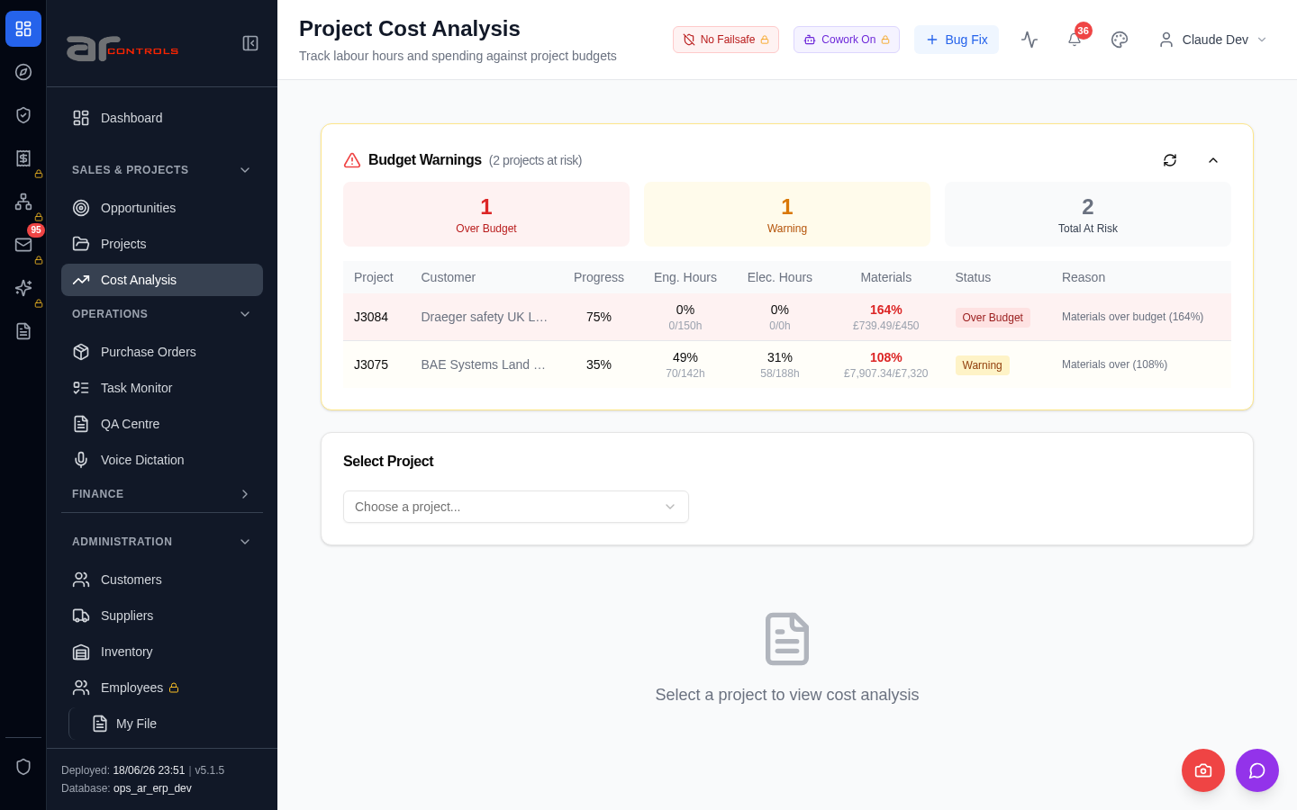
04-erp-proof-only-navigation-smoke-l2-09-open-cost-analysis-element.png

04-erp-proof-only-navigation-smoke-l2-10-cost-analysis-screen-visible.png

Console Errors
- [error] Failed to load resource: the server responded with a status of 502 (Bad Gateway)
- [error] Failed to load resource: the server responded with a status of 502 (Bad Gateway)

Network Issues
- GET http://100.121.252.85:3180/api/notifications/stream?access_token=eyJhbGciOiJIUzI1NiIsInR5cCI6IkpXVCJ9.eyJzdWIiOiJjbGF1ZGUtZGV2QGFyY29udHJvbHMuaW50ZXJuYWwiLCJ1c2VyX2lkIjoiN2NlNDFmZjAtZDBmNy00NzMxLTkzNG — net::ERR_ABORTED
- GET http://100.121.252.85:3180/api/notifications/stream?access_token=eyJhbGciOiJIUzI1NiIsInR5cCI6IkpXVCJ9.eyJzdWIiOiJjbGF1ZGUtZGV2QGFyY29udHJvbHMuaW50ZXJuYWwiLCJ1c2VyX2lkIjoiN2NlNDFmZjAtZDBmNy00NzMxLTkzNG — net::ERR_ABORTED
- GET http://100.121.252.85:3180/api/notifications/stream?access_token=eyJhbGciOiJIUzI1NiIsInR5cCI6IkpXVCJ9.eyJzdWIiOiJjbGF1ZGUtZGV2QGFyY29udHJvbHMuaW50ZXJuYWwiLCJ1c2VyX2lkIjoiN2NlNDFmZjAtZDBmNy00NzMxLTkzNG — net::ERR_ABORTED
- GET http://100.121.252.85:3180/api/notifications/stream?access_token=eyJhbGciOiJIUzI1NiIsInR5cCI6IkpXVCJ9.eyJzdWIiOiJjbGF1ZGUtZGV2QGFyY29udHJvbHMuaW50ZXJuYWwiLCJ1c2VyX2lkIjoiN2NlNDFmZjAtZDBmNy00NzMxLTkzNG — net::ERR_ABORTED
- GET http://100.121.252.85:3180/api/notifications/stream?access_token=eyJhbGciOiJIUzI1NiIsInR5cCI6IkpXVCJ9.eyJzdWIiOiJjbGF1ZGUtZGV2QGFyY29udHJvbHMuaW50ZXJuYWwiLCJ1c2VyX2lkIjoiN2NlNDFmZjAtZDBmNy00NzMxLTkzNG — net::ERR_ABORTED
- GET http://100.121.252.85:3180/api/notifications/stream?access_token=eyJhbGciOiJIUzI1NiIsInR5cCI6IkpXVCJ9.eyJzdWIiOiJjbGF1ZGUtZGV2QGFyY29udHJvbHMuaW50ZXJuYWwiLCJ1c2VyX2lkIjoiN2NlNDFmZjAtZDBmNy00NzMxLTkzNG — net::ERR_ABORTED
- GET http://100.121.252.85:3180/api/notifications/stream?access_token=eyJhbGciOiJIUzI1NiIsInR5cCI6IkpXVCJ9.eyJzdWIiOiJjbGF1ZGUtZGV2QGFyY29udHJvbHMuaW50ZXJuYWwiLCJ1c2VyX2lkIjoiN2NlNDFmZjAtZDBmNy00NzMxLTkzNG — net::ERR_ABORTED
- GET http://100.121.252.85:3180/api/notifications/stream?access_token=eyJhbGciOiJIUzI1NiIsInR5cCI6IkpXVCJ9.eyJzdWIiOiJjbGF1ZGUtZGV2QGFyY29udHJvbHMuaW50ZXJuYWwiLCJ1c2VyX2lkIjoiN2NlNDFmZjAtZDBmNy00NzMxLTkzNG — net::ERR_ABORTED
- GET http://100.121.252.85:3180/api/notifications/stream?access_token=eyJhbGciOiJIUzI1NiIsInR5cCI6IkpXVCJ9.eyJzdWIiOiJjbGF1ZGUtZGV2QGFyY29udHJvbHMuaW50ZXJuYWwiLCJ1c2VyX2lkIjoiN2NlNDFmZjAtZDBmNy00NzMxLTkzNG — net::ERR_ABORTED
- GET http://100.121.252.85:3180/api/notifications/stream?access_token=eyJhbGciOiJIUzI1NiIsInR5cCI6IkpXVCJ9.eyJzdWIiOiJjbGF1ZGUtZGV2QGFyY29udHJvbHMuaW50ZXJuYWwiLCJ1c2VyX2lkIjoiN2NlNDFmZjAtZDBmNy00NzMxLTkzNG — net::ERR_ABORTED
- GET http://100.121.252.85:3180/api/notifications/stream?access_token=eyJhbGciOiJIUzI1NiIsInR5cCI6IkpXVCJ9.eyJzdWIiOiJjbGF1ZGUtZGV2QGFyY29udHJvbHMuaW50ZXJuYWwiLCJ1c2VyX2lkIjoiN2NlNDFmZjAtZDBmNy00NzMxLTkzNG — net::ERR_ABORTED
- GET http://100.121.252.85:3180/api/notifications/stream?access_token=eyJhbGciOiJIUzI1NiIsInR5cCI6IkpXVCJ9.eyJzdWIiOiJjbGF1ZGUtZGV2QGFyY29udHJvbHMuaW50ZXJuYWwiLCJ1c2VyX2lkIjoiN2NlNDFmZjAtZDBmNy00NzMxLTkzNG — net::ERR_ABORTED
- GET http://100.121.252.85:3180/api/notifications/stream?access_token=eyJhbGciOiJIUzI1NiIsInR5cCI6IkpXVCJ9.eyJzdWIiOiJjbGF1ZGUtZGV2QGFyY29udHJvbHMuaW50ZXJuYWwiLCJ1c2VyX2lkIjoiN2NlNDFmZjAtZDBmNy00NzMxLTkzNG — net::ERR_ABORTED
- GET http://100.121.252.85:3180/api/notifications/stream?access_token=eyJhbGciOiJIUzI1NiIsInR5cCI6IkpXVCJ9.eyJzdWIiOiJjbGF1ZGUtZGV2QGFyY29udHJvbHMuaW50ZXJuYWwiLCJ1c2VyX2lkIjoiN2NlNDFmZjAtZDBmNy00NzMxLTkzNG — net::ERR_ABORTED
- GET http://100.121.252.85:3180/api/notifications/stream?access_token=eyJhbGciOiJIUzI1NiIsInR5cCI6IkpXVCJ9.eyJzdWIiOiJjbGF1ZGUtZGV2QGFyY29udHJvbHMuaW50ZXJuYWwiLCJ1c2VyX2lkIjoiN2NlNDFmZjAtZDBmNy00NzMxLTkzNG — net::ERR_ABORTED
- GET http://100.121.252.85:3180/api/notifications/stream?access_token=eyJhbGciOiJIUzI1NiIsInR5cCI6IkpXVCJ9.eyJzdWIiOiJjbGF1ZGUtZGV2QGFyY29udHJvbHMuaW50ZXJuYWwiLCJ1c2VyX2lkIjoiN2NlNDFmZjAtZDBmNy00NzMxLTkzNG — net::ERR_ABORTED
- GET http://100.121.252.85:3180/api/notifications/stream?access_token=eyJhbGciOiJIUzI1NiIsInR5cCI6IkpXVCJ9.eyJzdWIiOiJjbGF1ZGUtZGV2QGFyY29udHJvbHMuaW50ZXJuYWwiLCJ1c2VyX2lkIjoiN2NlNDFmZjAtZDBmNy00NzMxLTkzNG — net::ERR_ABORTED
- GET http://100.121.252.85:3180/api/notifications/stream?access_token=eyJhbGciOiJIUzI1NiIsInR5cCI6IkpXVCJ9.eyJzdWIiOiJjbGF1ZGUtZGV2QGFyY29udHJvbHMuaW50ZXJuYWwiLCJ1c2VyX2lkIjoiN2NlNDFmZjAtZDBmNy00NzMxLTkzNG — net::ERR_ABORTED
- GET http://100.121.252.85:3180/api/notifications/stream?access_token=eyJhbGciOiJIUzI1NiIsInR5cCI6IkpXVCJ9.eyJzdWIiOiJjbGF1ZGUtZGV2QGFyY29udHJvbHMuaW50ZXJuYWwiLCJ1c2VyX2lkIjoiN2NlNDFmZjAtZDBmNy00NzMxLTkzNG — net::ERR_ABORTED
- GET http://100.121.252.85:3180/api/notifications/stream?access_token=eyJhbGciOiJIUzI1NiIsInR5cCI6IkpXVCJ9.eyJzdWIiOiJjbGF1ZGUtZGV2QGFyY29udHJvbHMuaW50ZXJuYWwiLCJ1c2VyX2lkIjoiN2NlNDFmZjAtZDBmNy00NzMxLTkzNG — net::ERR_ABORTED

