ERP Verification Evidence Pack — [ERP bug-fix] Bug from /purchase-orders — proof-only
Result: FAIL — FAIL — 3 browser check(s) failed · 3 console error(s) · 3 server-5xx response(s) · 1 runtime start check(s) failed
When: 20260619T001022Z
Verified URL: http://100.121.252.85:3180/

Runtime Start Checks
frontend_http: PASS — http://100.121.252.85:3180/ returned HTTP 200 (text/html; charset=utf-8); body starts '<!doctype html><html lang="en"><head><meta charset="utf-8"/><link rel="icon" href="/favicon.ico"/><link rel="icon" type='
backend_health: FAIL — 100.121.252.85 http://127.0.0.1:8002/health failed: <urlopen error [Errno 111] Connection refused>
pm2_backend-dev: PASS — backend-dev status=online
pm2_frontend-dev: PASS — frontend-dev status=online

Notes
- Verification level 2
- ✓ task proof plan L2: 7 task browser check(s), 0 API check(s)
- Playwright MCP required for level 2+ UI proof; validating worker-declared MCP-backed checks.
- ✓ readiness gate: app ready after 1 probe(s) (status 200)
- Logged in as claude-dev@arcontrols.internal
- ✓ selector present: #root > *
- ✓ smoke_text present: Dashboard
- ✓ l2-menu-smoke: step 1 #root *
- ✓ l2-menu-smoke: step 2 menu_sweep: Opportunities, Dashboard, Projects, Cost Analysis, Purchase Orders
- ✓ changed-surface-1: selector present: a[href='/purchase-orders']
- ✓ changed-surface-1: selector present: input[placeholder='Search PO, supplier or project...']
- ✓ changed-surface-1: selector present: [data-testid='po-toolbar-row']
- ✓ changed-surface-1: selector present: [data-testid='po-toolbar-actions-right']
- ✓ changed-surface-1: selector present: [data-testid='purchase-orders-orders-button']
- ✓ changed-surface-1: selector present: [data-testid='purchase-orders-assemblies-button']
- ✗ changed-surface-1: selector missing: input[placeholder='Search assemblies...']
- Browser flow 'purchase-order-first-approval' started at /; target is /purchase-orders. Navigation must use visible UI actions from here.
- ✓ purchase-order-first-approval: step 1 navigate
- ✓ purchase-order-first-approval: step 2 input[placeholder="Search PO, supplier or project..."]
- ✓ purchase-order-first-approval: step 3 [data-testid="po-filter-pending-approval"]
- ✗ browser check 'purchase-order-first-approval' failed: Page.wait_for_selector: Timeout 30000ms exceeded.
Call log:
- waiting for locator("tr:has-text(\"Pending Approval\"):has([data-testid^=\"po-view-\"])") to be visible
- Browser flow 'purchase-order-over-limit-auto-submits-for-approval' started at /; target is /purchase-orders. Navigation must use visible UI actions from here.
- ✓ purchase-order-over-limit-auto-submits-for-approval: step 1 navigate
- ✓ purchase-order-over-limit-auto-submits-for-approval: step 2 input[placeholder="Search PO, supplier or project..."]
- ✓ purchase-order-over-limit-auto-submits-for-approval: step 3 [data-testid="po-filter-pending-approval"]
- ✗ browser check 'purchase-order-over-limit-auto-submits-for-approval' failed: Page.wait_for_selector: Timeout 30000ms exceeded.
Call log:
- waiting for locator("tr:has-text(\"Pending Approval\")") to be visible
- Browser flow 'po-telegram-digest-excludes-requested-2026-06-16' started at /; target is /purchase-orders. Navigation must use visible UI actions from here.
- ✓ po-telegram-digest-excludes-requested-2026-06-16: step 1 navigate
- ✓ po-telegram-digest-excludes-requested-2026-06-16: step 2 a[href="/purchase-orders"]
- ✓ po-telegram-digest-excludes-requested-2026-06-16: step 3 a[href="/purchase-orders"]
- ✓ po-telegram-digest-excludes-requested-2026-06-16: step 4 input[placeholder="Search PO, supplier or project..."]
- ✓ po-telegram-digest-excludes-requested-2026-06-16: step 5 [data-testid="po-filter-pending-approval"]
- ✓ po-telegram-digest-excludes-requested-2026-06-16: step 6 [data-testid="po-filter-pending-approval"]
- ✓ po-telegram-digest-excludes-requested-2026-06-16: step 7 Purchase Orders
- ✓ po-telegram-digest-excludes-requested-2026-06-16: browser flow reached target path /purchase-orders
- Browser flow 'po-toolbar-no-overlap-and-consistent-height-2026-06-16' started at /; target is /purchase-orders. Navigation must use visible UI actions from here.
- ✓ po-toolbar-no-overlap-and-consistent-height-2026-06-16: step 1 navigate
- ✓ po-toolbar-no-overlap-and-consistent-height-2026-06-16: step 2 a[href="/purchase-orders"]
- ✓ po-toolbar-no-overlap-and-consistent-height-2026-06-16: step 3 a[href="/purchase-orders"]
- ✓ po-toolbar-no-overlap-and-consistent-height-2026-06-16: step 4 input[placeholder="Search PO, supplier or project..."]
- ✓ po-toolbar-no-overlap-and-consistent-height-2026-06-16: step 5 [data-testid="po-toolbar-row"]
- ✓ po-toolbar-no-overlap-and-consistent-height-2026-06-16: step 6 [data-testid="purchase-orders-assemblies-button"]
- ✓ po-toolbar-no-overlap-and-consistent-height-2026-06-16: step 7 input[placeholder="Search assemblies..."]
- ✓ po-toolbar-no-overlap-and-consistent-height-2026-06-16: step 8 [data-testid="po-toolbar-row"]
- ✓ po-toolbar-no-overlap-and-consistent-height-2026-06-16: step 9 [data-testid="purchase-orders-orders-button"]
- ✓ po-toolbar-no-overlap-and-consistent-height-2026-06-16: step 10 input[placeholder="Search PO, supplier or project..."]
- ✓ po-toolbar-no-overlap-and-consistent-height-2026-06-16: step 11 [data-testid="po-toolbar-row"]
- ✓ po-toolbar-no-overlap-and-consistent-height-2026-06-16: step 12 [data-testid="po-toolbar-actions-right"]
- ✓ po-toolbar-no-overlap-and-consistent-height-2026-06-16: step 13 Purchase Orders
- ✓ po-toolbar-no-overlap-and-consistent-height-2026-06-16: step 14 View Cancelled
- ✓ po-toolbar-no-overlap-and-consistent-height-2026-06-16: browser flow reached target path /purchase-orders
- Browser flow 'suppliers-list-renders' started at /; target is /suppliers. Navigation must use visible UI actions from here.
- ✓ suppliers-list-renders: step 1 a[href="/suppliers"]
- ✓ suppliers-list-renders: step 2 input[placeholder="Search suppliers..."]
- ✓ suppliers-list-renders: step 3 Suppliers
- ✓ suppliers-list-renders: step 4 Manage your supplier database
- ✓ suppliers-list-renders: browser flow reached target path /suppliers
- Browser flow 'inventory-list-renders' started at /; target is /inventory. Navigation must use visible UI actions from here.
- ✓ inventory-list-renders: step 1 a[href="/inventory"]
- ✓ inventory-list-renders: step 2 input[placeholder="Search items..."]
- ✓ inventory-list-renders: step 3 Inventory Management
- ✓ inventory-list-renders: step 4 Manage your inventory items
- ✓ inventory-list-renders: browser flow reached target path /inventory
- Ignored 28 aborted background fetch console error(s); task browser checks, API checks, and runtime checks decide this proof.

Screenshots
01-landing.png
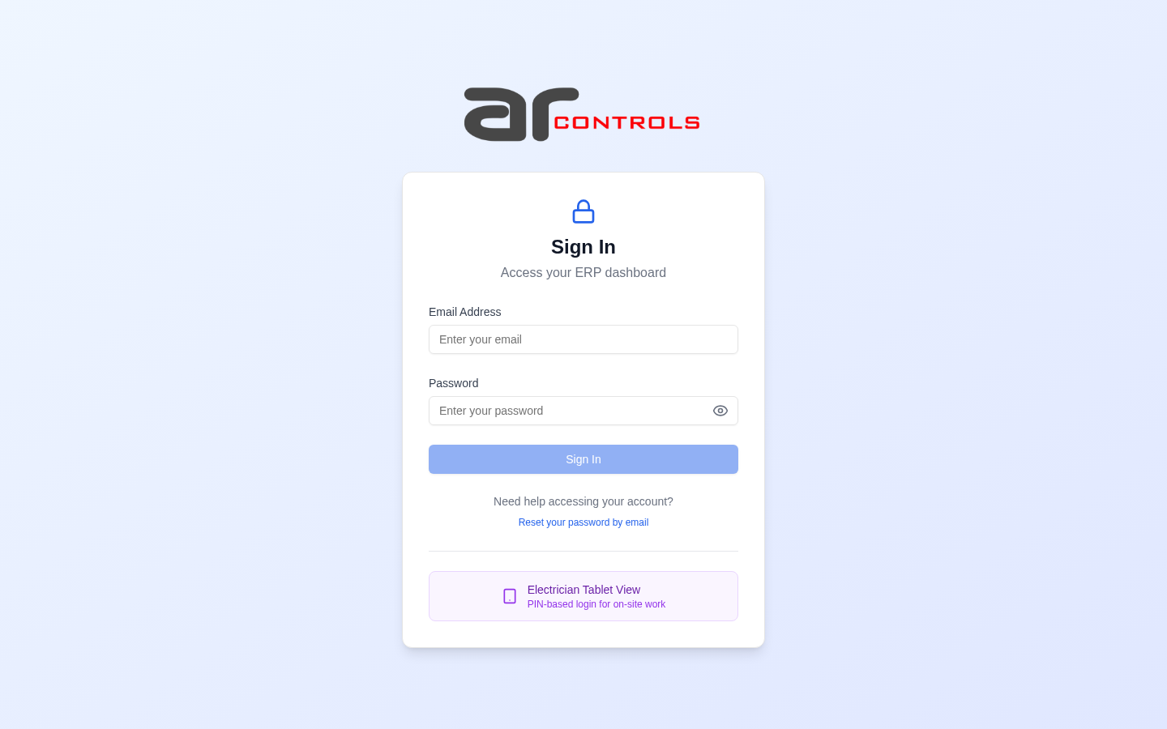
02-post-login.png
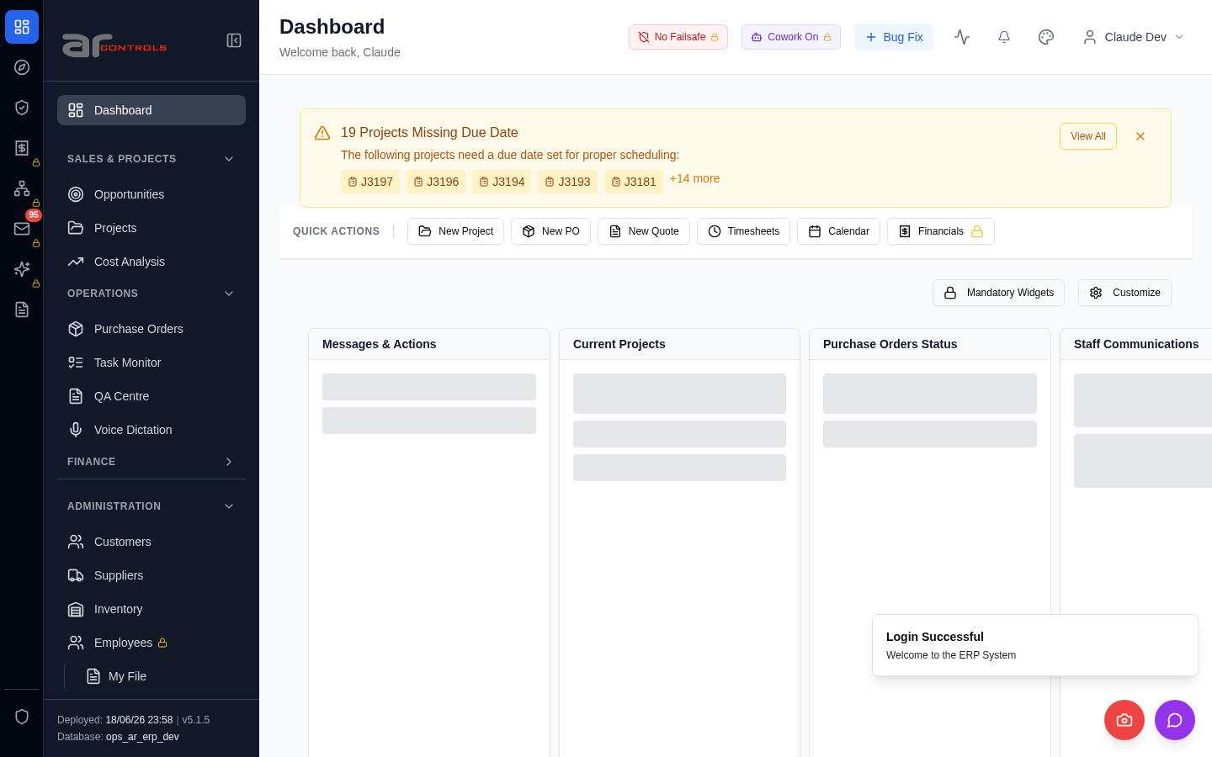
03-l2-menu-smoke-01-root.png
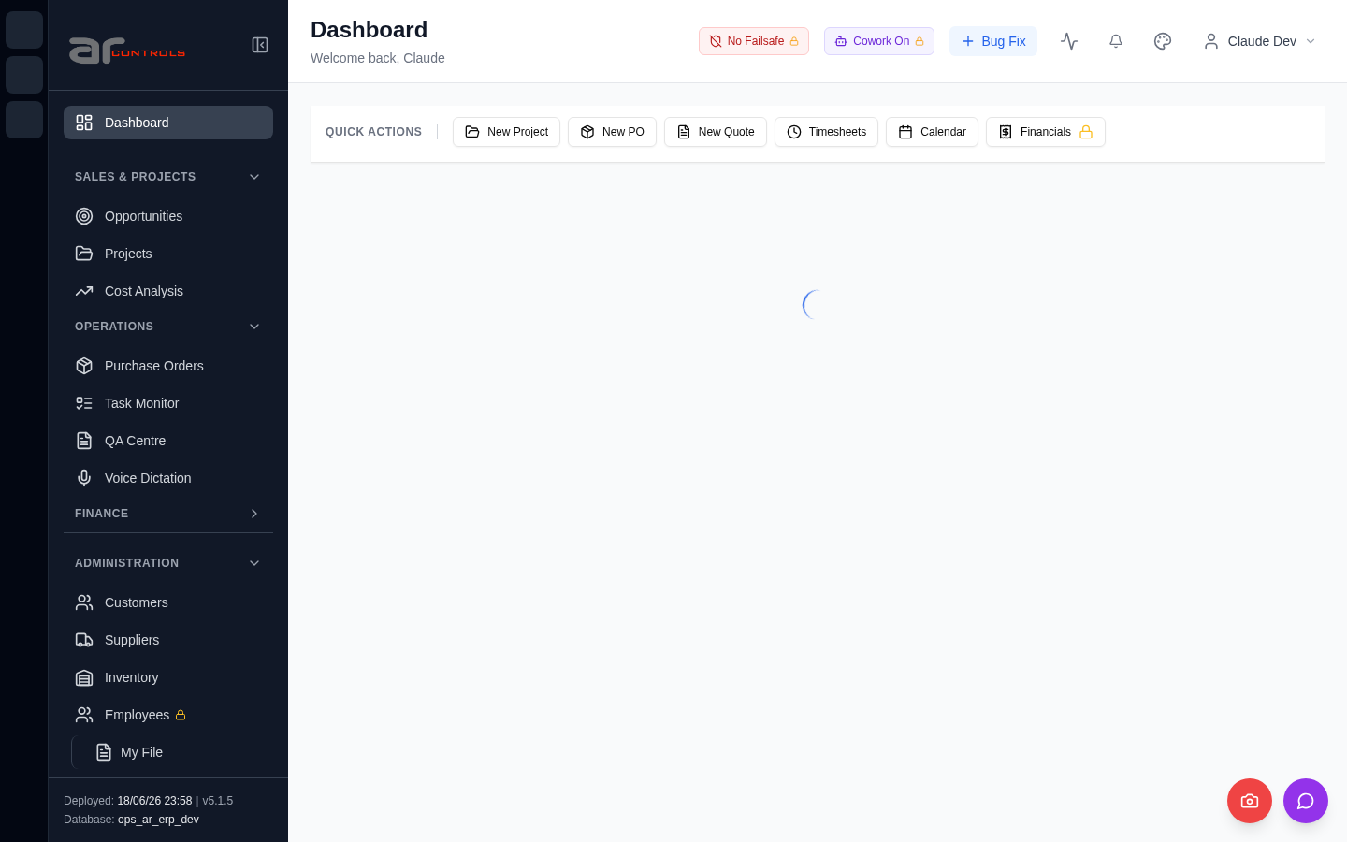
03-l2-menu-smoke-01-root-element.png
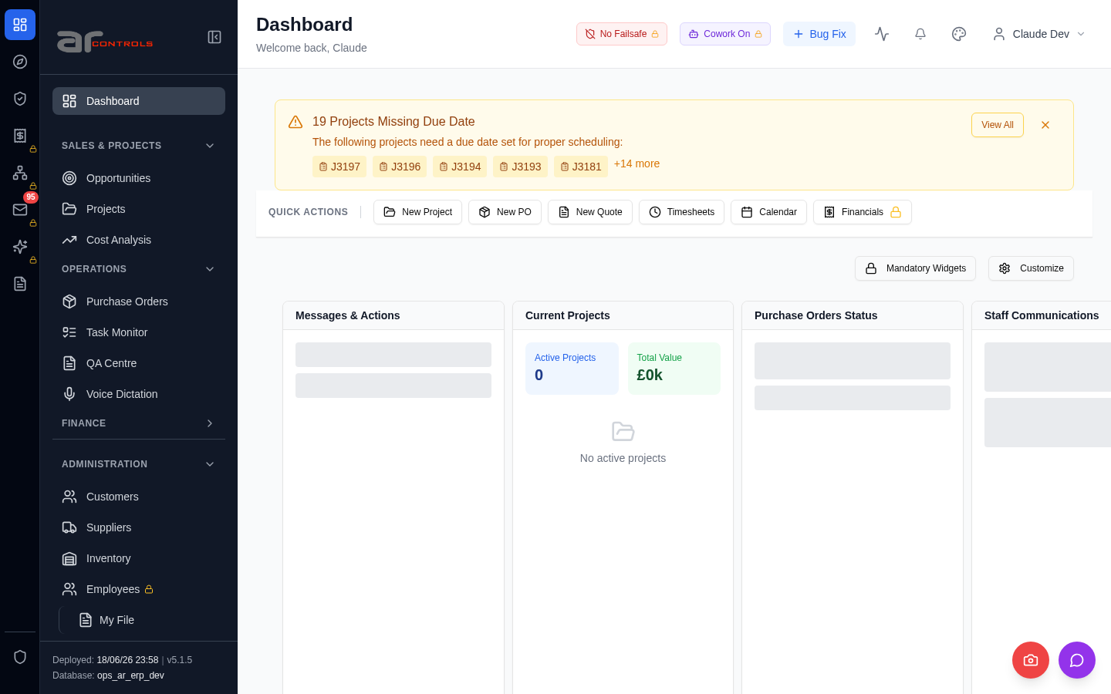
03-l2-menu-smoke-02-menu-sweep-opportunities-dashboard-projects-cost-analysis-purchase-orders.png
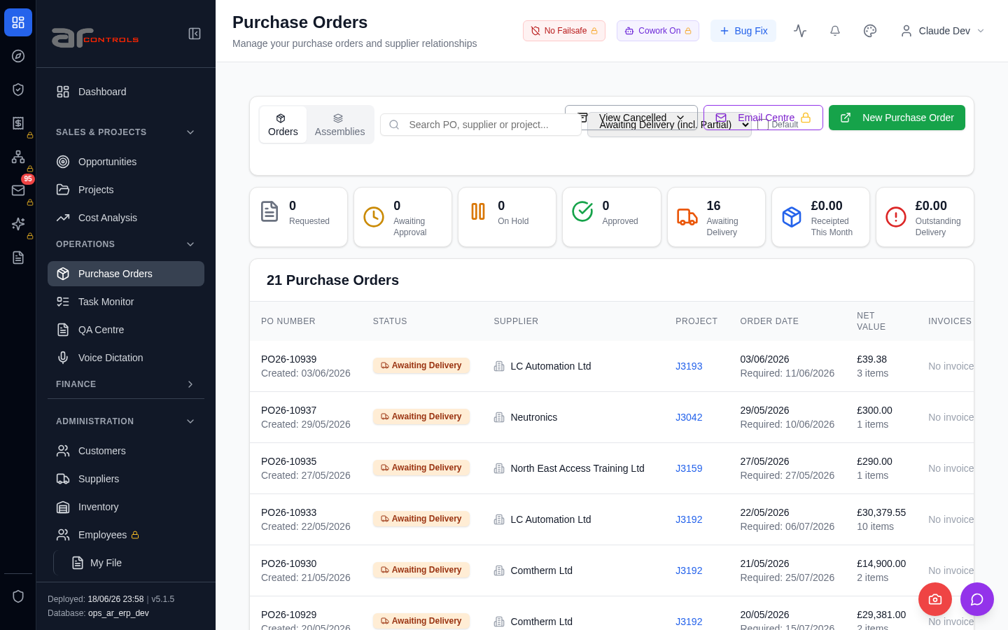
03-l2-menu-smoke.png
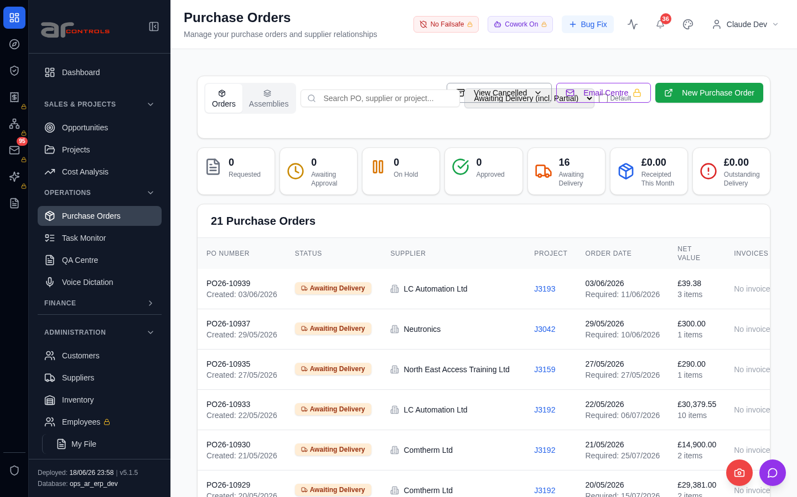
04-changed-surface-1.png
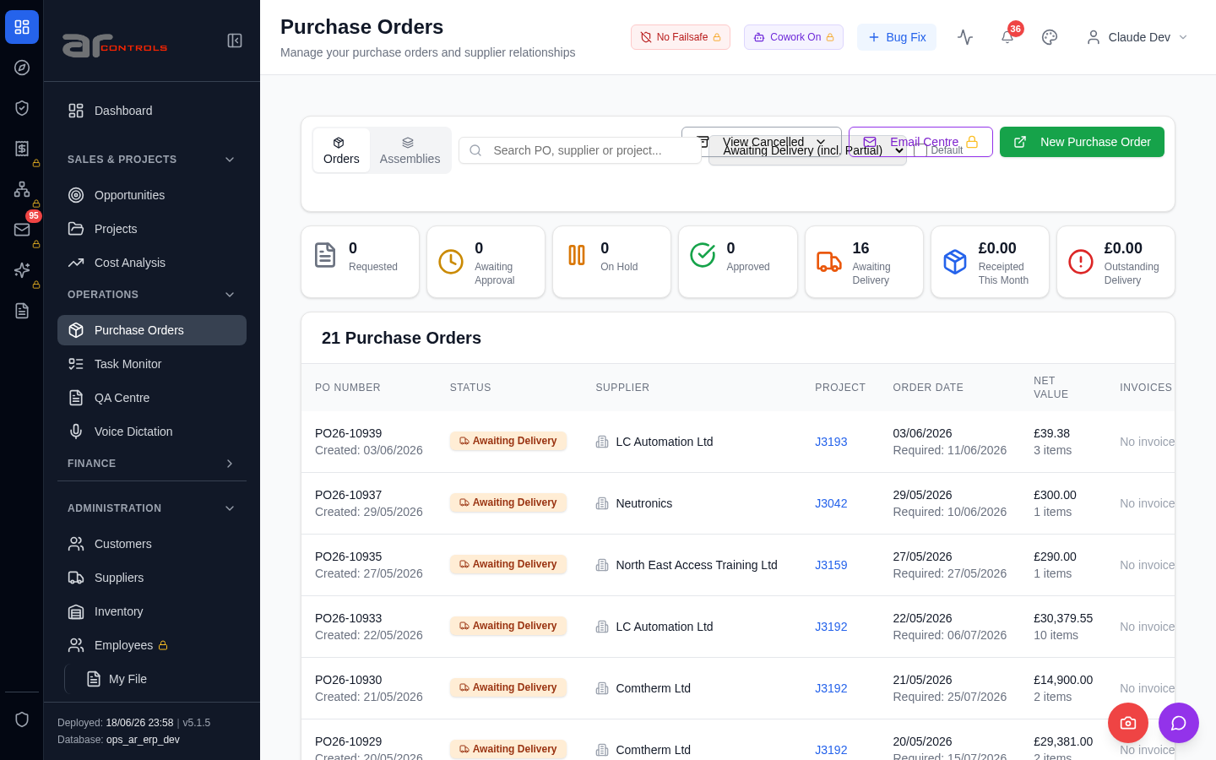
05-purchase-order-first-approval-00-journey-start.png
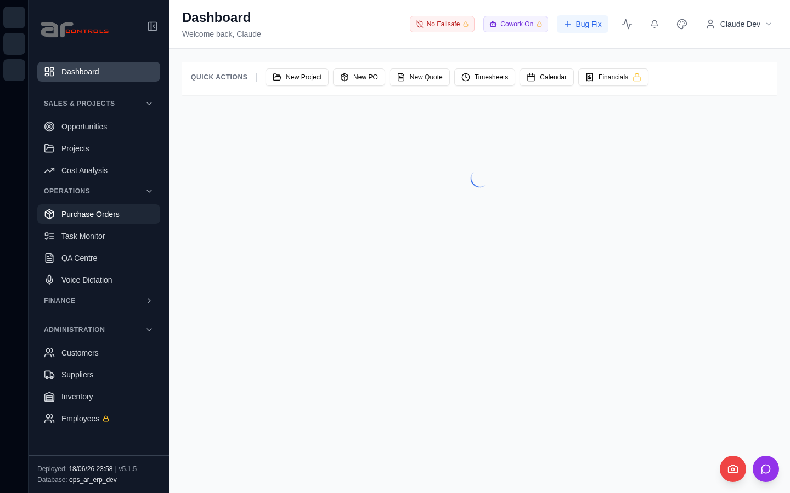
05-purchase-order-first-approval-01-navigate.png
05-purchase-order-first-approval-02-input-placeholder-search-po-supplier-or-project.png
05-purchase-order-first-approval-02-input-placeholder-search-po-supplier-or-project-element.png
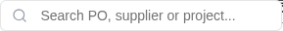
05-purchase-order-first-approval-03-data-testid-po-filter-pending-approval.png
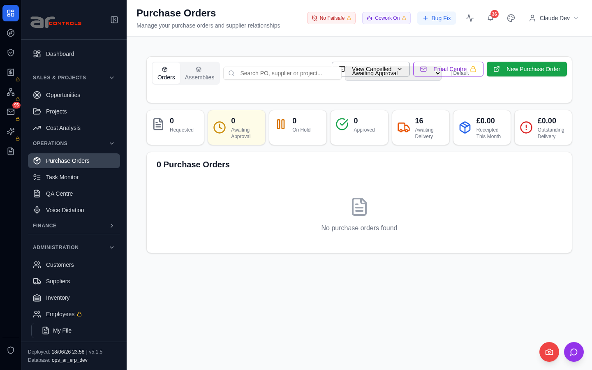
05-purchase-order-first-approval-03-data-testid-po-filter-pending-approval-element.png
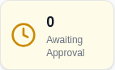
05-purchase-order-first-approval-failed.png
06-purchase-order-over-limit-auto-submits-for-approval-00-journey-start.png
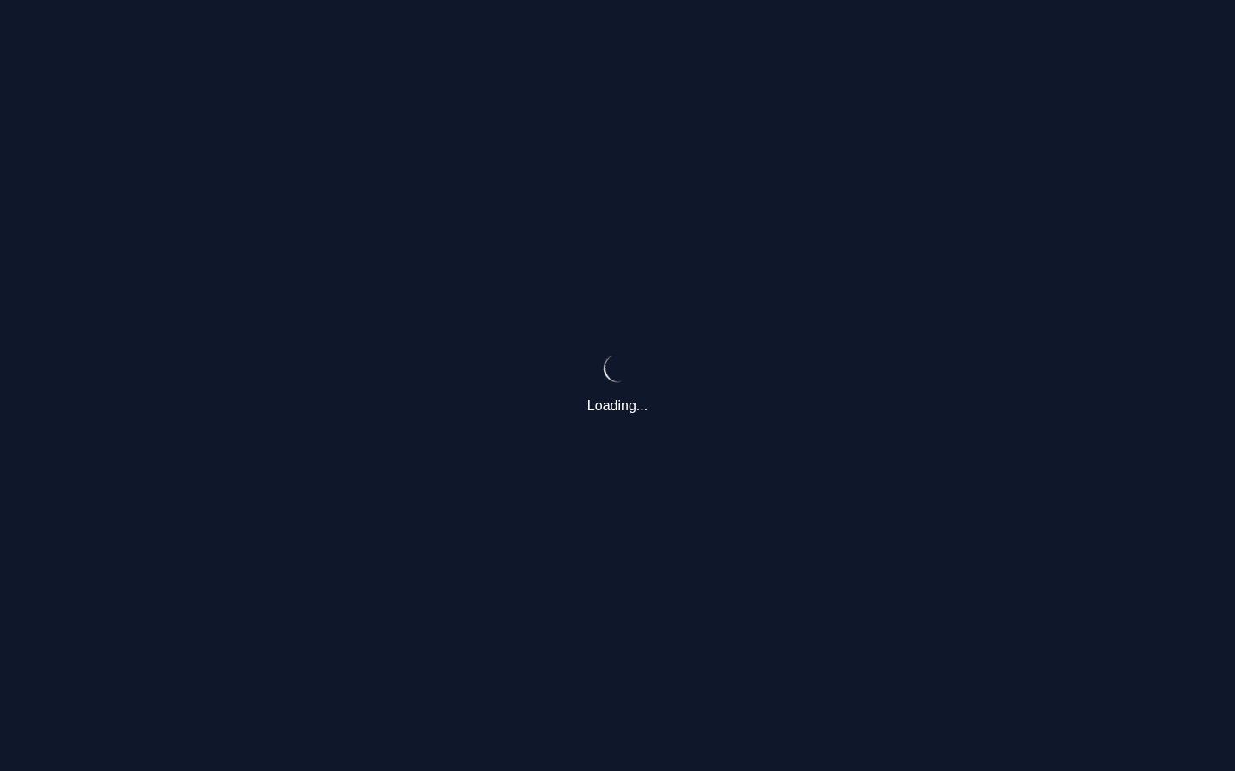
06-purchase-order-over-limit-auto-submits-for-approval-01-navigate.png
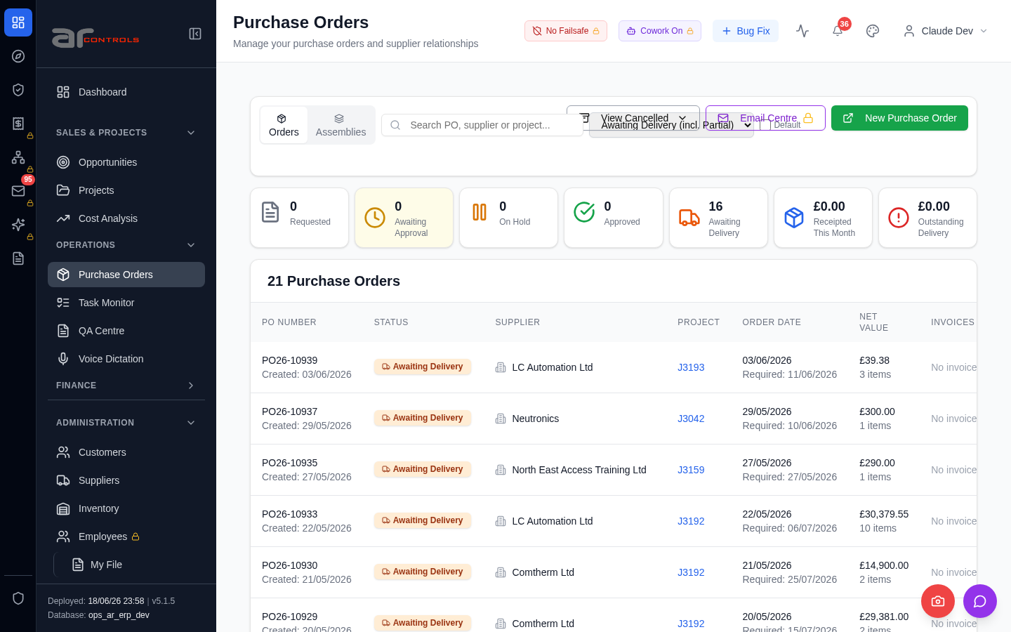
06-purchase-order-over-limit-auto-submits-for-approval-02-input-placeholder-search-po-supplier-or-project.png
06-purchase-order-over-limit-auto-submits-for-approval-02-input-placeholder-search-po-supplier-or-project-element.png
06-purchase-order-over-limit-auto-submits-for-approval-03-data-testid-po-filter-pending-approval.png
06-purchase-order-over-limit-auto-submits-for-approval-03-data-testid-po-filter-pending-approval-element.png
06-purchase-order-over-limit-auto-submits-for-approval-failed.png
07-po-telegram-digest-excludes-requested-2026-06-16-00-journey-start.png
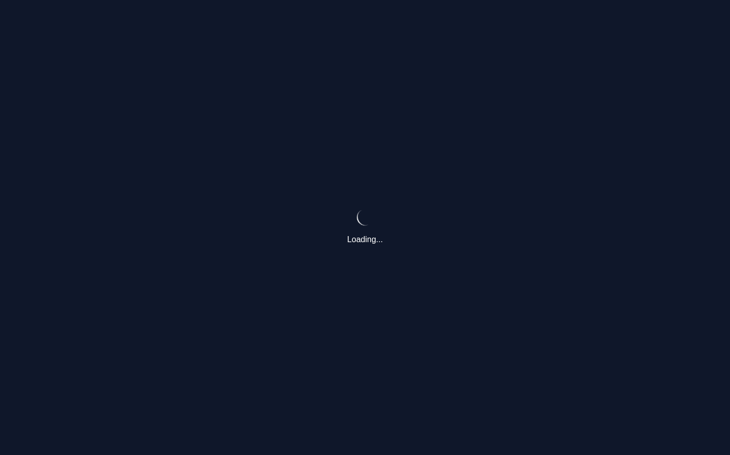
07-po-telegram-digest-excludes-requested-2026-06-16-01-navigate.png
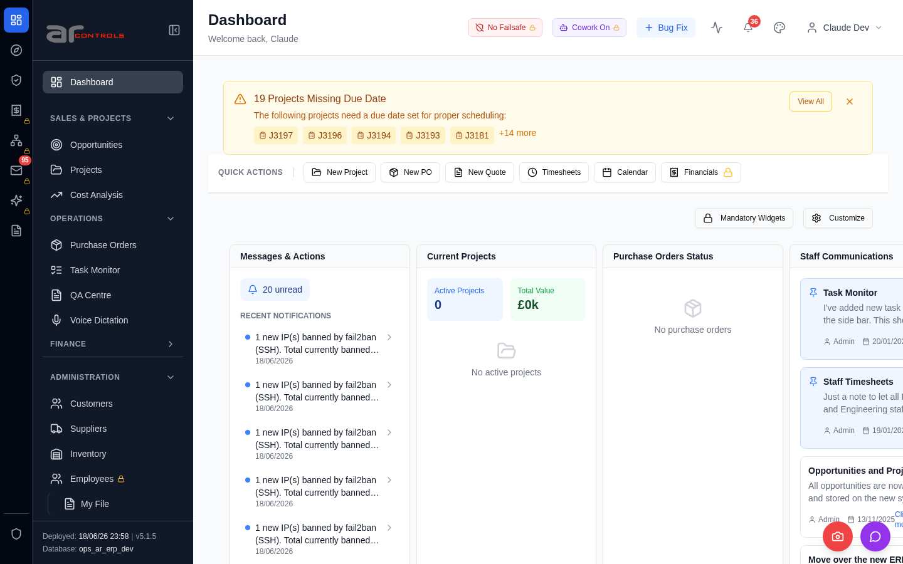
07-po-telegram-digest-excludes-requested-2026-06-16-02-a-href-purchase-orders.png
07-po-telegram-digest-excludes-requested-2026-06-16-02-a-href-purchase-orders-element.png

07-po-telegram-digest-excludes-requested-2026-06-16-03-a-href-purchase-orders.png
07-po-telegram-digest-excludes-requested-2026-06-16-03-a-href-purchase-orders-element.png

07-po-telegram-digest-excludes-requested-2026-06-16-04-input-placeholder-search-po-supplier-or-project.png
07-po-telegram-digest-excludes-requested-2026-06-16-04-input-placeholder-search-po-supplier-or-project-element.png
07-po-telegram-digest-excludes-requested-2026-06-16-05-data-testid-po-filter-pending-approval.png
07-po-telegram-digest-excludes-requested-2026-06-16-05-data-testid-po-filter-pending-approval-element.png
07-po-telegram-digest-excludes-requested-2026-06-16-06-data-testid-po-filter-pending-approval.png
07-po-telegram-digest-excludes-requested-2026-06-16-06-data-testid-po-filter-pending-approval-element.png
07-po-telegram-digest-excludes-requested-2026-06-16-07-purchase-orders.png
07-po-telegram-digest-excludes-requested-2026-06-16.png
08-po-toolbar-no-overlap-and-consistent-height-2026-06-16-00-journey-start.png
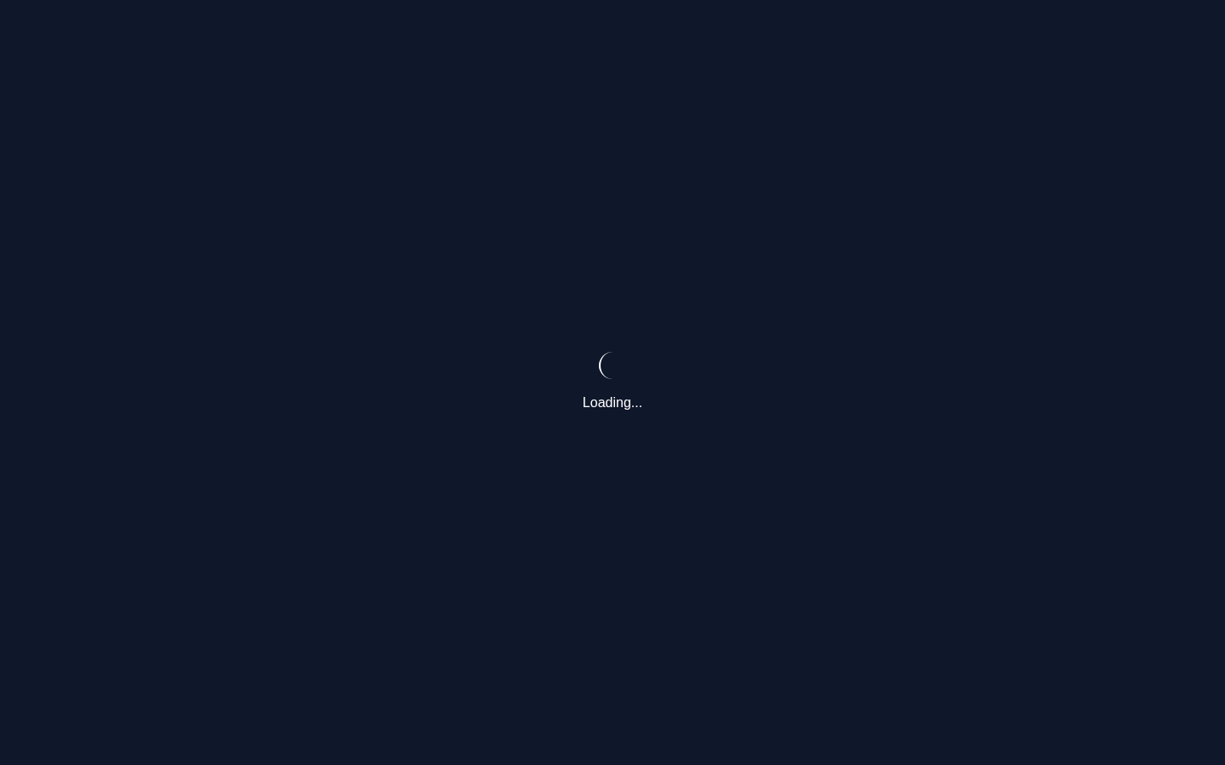
08-po-toolbar-no-overlap-and-consistent-height-2026-06-16-01-navigate.png
08-po-toolbar-no-overlap-and-consistent-height-2026-06-16-02-a-href-purchase-orders.png
08-po-toolbar-no-overlap-and-consistent-height-2026-06-16-02-a-href-purchase-orders-element.png
08-po-toolbar-no-overlap-and-consistent-height-2026-06-16-03-a-href-purchase-orders.png
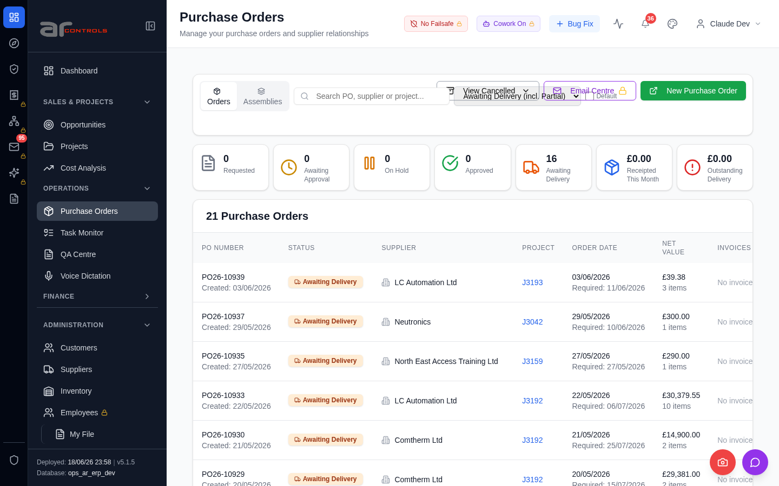
08-po-toolbar-no-overlap-and-consistent-height-2026-06-16-03-a-href-purchase-orders-element.png
08-po-toolbar-no-overlap-and-consistent-height-2026-06-16-04-input-placeholder-search-po-supplier-or-project.png
08-po-toolbar-no-overlap-and-consistent-height-2026-06-16-04-input-placeholder-search-po-supplier-or-project-element.png
08-po-toolbar-no-overlap-and-consistent-height-2026-06-16-05-data-testid-po-toolbar-row.png
08-po-toolbar-no-overlap-and-consistent-height-2026-06-16-05-data-testid-po-toolbar-row-element.png
08-po-toolbar-no-overlap-and-consistent-height-2026-06-16-06-data-testid-purchase-orders-assemblies-button.png
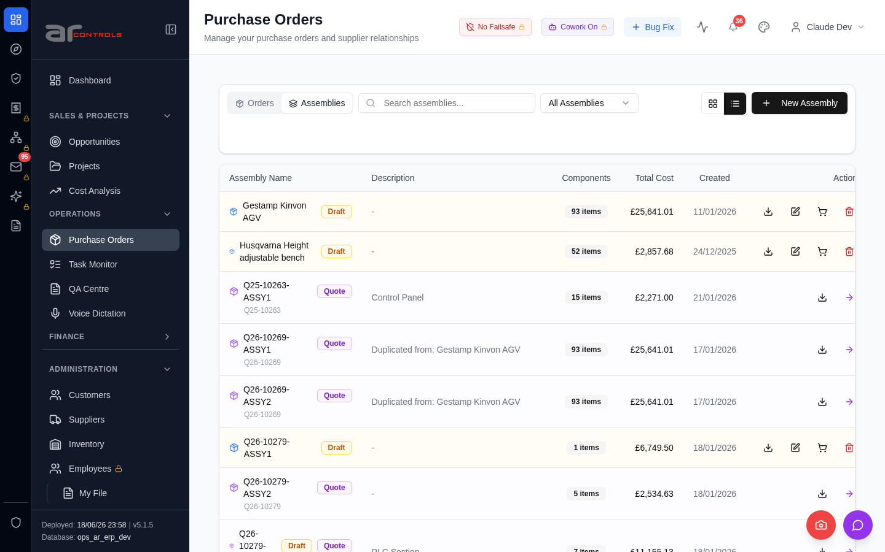
08-po-toolbar-no-overlap-and-consistent-height-2026-06-16-06-data-testid-purchase-orders-assemblies-button-element.png

08-po-toolbar-no-overlap-and-consistent-height-2026-06-16-07-input-placeholder-search-assemblies.png
08-po-toolbar-no-overlap-and-consistent-height-2026-06-16-07-input-placeholder-search-assemblies-element.png

08-po-toolbar-no-overlap-and-consistent-height-2026-06-16-08-data-testid-po-toolbar-row.png
08-po-toolbar-no-overlap-and-consistent-height-2026-06-16-08-data-testid-po-toolbar-row-element.png
08-po-toolbar-no-overlap-and-consistent-height-2026-06-16-09-data-testid-purchase-orders-orders-button.png
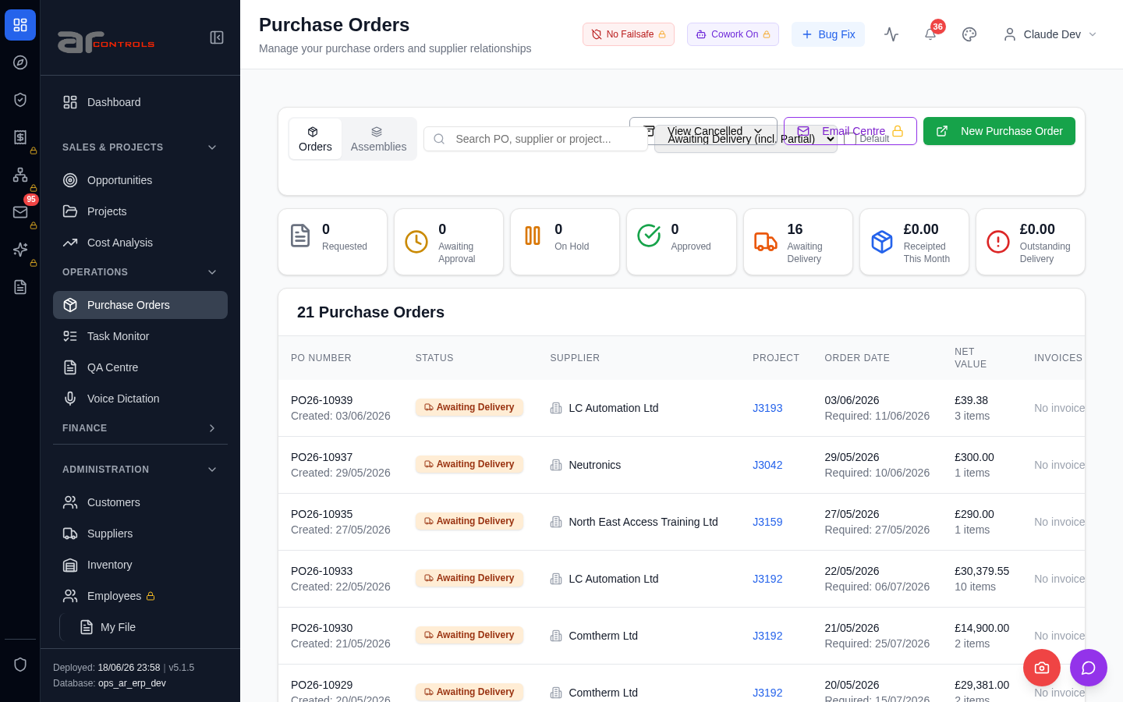
08-po-toolbar-no-overlap-and-consistent-height-2026-06-16-09-data-testid-purchase-orders-orders-button-element.png
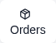
08-po-toolbar-no-overlap-and-consistent-height-2026-06-16-10-input-placeholder-search-po-supplier-or-project.png
08-po-toolbar-no-overlap-and-consistent-height-2026-06-16-10-input-placeholder-search-po-supplier-or-project-element.png
08-po-toolbar-no-overlap-and-consistent-height-2026-06-16-11-data-testid-po-toolbar-row.png
08-po-toolbar-no-overlap-and-consistent-height-2026-06-16-11-data-testid-po-toolbar-row-element.png
08-po-toolbar-no-overlap-and-consistent-height-2026-06-16-12-data-testid-po-toolbar-actions-right.png
08-po-toolbar-no-overlap-and-consistent-height-2026-06-16-12-data-testid-po-toolbar-actions-right-element.png
08-po-toolbar-no-overlap-and-consistent-height-2026-06-16-13-purchase-orders.png
08-po-toolbar-no-overlap-and-consistent-height-2026-06-16-14-view-cancelled.png
08-po-toolbar-no-overlap-and-consistent-height-2026-06-16.png
09-suppliers-list-renders-00-journey-start.png
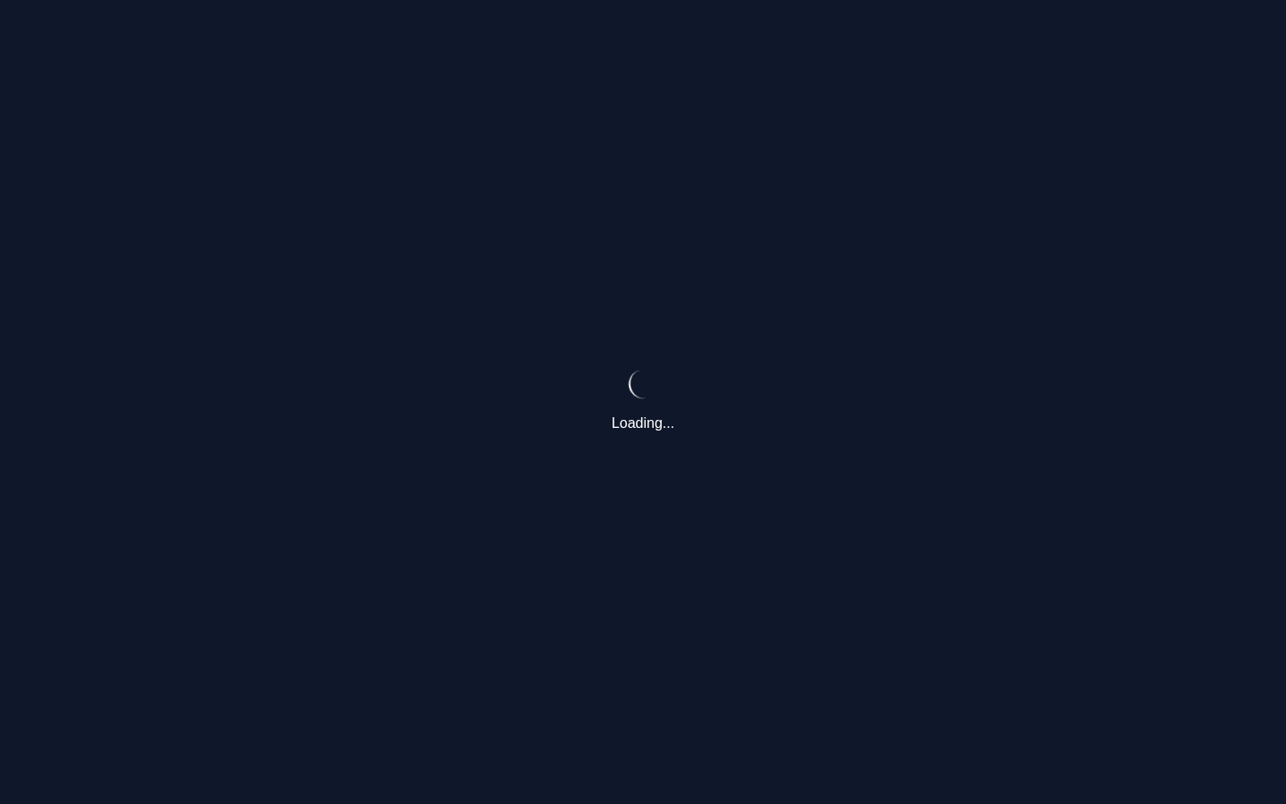
09-suppliers-list-renders-01-a-href-suppliers.png
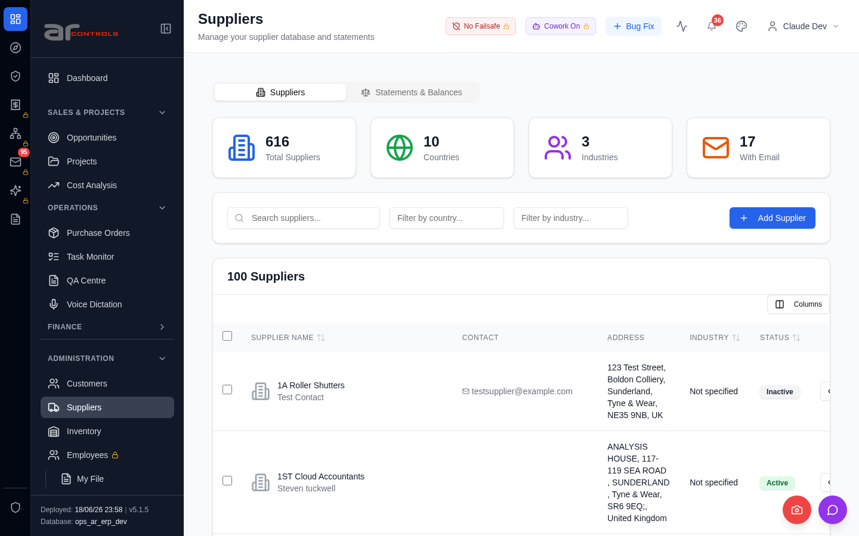
09-suppliers-list-renders-01-a-href-suppliers-element.png

09-suppliers-list-renders-02-input-placeholder-search-suppliers.png
09-suppliers-list-renders-02-input-placeholder-search-suppliers-element.png
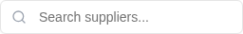
09-suppliers-list-renders-03-suppliers.png
09-suppliers-list-renders-04-manage-your-supplier-database.png
09-suppliers-list-renders.png
10-inventory-list-renders-00-journey-start.png
10-inventory-list-renders-01-a-href-inventory.png
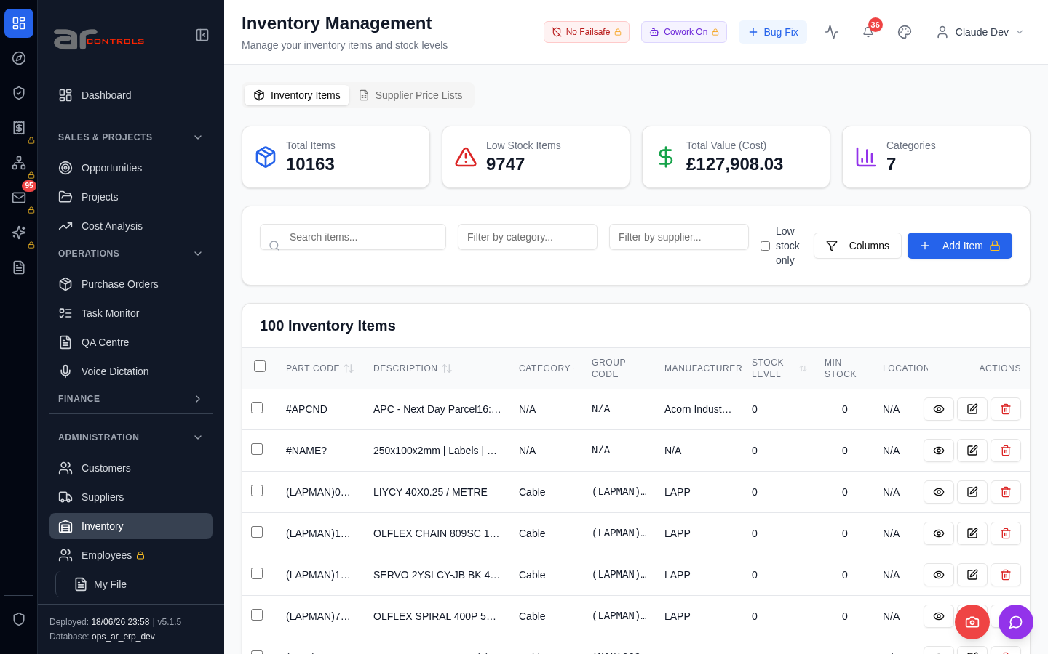
10-inventory-list-renders-01-a-href-inventory-element.png

10-inventory-list-renders-02-input-placeholder-search-items.png
10-inventory-list-renders-02-input-placeholder-search-items-element.png
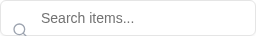
10-inventory-list-renders-03-inventory-management.png
10-inventory-list-renders-04-manage-your-inventory-items.png
10-inventory-list-renders.png

Console Errors
- [error] Error fetching tasks: TypeError: Failed to fetch
at o (http://100.121.252.85:3180/static/js/872.89f56c8c.chunk.js:1:20462)
- [error] Error fetching staff comms: TypeError: Failed to fetch
at g (http://100.121.252.85:3180/static/js/872.89f56c8c.chunk.js:1:36764)
- [error] Failed to fetch HR settings: TypeError: Failed to fetch
at http://100.121.252.85:3180/static/js/9627.6c769993.chunk.js:1:1868
- [error] Error fetching budget warnings: TypeError: Failed to fetch
at x (http://100.121.252.85:3180/static/js/872.89f56c8c.chunk.js:1:23348)
- [error] Error fetching PO requests: TypeError: Failed to fetch
at d (http://100.121.252.85:3180/static/js/872.89f56c8c.chunk.js:1:45670)
- [error] Error fetching projects: TypeError: Failed to fetch
at x (http://100.121.252.85:3180/static/js/872.89f56c8c.chunk.js:1:15247)
- [error] Failed to check timesheet compliance: TypeError: Failed to fetch
at u (http://100.121.252.85:3180/static/js/9627.6c769993.chunk.js:1:14135)
- [error] Error fetching batch widget data: TypeError: Failed to fetch
at P (http://100.121.252.85:3180/static/js/872.89f56c8c.chunk.js:1:67040)
- [error] Error fetching checklist settings: TypeError: Failed to fetch
at h (http://100.121.252.85:3180/static/js/9627.6c769993.chunk.js:1:16839)
- [error] Failed to fetch new task count: TypeError: Failed to fetch
at e (http://100.121.252.85:3180/static/js/9627.6c769993.chunk.js:1:1521)
- [error] Error fetching approval requests: TypeError: Failed to fetch
at x (http://100.121.252.85:3180/static/js/872.89f56c8c.chunk.js:1:48850)
- [error] 🔔 NotificationsDropdown: Error fetching notification summary: TypeError: Failed to fetch
at T (http://100.121.252.85:3180/static/js/505.03a7c875.chunk.js:1:76319)
- [error] Error fetching POs: TypeError: Failed to fetch
at d (http://100.121.252.85:3180/static/js/872.89f56c8c.chunk.js:1:18190)
- [error] 🔔 NotificationsDropdown: Error fetching notification summary: TypeError: Failed to fetch
at T (http://100.121.252.85:3180/static/js/505.03a7c875.chunk.js:1:76319)
- [error] Failed to fetch new task count: TypeError: Failed to fetch
at e (http://100.121.252.85:3180/static/js/9627.6c769993.chunk.js:1:1521)
- [error] Failed to check projects due date: TypeError: Failed to fetch
at http://100.121.252.85:3180/static/js/872.89f56c8c.chunk.js:1:89576
- [error] 🔔 NotificationsDropdown: Error fetching notification summary: TypeError: Failed to fetch
at T (http://100.121.252.85:3180/static/js/505.03a7c875.chunk.js:1:76319)
- [error] Failed to fetch HR settings: TypeError: Failed to fetch
at http://100.121.252.85:3180/static/js/9627.6c769993.chunk.js:1:1868
- [error] 🔔 NotificationsDropdown: Error fetching notification summary: TypeError: Failed to fetch
at T (http://100.121.252.85:3180/static/js/505.03a7c875.chunk.js:1:76319)
- [error] Error fetching pending QA checks: TypeError: Failed to fetch
at g (http://100.121.252.85:3180/static/js/9627.6c769993.chunk.js:1:17127)

Network Issues
- GET http://100.121.252.85:3180/api/notifications/stream?access_token=[redacted] — net::ERR_ABORTED
- GET http://100.121.252.85:3180/api/notifications/stream?access_token=[redacted] — net::ERR_ABORTED
- GET http://100.121.252.85:3180/api/notifications/stream?access_token=[redacted] — net::ERR_ABORTED
- GET http://100.121.252.85:3180/api/notifications/stream?access_token=[redacted] — net::ERR_ABORTED
- GET http://100.121.252.85:3180/api/notifications/stream?access_token=[redacted] — net::ERR_ABORTED
- GET http://100.121.252.85:3180/api/notifications/stream?access_token=[redacted] — net::ERR_ABORTED
- GET http://100.121.252.85:3180/api/notifications/stream?access_token=[redacted] — net::ERR_ABORTED
- GET http://100.121.252.85:3180/api/notifications/stream?access_token=[redacted] — net::ERR_ABORTED
- GET http://100.121.252.85:3180/api/notifications/stream?access_token=[redacted] — net::ERR_ABORTED
- GET http://100.121.252.85:3180/api/notifications/stream?access_token=[redacted] — net::ERR_ABORTED
- GET http://100.121.252.85:3180/api/notifications/stream?access_token=[redacted] — net::ERR_ABORTED
- GET http://100.121.252.85:3180/api/notifications/stream?access_token=[redacted] — net::ERR_ABORTED
- GET http://100.121.252.85:3180/api/notifications/stream?access_token=[redacted] — net::ERR_ABORTED
- GET http://100.121.252.85:3180/api/notifications/stream?access_token=[redacted] — net::ERR_ABORTED
- GET http://100.121.252.85:3180/api/notifications/stream?access_token=[redacted] — net::ERR_ABORTED
- GET http://100.121.252.85:3180/api/notifications/stream?access_token=[redacted] — net::ERR_ABORTED
- GET http://100.121.252.85:3180/api/dashboard/widgets/task-allocations — net::ERR_ABORTED
- GET http://100.121.252.85:3180/api/dashboard/widgets/staff-comms — net::ERR_ABORTED
- GET http://100.121.252.85:3180/api/employees/my-file — net::ERR_ABORTED
- GET http://100.121.252.85:3180/api/notifications/stream?access_token=[redacted] — net::ERR_ABORTED

