ERP Verification Evidence Pack — [ERP bug-fix] Bug from /invoicing
Result: FAIL — FAIL — 1 browser check(s) failed
When: 20260615T142453Z
Verified URL: http://100.68.36.49:3080/

Runtime Start Checks
No runtime checks were configured.

Notes
- Verification level 2
- ✓ task proof plan L2: 1 task browser check(s), 0 API check(s)
- Task-proof-only mode: Level 1 launch smoke already passed; skipping baseline browser checks.
- Playwright MCP required for level 2+ UI proof; validating worker-declared MCP-backed checks.
- ✓ readiness gate: app ready after 1 probe(s) (status 200)
- networkidle not reached after login (app polls continuously) — non-fatal; confirming login via login-form disappearance instead.
- Logged in as claude-dev@arcontrols.internal
- ✓ invoicing-this-month-turnover-is-month-bounded: step 1 navigate
- ✓ invoicing-this-month-turnover-is-month-bounded: step 2 [data-testid="invoicing-this-month-turnover-card"]
- ✗ invoicing-this-month-turnover-is-month-bounded: step 3 This Month Turnover: text missing: This Month Turnover
- ✓ invoicing-this-month-turnover-is-month-bounded: step 4 Financials
- ✓ invoicing-this-month-turnover-is-month-bounded: text present: Financials

Screenshots
01-landing.png
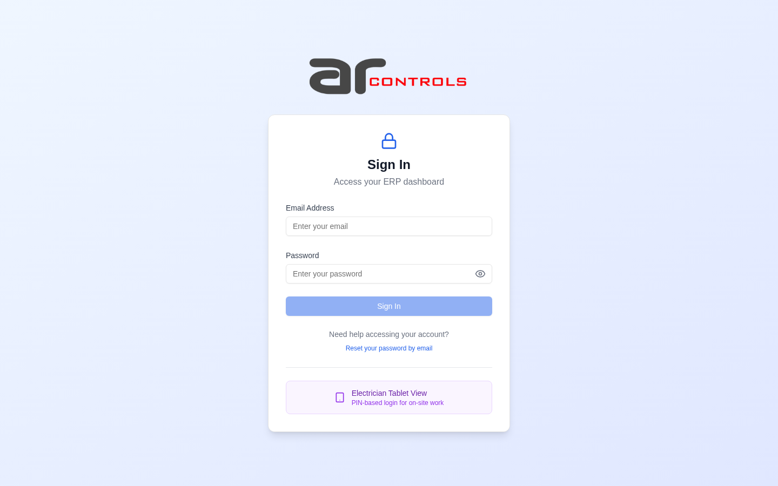
02-post-login.png
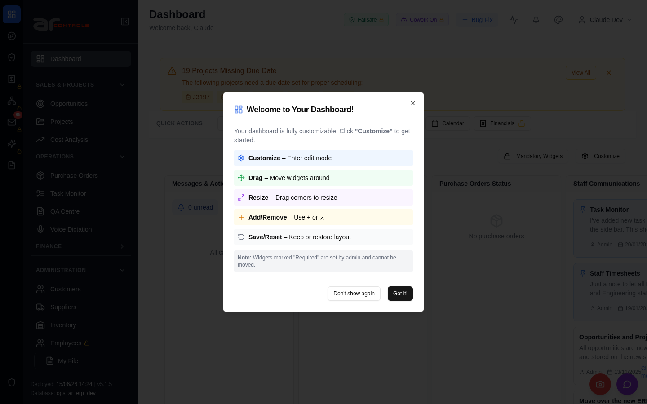
03-invoicing-this-month-turnover-is-month-bounded-01-navigate.png
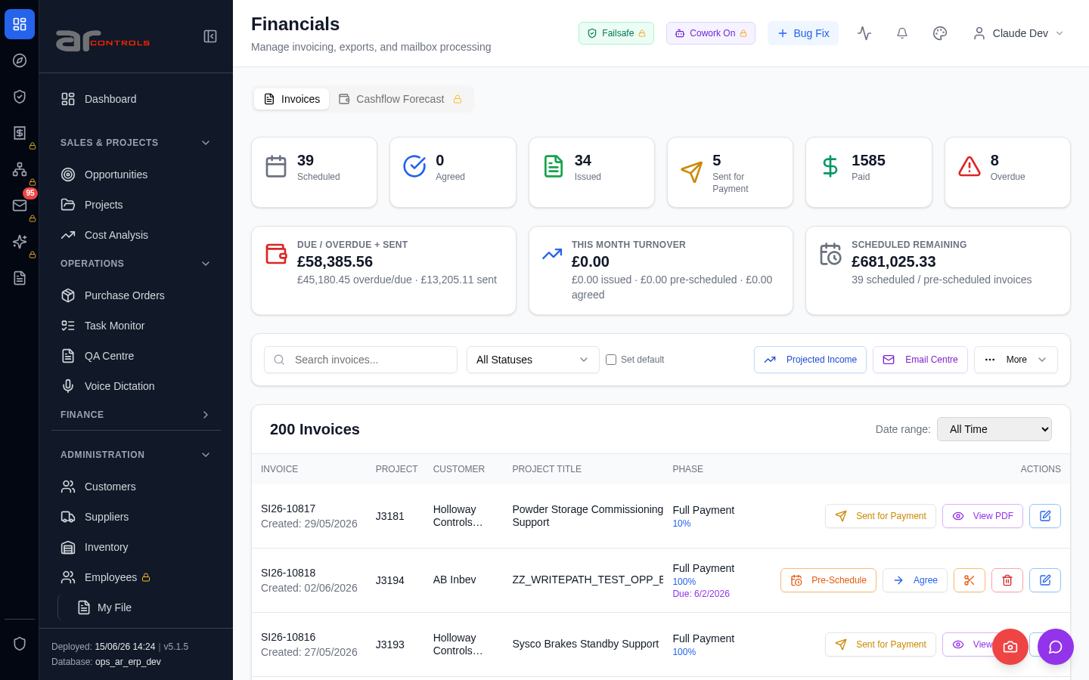
03-invoicing-this-month-turnover-is-month-bounded-02-data-testid-invoicing-this-month-turnover-card.png
03-invoicing-this-month-turnover-is-month-bounded-02-data-testid-invoicing-this-month-turnover-card-element.png

03-invoicing-this-month-turnover-is-month-bounded-03-this-month-turnover.png
03-invoicing-this-month-turnover-is-month-bounded-04-financials.png
03-invoicing-this-month-turnover-is-month-bounded.png

Network Issues
- GET http://100.68.36.49:3080/api/notifications/stream?access_token=eyJhbGciOiJIUzI1NiIsInR5cCI6IkpXVCJ9.eyJzdWIiOiJjbGF1ZGUtZGV2QGFyY29udHJvbHMuaW50ZXJuYWwiLCJ1c2VyX2lkIjoiN2NlNDFmZjAtZDBmNy00NzMxLTkzNGIt — net::ERR_ABORTED
- GET http://100.68.36.49:3080/api/notifications/stream?access_token=eyJhbGciOiJIUzI1NiIsInR5cCI6IkpXVCJ9.eyJzdWIiOiJjbGF1ZGUtZGV2QGFyY29udHJvbHMuaW50ZXJuYWwiLCJ1c2VyX2lkIjoiN2NlNDFmZjAtZDBmNy00NzMxLTkzNGIt — net::ERR_ABORTED

