ERP Verification Evidence Pack — [ERP bug-fix] Bug from /projects
Result: FAIL — FAIL — 1 browser check(s) failed
When: 20260615T154407Z
Verified URL: http://100.68.36.49:3080/

Runtime Start Checks
No runtime checks were configured.

Notes
- Verification level 2
- ✓ task proof plan L2: 2 task browser check(s), 0 API check(s)
- Task-proof-only mode: Level 1 launch smoke already passed; skipping baseline browser checks.
- Playwright MCP required for level 2+ UI proof; validating worker-declared MCP-backed checks.
- ✓ readiness gate: app ready after 1 probe(s) (status 200)
- networkidle not reached after login (app polls continuously) — non-fatal; confirming login via login-form disappearance instead.
- Logged in as claude-dev@arcontrols.internal
- Browser flow 'projects-table-column-order' started at /; target is /projects. Navigation must use visible UI actions from here.
- ✓ projects-table-column-order: step 1 navigate
- ✓ projects-table-column-order: step 2 body
- ✓ projects-table-column-order: step 3 navigate
- ✓ projects-table-column-order: step 4 [data-testid="projects-table-header-customer"]
- ✓ projects-table-column-order: step 5 [data-testid="projects-table-header-description"]
- ✓ projects-table-column-order: step 6 [data-testid="projects-table-header-description"]
- ✓ projects-table-column-order: step 7 [data-testid="projects-table-header-customer"]
- ✓ projects-table-column-order: step 8 Customer
- ✓ projects-table-column-order: step 9 Description
- ✓ projects-table-column-order: step 10 Projects
- ✓ projects-table-column-order: browser flow reached target path /projects
- ✓ projects-table-column-order: text present: Projects
- Browser flow 'projects-stats-match-financials' started at /; target is /projects. Navigation must use visible UI actions from here.
- ✓ projects-stats-match-financials: step 1 navigate
- ✓ projects-stats-match-financials: step 2 body
- ✓ projects-stats-match-financials: step 3 navigate
- ✓ projects-stats-match-financials: step 4 [data-testid="projects-stat-active-invoiced-value"]
- ✓ projects-stats-match-financials: step 5 [data-testid="projects-stat-outstanding-balance-value"]
- ✗ projects-stats-match-financials: step 6 a[href="/invoicing"]: Locator.click: Timeout 30000ms exceeded.
Call log:
- waiting for locator("a[href=\"/invoicing\"]")
| DIAGNOSIS: selector 'a[href="/invoicing"]' matched 0 elements; the row/control may not exist in dev. Seed a fixture id and target it, or verify the selector against the rendered page.
- ✗ browser check 'projects-stats-match-financials' failed: Page.wait_for_selector: Timeout 30000ms exceeded.
Call log:
- waiting for locator("text=Should be Received") to be visible

Screenshots
01-landing.png
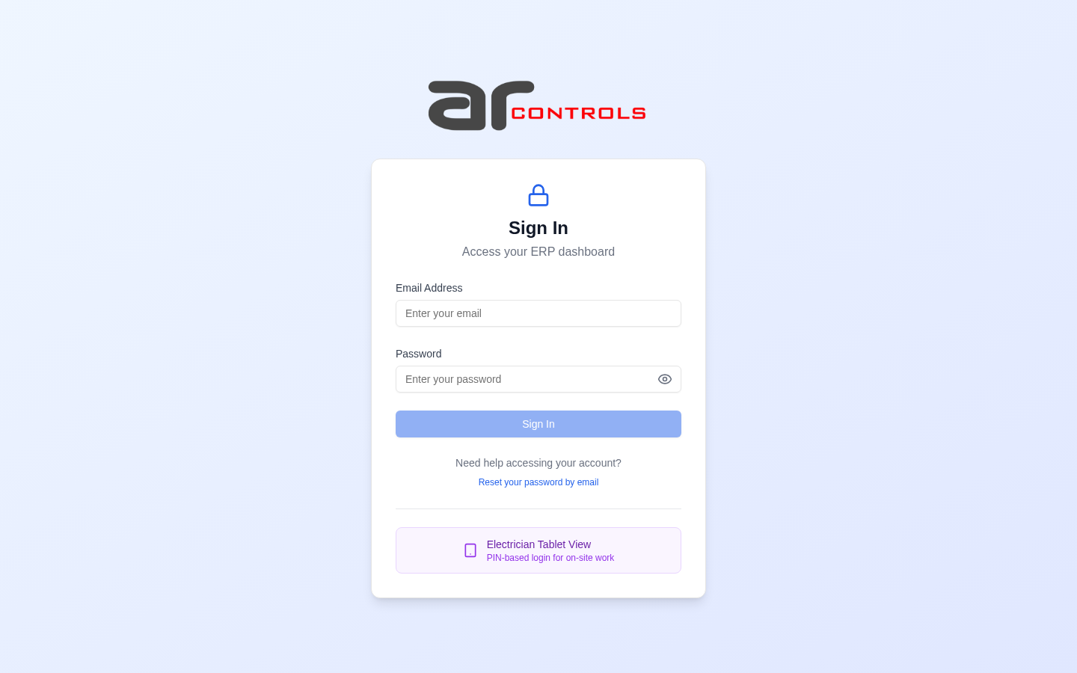
02-post-login.png
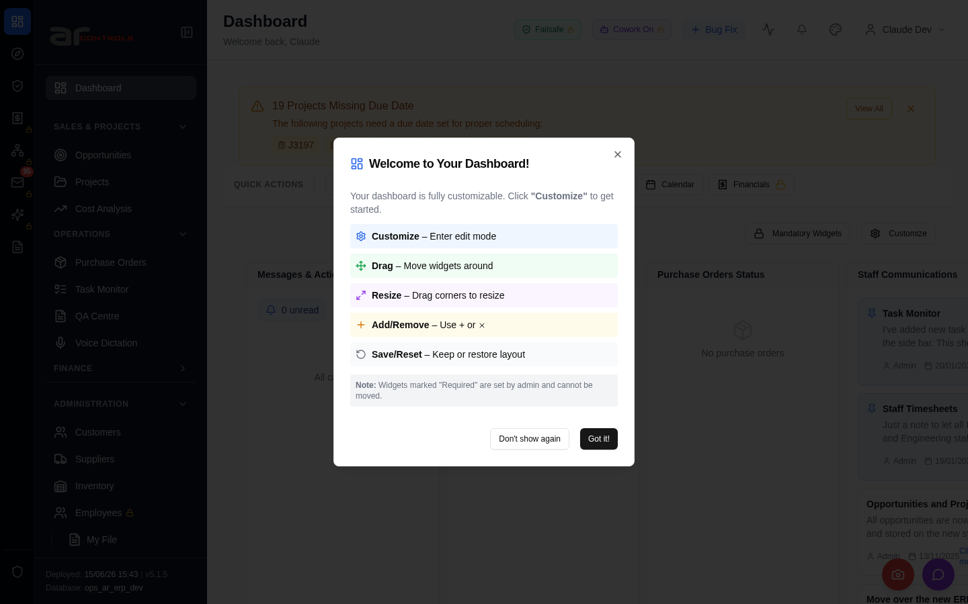
03-projects-table-column-order-00-journey-start.png
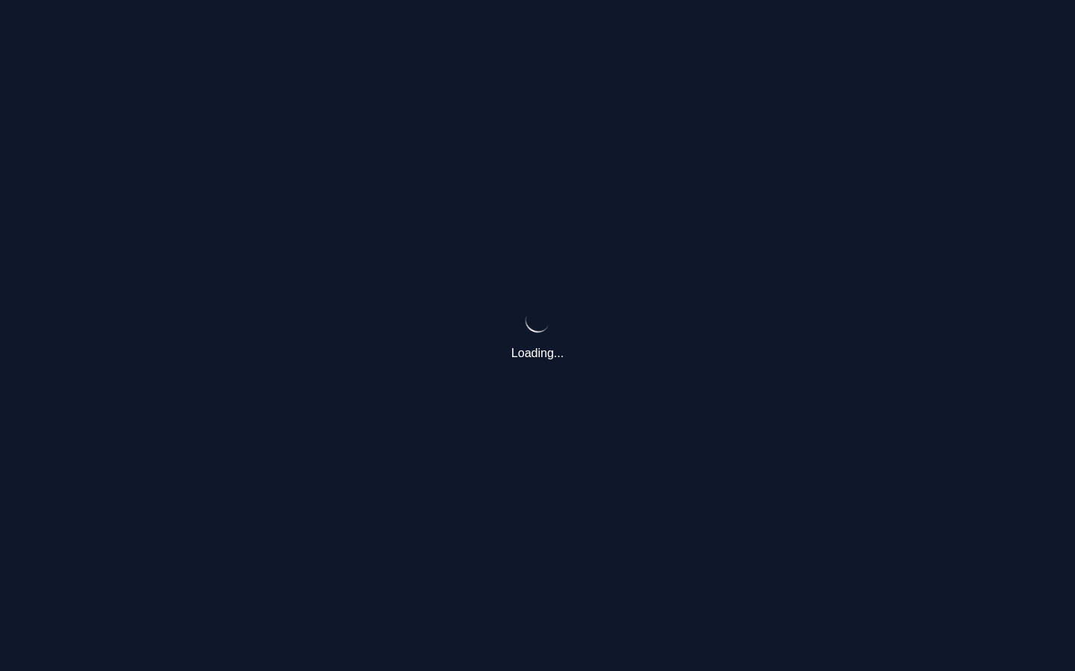
03-projects-table-column-order-01-navigate.png
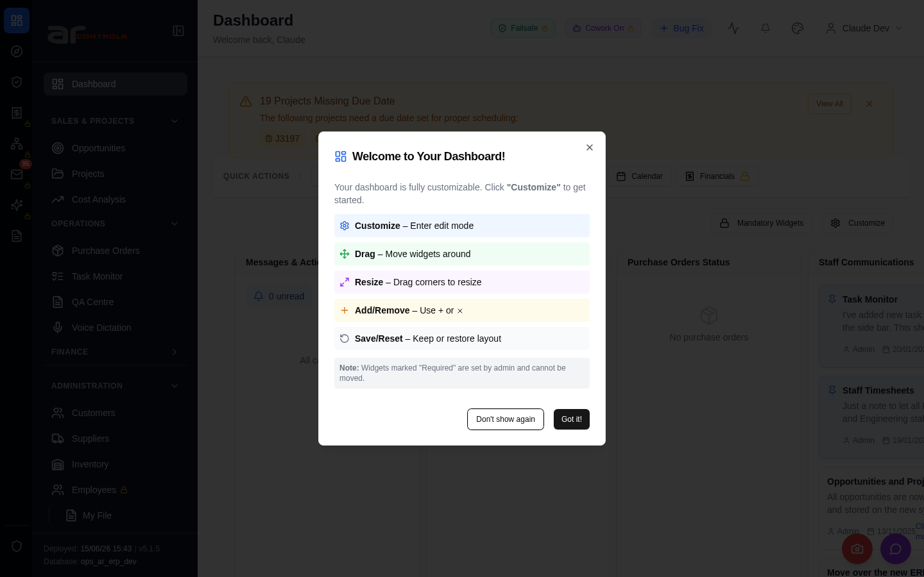
03-projects-table-column-order-02-body.png
03-projects-table-column-order-02-body-element.png
03-projects-table-column-order-03-navigate.png
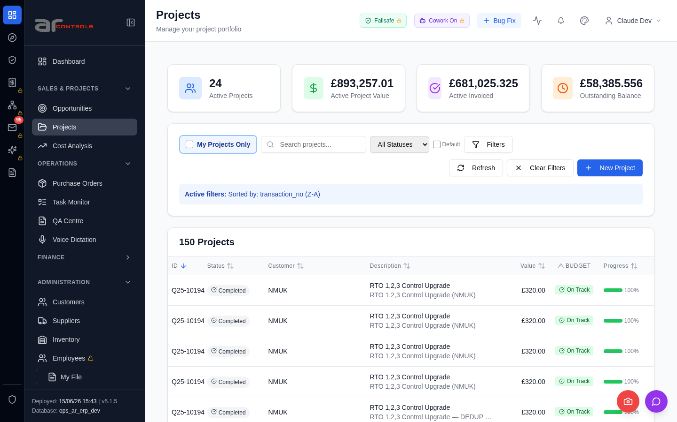
03-projects-table-column-order-04-data-testid-projects-table-header-customer.png
03-projects-table-column-order-04-data-testid-projects-table-header-customer-element.png
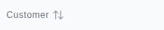
03-projects-table-column-order-05-data-testid-projects-table-header-description.png
03-projects-table-column-order-05-data-testid-projects-table-header-description-element.png
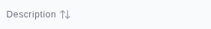
03-projects-table-column-order-06-data-testid-projects-table-header-description.png
03-projects-table-column-order-06-data-testid-projects-table-header-description-element.png
03-projects-table-column-order-07-data-testid-projects-table-header-customer.png
03-projects-table-column-order-07-data-testid-projects-table-header-customer-element.png
03-projects-table-column-order-08-customer.png
03-projects-table-column-order-09-description.png
03-projects-table-column-order-10-projects.png
03-projects-table-column-order.png
04-projects-stats-match-financials-00-journey-start.png
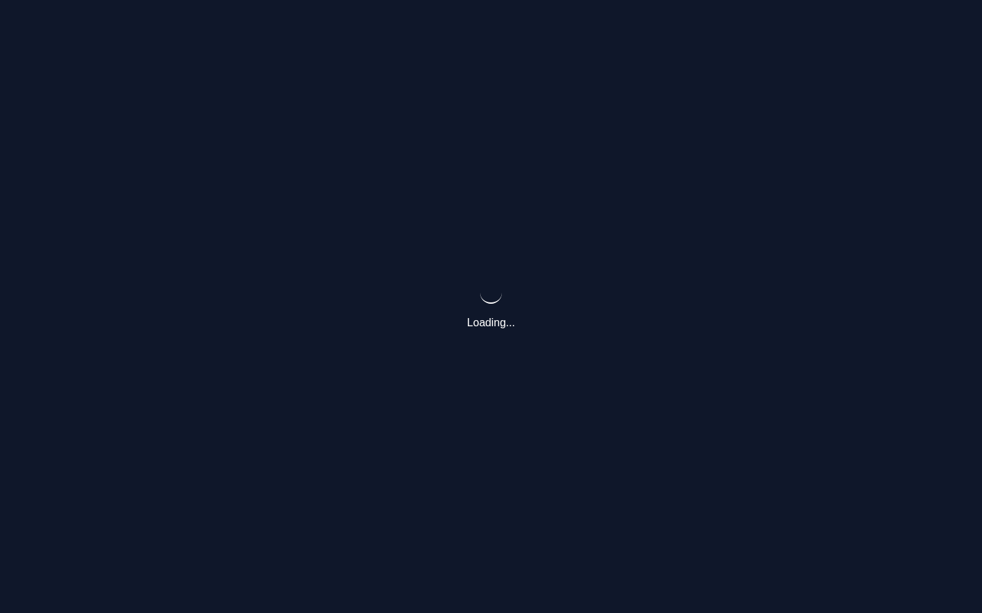
04-projects-stats-match-financials-01-navigate.png
04-projects-stats-match-financials-02-body.png
04-projects-stats-match-financials-02-body-element.png
04-projects-stats-match-financials-03-navigate.png
04-projects-stats-match-financials-04-data-testid-projects-stat-active-invoiced-value.png
04-projects-stats-match-financials-04-data-testid-projects-stat-active-invoiced-value-element.png
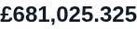
04-projects-stats-match-financials-05-data-testid-projects-stat-outstanding-balance-value.png
04-projects-stats-match-financials-05-data-testid-projects-stat-outstanding-balance-value-element.png
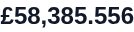
04-projects-stats-match-financials-06-a-href-invoicing.png
04-projects-stats-match-financials-failed.png

Network Issues
- GET http://100.68.36.49:3080/api/notifications/stream?access_token=eyJhbGciOiJIUzI1NiIsInR5cCI6IkpXVCJ9.eyJzdWIiOiJjbGF1ZGUtZGV2QGFyY29udHJvbHMuaW50ZXJuYWwiLCJ1c2VyX2lkIjoiN2NlNDFmZjAtZDBmNy00NzMxLTkzNGIt — net::ERR_ABORTED
- GET http://100.68.36.49:3080/api/notifications/stream?access_token=eyJhbGciOiJIUzI1NiIsInR5cCI6IkpXVCJ9.eyJzdWIiOiJjbGF1ZGUtZGV2QGFyY29udHJvbHMuaW50ZXJuYWwiLCJ1c2VyX2lkIjoiN2NlNDFmZjAtZDBmNy00NzMxLTkzNGIt — net::ERR_ABORTED
- GET http://100.68.36.49:3080/api/notifications/stream?access_token=eyJhbGciOiJIUzI1NiIsInR5cCI6IkpXVCJ9.eyJzdWIiOiJjbGF1ZGUtZGV2QGFyY29udHJvbHMuaW50ZXJuYWwiLCJ1c2VyX2lkIjoiN2NlNDFmZjAtZDBmNy00NzMxLTkzNGIt — net::ERR_ABORTED
- GET http://100.68.36.49:3080/api/notifications/stream?access_token=eyJhbGciOiJIUzI1NiIsInR5cCI6IkpXVCJ9.eyJzdWIiOiJjbGF1ZGUtZGV2QGFyY29udHJvbHMuaW50ZXJuYWwiLCJ1c2VyX2lkIjoiN2NlNDFmZjAtZDBmNy00NzMxLTkzNGIt — net::ERR_ABORTED
- GET http://100.68.36.49:3080/api/notifications/stream?access_token=eyJhbGciOiJIUzI1NiIsInR5cCI6IkpXVCJ9.eyJzdWIiOiJjbGF1ZGUtZGV2QGFyY29udHJvbHMuaW50ZXJuYWwiLCJ1c2VyX2lkIjoiN2NlNDFmZjAtZDBmNy00NzMxLTkzNGIt — net::ERR_ABORTED
- GET http://100.68.36.49:3080/api/notifications/stream?access_token=eyJhbGciOiJIUzI1NiIsInR5cCI6IkpXVCJ9.eyJzdWIiOiJjbGF1ZGUtZGV2QGFyY29udHJvbHMuaW50ZXJuYWwiLCJ1c2VyX2lkIjoiN2NlNDFmZjAtZDBmNy00NzMxLTkzNGIt — net::ERR_ABORTED
- GET http://100.68.36.49:3080/api/notifications/stream?access_token=eyJhbGciOiJIUzI1NiIsInR5cCI6IkpXVCJ9.eyJzdWIiOiJjbGF1ZGUtZGV2QGFyY29udHJvbHMuaW50ZXJuYWwiLCJ1c2VyX2lkIjoiN2NlNDFmZjAtZDBmNy00NzMxLTkzNGIt — net::ERR_ABORTED
- GET http://100.68.36.49:3080/api/notifications/stream?access_token=eyJhbGciOiJIUzI1NiIsInR5cCI6IkpXVCJ9.eyJzdWIiOiJjbGF1ZGUtZGV2QGFyY29udHJvbHMuaW50ZXJuYWwiLCJ1c2VyX2lkIjoiN2NlNDFmZjAtZDBmNy00NzMxLTkzNGIt — net::ERR_ABORTED

