ERP Verification Evidence Pack — [ERP bug-fix] Bug from /projects
Result: PASS — PASS — 27 screenshot(s), 0 smoke selector(s), 1 task browser check(s)
When: 20260615T202949Z
Verified URL: http://100.68.36.49:3080/

Runtime Start Checks
No runtime checks were configured.

Notes
- Verification level 2
- ✓ task proof plan L2: 1 task browser check(s), 0 API check(s)
- Task-proof-only mode: Level 1 launch smoke already passed; skipping baseline browser checks.
- Playwright MCP required for level 2+ UI proof; validating worker-declared MCP-backed checks.
- ✓ readiness gate: app ready after 1 probe(s) (status 200)
- networkidle not reached after login (app polls continuously) — non-fatal; confirming login via login-form disappearance instead.
- Logged in as claude-dev@arcontrols.internal
- Browser flow 'projects-list-column-order-and-financials' started at /; target is /projects. Navigation must use visible UI actions from here.
- ✓ projects-list-column-order-and-financials: step 1 navigate
- ✓ projects-list-column-order-and-financials: step 2 a[href="/projects"]
- ✓ projects-list-column-order-and-financials: step 3 a[href="/projects"]
- ✓ projects-list-column-order-and-financials: step 4 [data-testid="projects-search-projects-input"]
- ✓ projects-list-column-order-and-financials: step 5 table thead th:has-text("Customer")
- ✓ projects-list-column-order-and-financials: step 6 table thead th:has-text("Description")
- ✓ projects-list-column-order-and-financials: step 7 table thead th:has-text("Customer") button
- ✓ projects-list-column-order-and-financials: step 8 text=Sorted by: customer_name
- ✓ projects-list-column-order-and-financials: step 9 [data-testid="projects-search-projects-input"]
- ✓ projects-list-column-order-and-financials: step 10 table tbody tr
- ✓ projects-list-column-order-and-financials: step 11 Projects
- ✓ projects-list-column-order-and-financials: step 12 Manage your project portfolio
- ✓ projects-list-column-order-and-financials: step 13 Customer
- ✓ projects-list-column-order-and-financials: step 14 Description
- ✓ projects-list-column-order-and-financials: browser flow reached target path /projects
- ✓ projects-list-column-order-and-financials: text present: Projects

Screenshots
01-landing.png
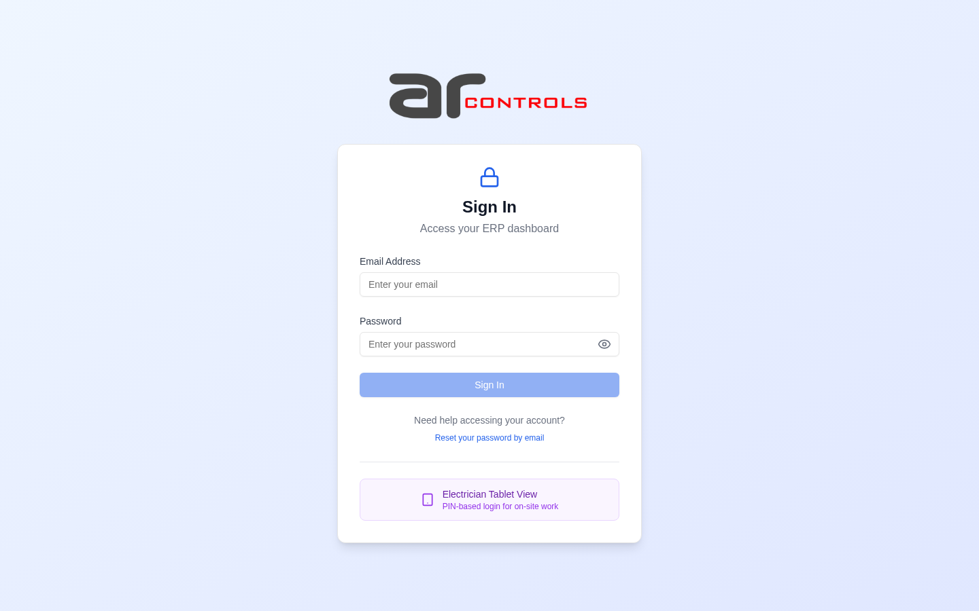
02-post-login.png
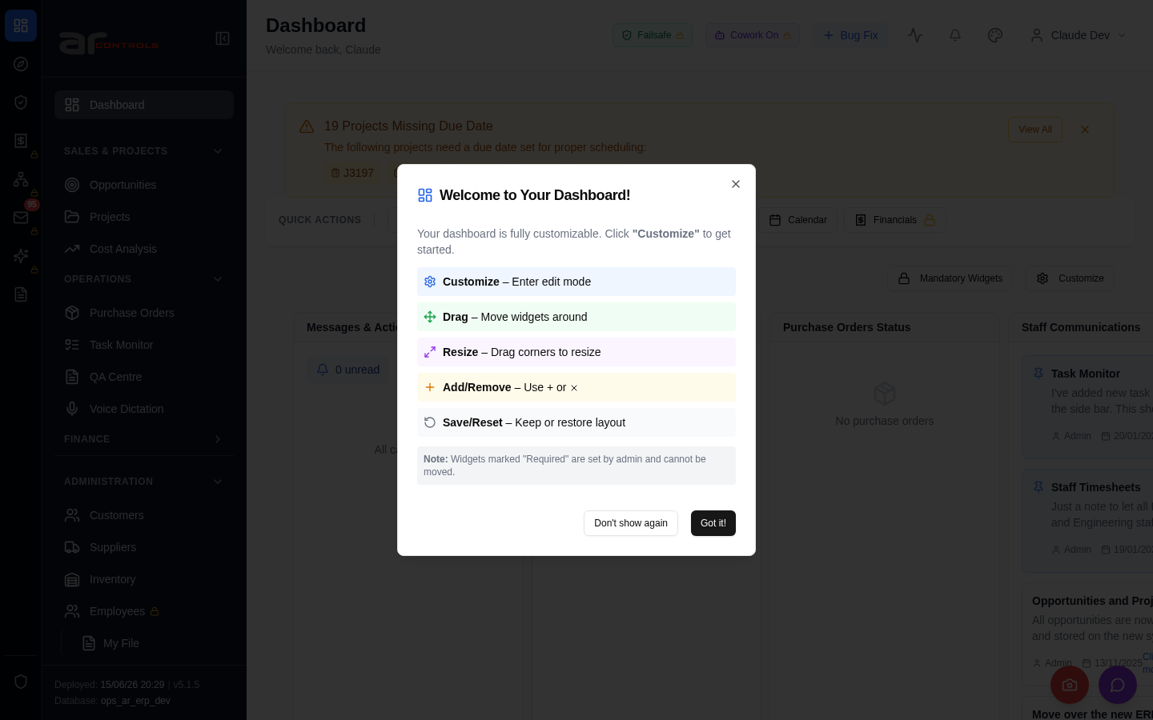
03-projects-list-column-order-and-financials-00-journey-start.png
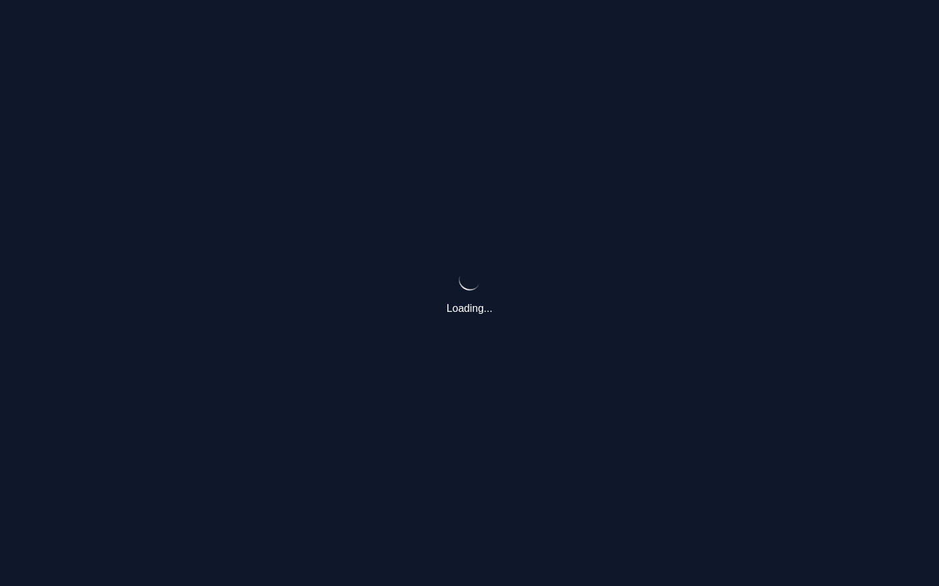
03-projects-list-column-order-and-financials-01-navigate.png
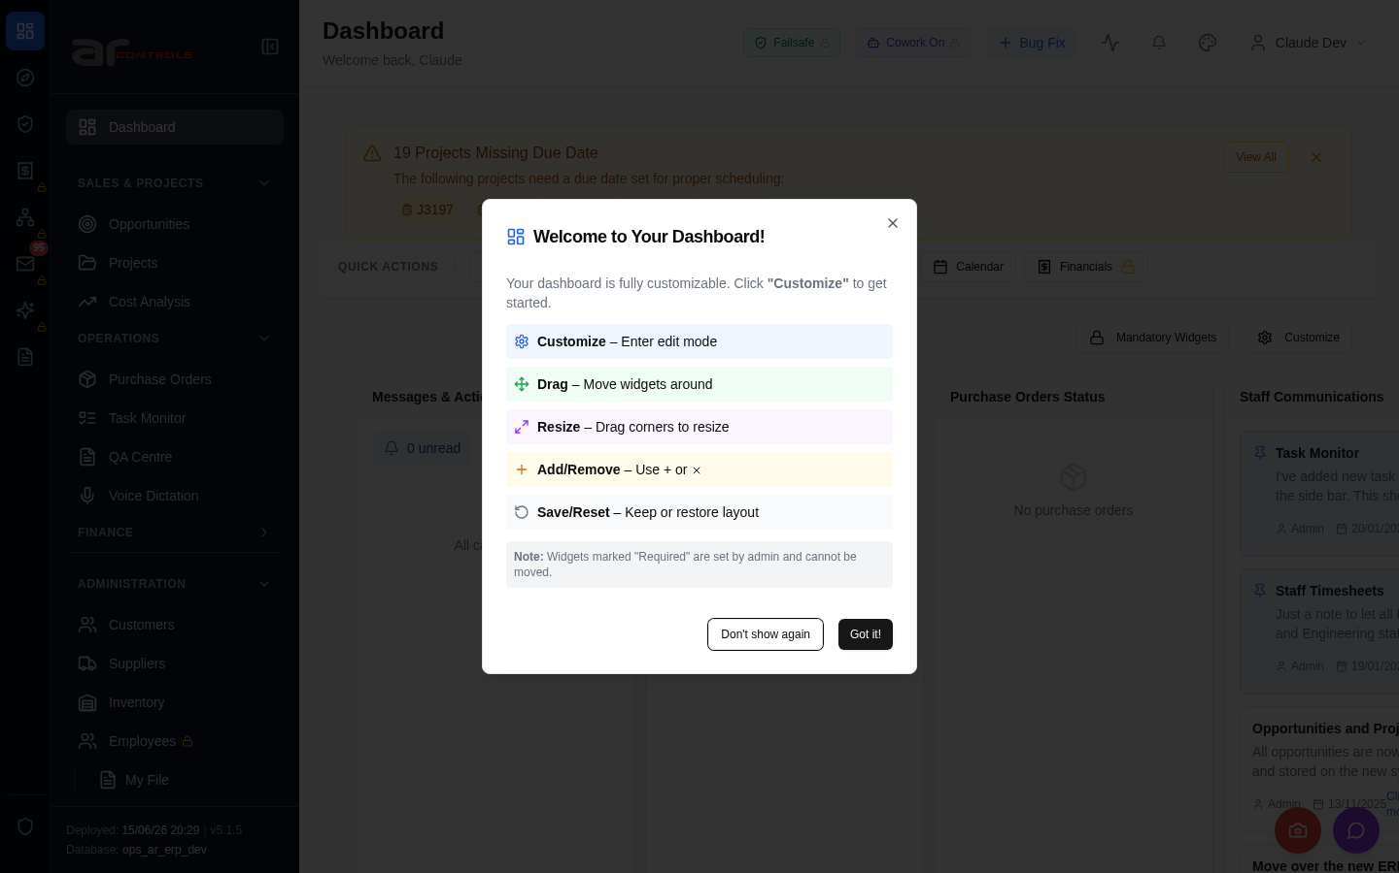
03-projects-list-column-order-and-financials-02-a-href-projects.png
03-projects-list-column-order-and-financials-02-a-href-projects-element.png

03-projects-list-column-order-and-financials-03-a-href-projects.png
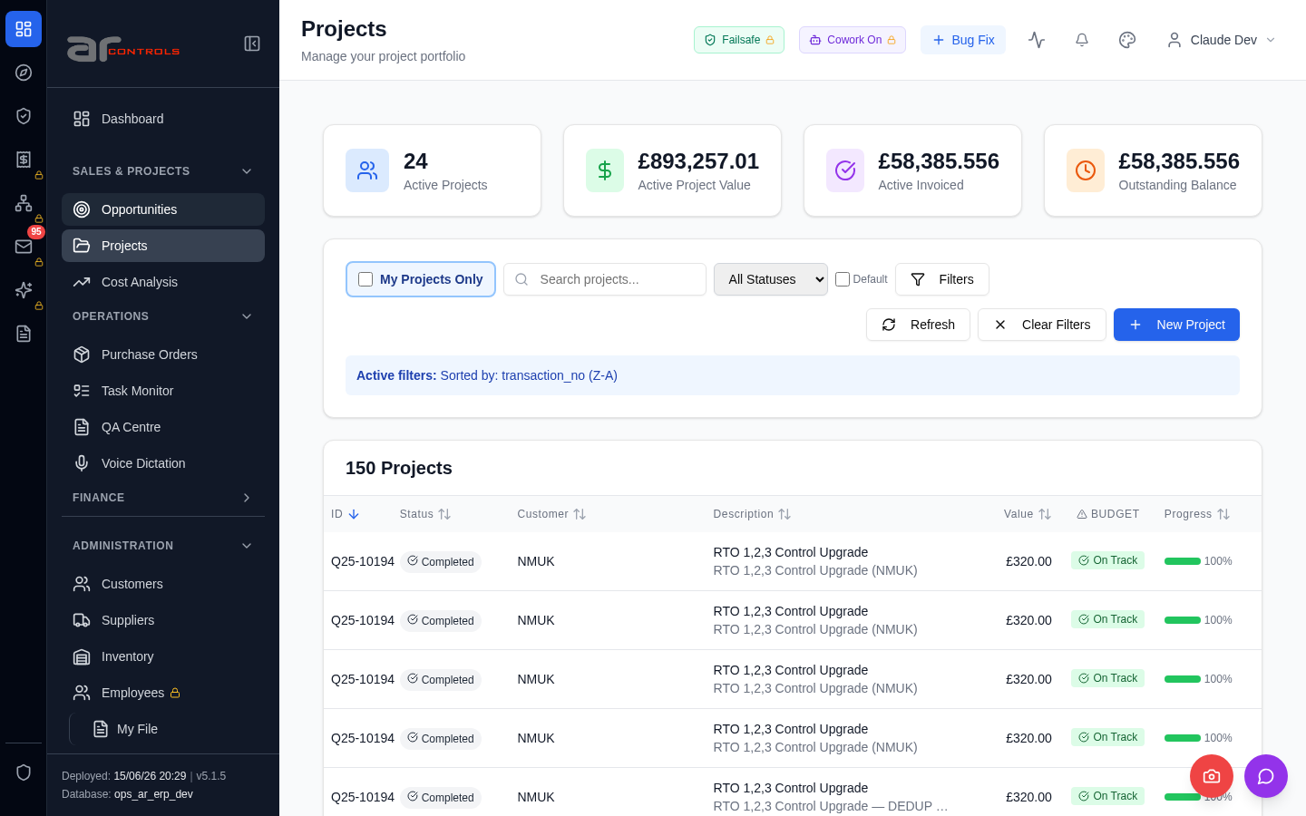
03-projects-list-column-order-and-financials-03-a-href-projects-element.png

03-projects-list-column-order-and-financials-04-data-testid-projects-search-projects-input.png
03-projects-list-column-order-and-financials-04-data-testid-projects-search-projects-input-element.png
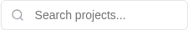
03-projects-list-column-order-and-financials-05-table-thead-th-has-text-customer.png
03-projects-list-column-order-and-financials-05-table-thead-th-has-text-customer-element.png
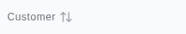
03-projects-list-column-order-and-financials-06-table-thead-th-has-text-description.png
03-projects-list-column-order-and-financials-06-table-thead-th-has-text-description-element.png

03-projects-list-column-order-and-financials-07-table-thead-th-has-text-customer-button.png
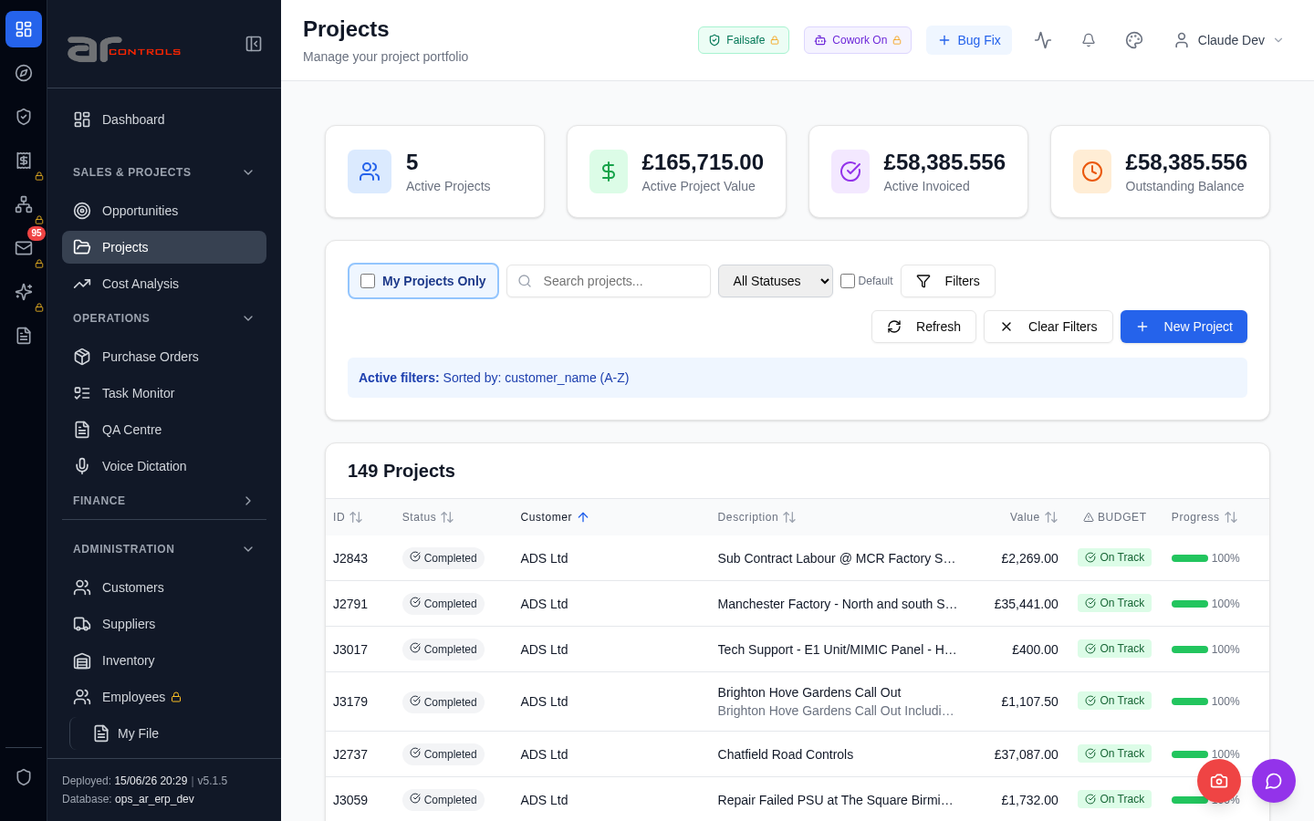
03-projects-list-column-order-and-financials-07-table-thead-th-has-text-customer-button-element.png
03-projects-list-column-order-and-financials-08-text-sorted-by-customer-name.png
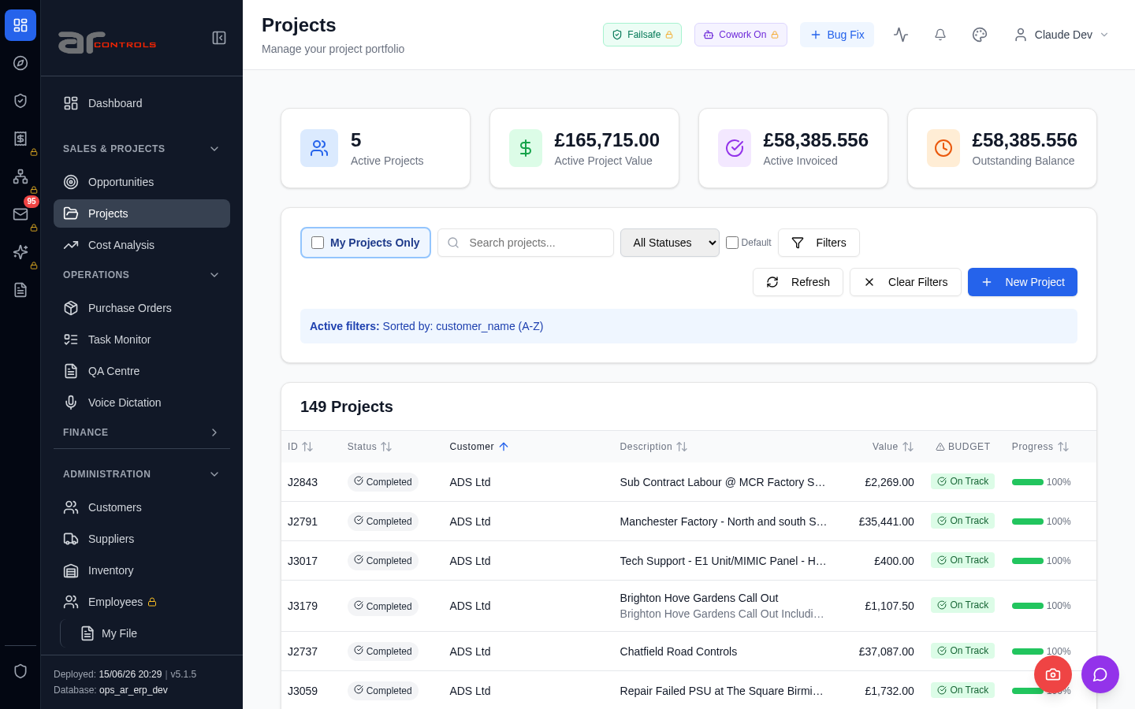
03-projects-list-column-order-and-financials-08-text-sorted-by-customer-name-element.png
03-projects-list-column-order-and-financials-09-data-testid-projects-search-projects-input.png
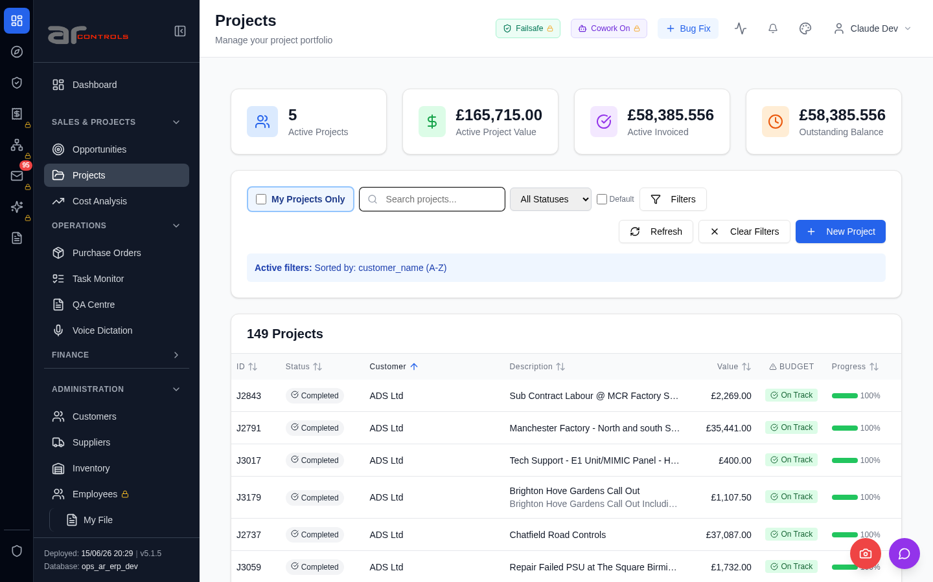
03-projects-list-column-order-and-financials-09-data-testid-projects-search-projects-input-element.png

03-projects-list-column-order-and-financials-10-table-tbody-tr.png
03-projects-list-column-order-and-financials-10-table-tbody-tr-element.png
03-projects-list-column-order-and-financials-11-projects.png
03-projects-list-column-order-and-financials-12-manage-your-project-portfolio.png
03-projects-list-column-order-and-financials-13-customer.png
03-projects-list-column-order-and-financials-14-description.png
03-projects-list-column-order-and-financials.png

Network Issues
- GET http://100.68.36.49:3080/api/notifications/stream?access_token=eyJhbGciOiJIUzI1NiIsInR5cCI6IkpXVCJ9.eyJzdWIiOiJjbGF1ZGUtZGV2QGFyY29udHJvbHMuaW50ZXJuYWwiLCJ1c2VyX2lkIjoiN2NlNDFmZjAtZDBmNy00NzMxLTkzNGIt — net::ERR_ABORTED
- GET http://100.68.36.49:3080/api/notifications/stream?access_token=eyJhbGciOiJIUzI1NiIsInR5cCI6IkpXVCJ9.eyJzdWIiOiJjbGF1ZGUtZGV2QGFyY29udHJvbHMuaW50ZXJuYWwiLCJ1c2VyX2lkIjoiN2NlNDFmZjAtZDBmNy00NzMxLTkzNGIt — net::ERR_ABORTED
- GET http://100.68.36.49:3080/api/notifications/stream?access_token=eyJhbGciOiJIUzI1NiIsInR5cCI6IkpXVCJ9.eyJzdWIiOiJjbGF1ZGUtZGV2QGFyY29udHJvbHMuaW50ZXJuYWwiLCJ1c2VyX2lkIjoiN2NlNDFmZjAtZDBmNy00NzMxLTkzNGIt — net::ERR_ABORTED
- GET http://100.68.36.49:3080/api/notifications/stream?access_token=eyJhbGciOiJIUzI1NiIsInR5cCI6IkpXVCJ9.eyJzdWIiOiJjbGF1ZGUtZGV2QGFyY29udHJvbHMuaW50ZXJuYWwiLCJ1c2VyX2lkIjoiN2NlNDFmZjAtZDBmNy00NzMxLTkzNGIt — net::ERR_ABORTED

