ERP Verification Evidence Pack — [ERP bug-fix] Bug from /projects
Result: PASS — PASS — 51 screenshot(s), 0 smoke selector(s), 2 task browser check(s)
When: 20260616T101118Z
Verified URL: http://100.68.36.49:3080/

Runtime Start Checks
No runtime checks were configured.

Notes
- Verification level 2
- ✓ task proof plan L2: 2 task browser check(s), 0 API check(s)
- Task-proof-only mode: Level 1 launch smoke already passed; skipping baseline browser checks.
- Playwright MCP required for level 2+ UI proof; validating worker-declared MCP-backed checks.
- ✓ readiness gate: app ready after 1 probe(s) (status 200)
- networkidle not reached after login (app polls continuously) — non-fatal; confirming login via login-form disappearance instead.
- Logged in as claude-dev@arcontrols.internal
- Browser flow 'projects-bugfix-kpi-and-columns-journey-2026-06-15' started at /; target is /projects. Navigation must use visible UI actions from here.
- ✓ projects-bugfix-kpi-and-columns-journey-2026-06-15: step 1 navigate
- ✓ projects-bugfix-kpi-and-columns-journey-2026-06-15: step 2 a[href="/projects"]
- ✓ projects-bugfix-kpi-and-columns-journey-2026-06-15: step 3 a[href="/projects"]
- ✓ projects-bugfix-kpi-and-columns-journey-2026-06-15: step 4 input[placeholder="Search projects..."]
- ✓ projects-bugfix-kpi-and-columns-journey-2026-06-15: step 5 [data-testid="projects-th-customer"]
- ✓ projects-bugfix-kpi-and-columns-journey-2026-06-15: step 6 table thead th:nth-child(3):has-text("Customer")
- ✓ projects-bugfix-kpi-and-columns-journey-2026-06-15: step 7 table thead th:nth-child(4):has-text("Description")
- ✓ projects-bugfix-kpi-and-columns-journey-2026-06-15: step 8 [data-testid="projects-th-customer"]
- ✓ projects-bugfix-kpi-and-columns-journey-2026-06-15: step 9 [data-testid="projects-th-description"]
- ✓ projects-bugfix-kpi-and-columns-journey-2026-06-15: step 10 [data-testid="projects-kpi-active-invoiced-value"]
- ✓ projects-bugfix-kpi-and-columns-journey-2026-06-15: step 11 [data-testid="projects-kpi-outstanding-balance-value"]
- ✓ projects-bugfix-kpi-and-columns-journey-2026-06-15: step 12 Customer
- ✓ projects-bugfix-kpi-and-columns-journey-2026-06-15: step 13 Description
- ✓ projects-bugfix-kpi-and-columns-journey-2026-06-15: step 14 Active Invoiced
- ✓ projects-bugfix-kpi-and-columns-journey-2026-06-15: step 15 Outstanding Balance
- ✓ projects-bugfix-kpi-and-columns-journey-2026-06-15: step 16 Projects
- ✓ projects-bugfix-kpi-and-columns-journey-2026-06-15: browser flow reached target path /projects
- ✓ projects-bugfix-kpi-and-columns-journey-2026-06-15: text present: Projects
- ✓ projects-bugfix-kpi-and-columns-render-2026-06-15: step 1 navigate
- ✓ projects-bugfix-kpi-and-columns-render-2026-06-15: step 2 input[placeholder="Search projects..."]
- ✓ projects-bugfix-kpi-and-columns-render-2026-06-15: step 3 table thead th:nth-child(3):has-text("Customer")
- ✓ projects-bugfix-kpi-and-columns-render-2026-06-15: step 4 table thead th:nth-child(4):has-text("Description")
- ✓ projects-bugfix-kpi-and-columns-render-2026-06-15: step 5 [data-testid="projects-th-customer"]
- ✓ projects-bugfix-kpi-and-columns-render-2026-06-15: step 6 [data-testid="projects-th-description"]
- ✓ projects-bugfix-kpi-and-columns-render-2026-06-15: step 7 [data-testid="projects-kpi-active-invoiced-value"]
- ✓ projects-bugfix-kpi-and-columns-render-2026-06-15: step 8 [data-testid="projects-kpi-outstanding-balance-value"]
- ✓ projects-bugfix-kpi-and-columns-render-2026-06-15: step 9 Customer
- ✓ projects-bugfix-kpi-and-columns-render-2026-06-15: step 10 Description
- ✓ projects-bugfix-kpi-and-columns-render-2026-06-15: step 11 Active Invoiced
- ✓ projects-bugfix-kpi-and-columns-render-2026-06-15: step 12 Outstanding Balance
- ✓ projects-bugfix-kpi-and-columns-render-2026-06-15: step 13 Projects
- ✓ projects-bugfix-kpi-and-columns-render-2026-06-15: text present: Projects
- Ignored 14 aborted background fetch console error(s); task browser checks, API checks, and runtime checks decide this proof.

Screenshots
01-landing.png
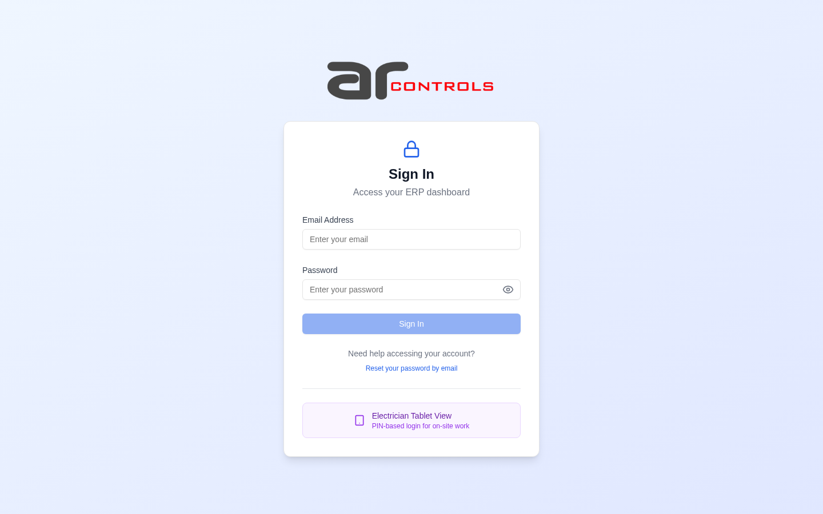
02-post-login.png
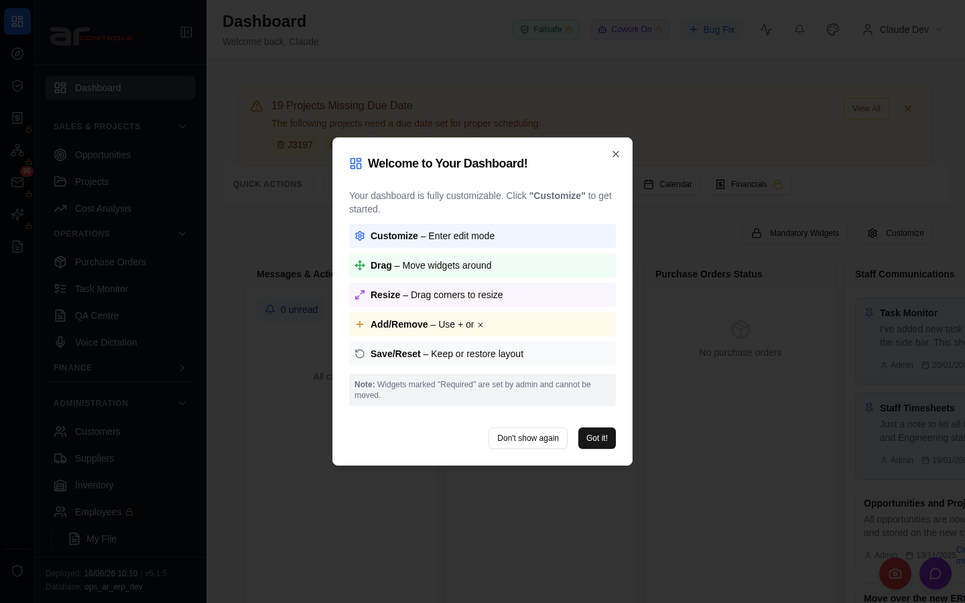
03-projects-bugfix-kpi-and-columns-journey-2026-06-15-00-journey-start.png
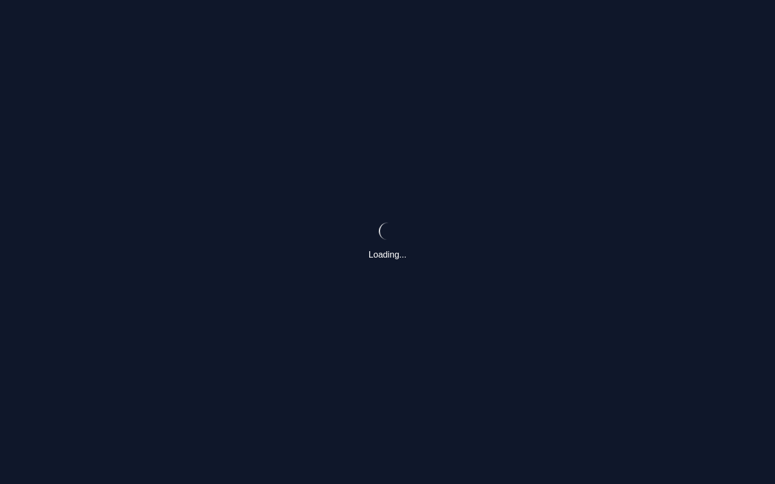
03-projects-bugfix-kpi-and-columns-journey-2026-06-15-01-navigate.png
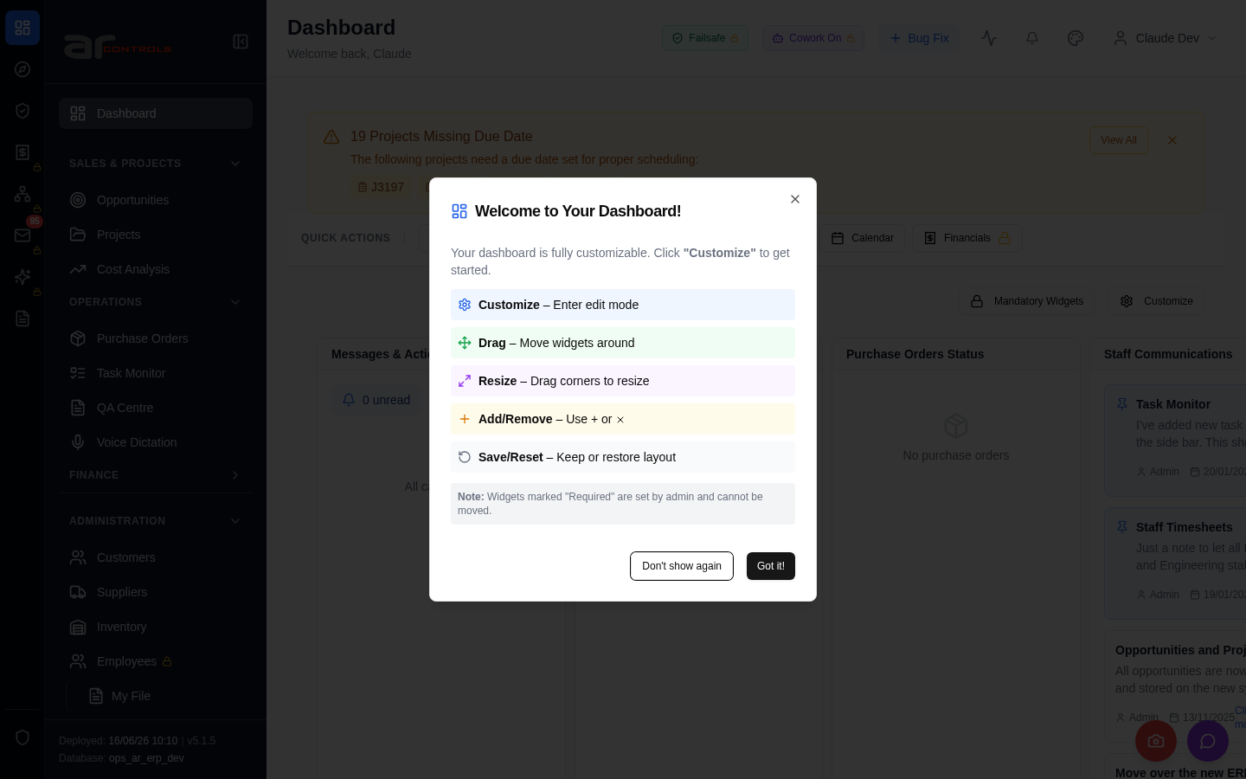
03-projects-bugfix-kpi-and-columns-journey-2026-06-15-02-a-href-projects.png
03-projects-bugfix-kpi-and-columns-journey-2026-06-15-02-a-href-projects-element.png

03-projects-bugfix-kpi-and-columns-journey-2026-06-15-03-a-href-projects.png
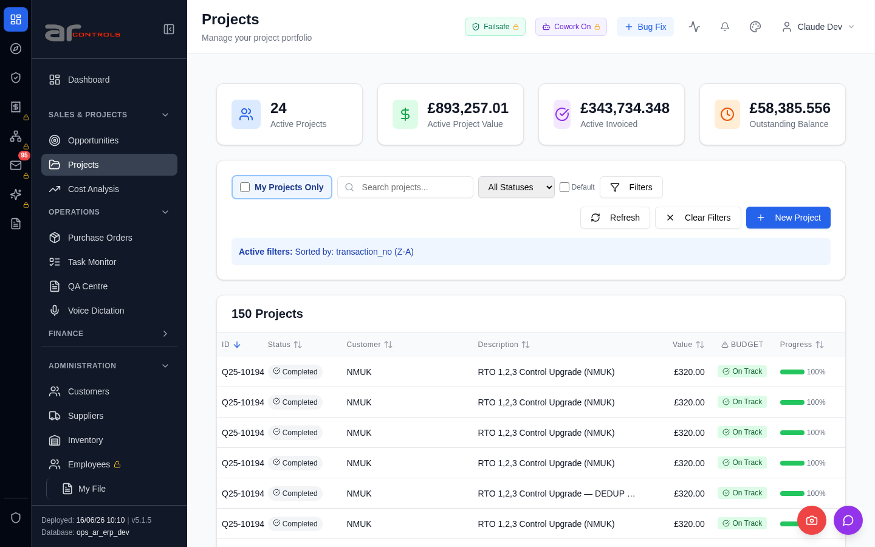
03-projects-bugfix-kpi-and-columns-journey-2026-06-15-03-a-href-projects-element.png

03-projects-bugfix-kpi-and-columns-journey-2026-06-15-04-input-placeholder-search-projects.png
03-projects-bugfix-kpi-and-columns-journey-2026-06-15-04-input-placeholder-search-projects-element.png
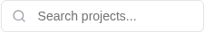
03-projects-bugfix-kpi-and-columns-journey-2026-06-15-05-data-testid-projects-th-customer.png
03-projects-bugfix-kpi-and-columns-journey-2026-06-15-05-data-testid-projects-th-customer-element.png
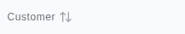
03-projects-bugfix-kpi-and-columns-journey-2026-06-15-06-table-thead-th-nth-child-3-has-text-customer.png
03-projects-bugfix-kpi-and-columns-journey-2026-06-15-06-table-thead-th-nth-child-3-has-text-customer-element.png
03-projects-bugfix-kpi-and-columns-journey-2026-06-15-07-table-thead-th-nth-child-4-has-text-description.png
03-projects-bugfix-kpi-and-columns-journey-2026-06-15-07-table-thead-th-nth-child-4-has-text-description-element.png
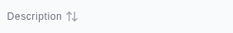
03-projects-bugfix-kpi-and-columns-journey-2026-06-15-08-data-testid-projects-th-customer.png
03-projects-bugfix-kpi-and-columns-journey-2026-06-15-08-data-testid-projects-th-customer-element.png
03-projects-bugfix-kpi-and-columns-journey-2026-06-15-09-data-testid-projects-th-description.png
03-projects-bugfix-kpi-and-columns-journey-2026-06-15-09-data-testid-projects-th-description-element.png
03-projects-bugfix-kpi-and-columns-journey-2026-06-15-10-data-testid-projects-kpi-active-invoiced-value.png
03-projects-bugfix-kpi-and-columns-journey-2026-06-15-10-data-testid-projects-kpi-active-invoiced-value-element.png
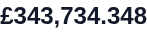
03-projects-bugfix-kpi-and-columns-journey-2026-06-15-11-data-testid-projects-kpi-outstanding-balance-value.png
03-projects-bugfix-kpi-and-columns-journey-2026-06-15-11-data-testid-projects-kpi-outstanding-balance-value-element.png
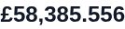
03-projects-bugfix-kpi-and-columns-journey-2026-06-15-12-customer.png
03-projects-bugfix-kpi-and-columns-journey-2026-06-15-13-description.png
03-projects-bugfix-kpi-and-columns-journey-2026-06-15-14-active-invoiced.png
03-projects-bugfix-kpi-and-columns-journey-2026-06-15-15-outstanding-balance.png
03-projects-bugfix-kpi-and-columns-journey-2026-06-15-16-projects.png
03-projects-bugfix-kpi-and-columns-journey-2026-06-15.png
04-projects-bugfix-kpi-and-columns-render-2026-06-15-01-navigate.png
04-projects-bugfix-kpi-and-columns-render-2026-06-15-02-input-placeholder-search-projects.png
04-projects-bugfix-kpi-and-columns-render-2026-06-15-02-input-placeholder-search-projects-element.png
04-projects-bugfix-kpi-and-columns-render-2026-06-15-03-table-thead-th-nth-child-3-has-text-customer.png
04-projects-bugfix-kpi-and-columns-render-2026-06-15-03-table-thead-th-nth-child-3-has-text-customer-element.png
04-projects-bugfix-kpi-and-columns-render-2026-06-15-04-table-thead-th-nth-child-4-has-text-description.png
04-projects-bugfix-kpi-and-columns-render-2026-06-15-04-table-thead-th-nth-child-4-has-text-description-element.png
04-projects-bugfix-kpi-and-columns-render-2026-06-15-05-data-testid-projects-th-customer.png
04-projects-bugfix-kpi-and-columns-render-2026-06-15-05-data-testid-projects-th-customer-element.png
04-projects-bugfix-kpi-and-columns-render-2026-06-15-06-data-testid-projects-th-description.png
04-projects-bugfix-kpi-and-columns-render-2026-06-15-06-data-testid-projects-th-description-element.png
04-projects-bugfix-kpi-and-columns-render-2026-06-15-07-data-testid-projects-kpi-active-invoiced-value.png
04-projects-bugfix-kpi-and-columns-render-2026-06-15-07-data-testid-projects-kpi-active-invoiced-value-element.png
04-projects-bugfix-kpi-and-columns-render-2026-06-15-08-data-testid-projects-kpi-outstanding-balance-value.png
04-projects-bugfix-kpi-and-columns-render-2026-06-15-08-data-testid-projects-kpi-outstanding-balance-value-element.png
04-projects-bugfix-kpi-and-columns-render-2026-06-15-09-customer.png
04-projects-bugfix-kpi-and-columns-render-2026-06-15-10-description.png
04-projects-bugfix-kpi-and-columns-render-2026-06-15-11-active-invoiced.png
04-projects-bugfix-kpi-and-columns-render-2026-06-15-12-outstanding-balance.png
04-projects-bugfix-kpi-and-columns-render-2026-06-15-13-projects.png
04-projects-bugfix-kpi-and-columns-render-2026-06-15.png

Console Errors
- [error] Failed to fetch HR settings: TypeError: Failed to fetch
at http://100.68.36.49:3080/static/js/9627.6c769993.chunk.js:1:1868
- [error] 🔔 NotificationsDropdown: Error fetching notification summary: TypeError: Failed to fetch
at T (http://100.68.36.49:3080/static/js/505.03a7c875.chunk.js:1:76319)
- [error] Error fetching checklist settings: TypeError: Failed to fetch
at h (http://100.68.36.49:3080/static/js/9627.6c769993.chunk.js:1:16839)
- [error] Error fetching dashboard config: TypeError: Failed to fetch
at O (http://100.68.36.49:3080/static/js/872.89f56c8c.chunk.js:1:66364)
- [error] Error fetching pending QA checks: TypeError: Failed to fetch
at g (http://100.68.36.49:3080/static/js/9627.6c769993.chunk.js:1:17127)
- [error] Error fetching widget types: TypeError: Failed to fetch
at F (http://100.68.36.49:3080/static/js/872.89f56c8c.chunk.js:1:66718)
- [error] Failed to check weekend availability: TypeError: Failed to fetch
at http://100.68.36.49:3080/static/js/872.89f56c8c.chunk.js:1:88958
- [error] Failed to fetch version info: TypeError: Failed to fetch
at http://100.68.36.49:3080/static/js/9627.6c769993.chunk.js:1:1290
at http://100.68.36.49:3080/static/js/9627.6c769993.chunk.js:1:1425
at vs (http://100.68.36.49:3080/static/js/main.c6a74405.js:2:177100)
at tc (http://100.68.3
- [error] Failed to fetch new task count: TypeError: Failed to fetch
at e (http://100.68.36.49:3080/static/js/9627.6c769993.chunk.js:1:1521)
- [error] Failed to check timesheet compliance: TypeError: Failed to fetch
at u (http://100.68.36.49:3080/static/js/9627.6c769993.chunk.js:1:14135)
- [error] Failed to check for nudges: TypeError: Failed to fetch
at d (http://100.68.36.49:3080/static/js/9627.6c769993.chunk.js:1:20111)
- [error] Failed to check projects due date: TypeError: Failed to fetch
at http://100.68.36.49:3080/static/js/872.89f56c8c.chunk.js:1:89576
- [error] 🔔 NotificationsDropdown: Error fetching notification summary: TypeError: Failed to fetch
at T (http://100.68.36.49:3080/static/js/505.03a7c875.chunk.js:1:76319)
- [error] Failed to fetch HR settings: TypeError: Failed to fetch
at http://100.68.36.49:3080/static/js/9627.6c769993.chunk.js:1:1868

Network Issues
- GET http://100.68.36.49:3080/api/notifications/stream?access_token=eyJhbGciOiJIUzI1NiIsInR5cCI6IkpXVCJ9.eyJzdWIiOiJjbGF1ZGUtZGV2QGFyY29udHJvbHMuaW50ZXJuYWwiLCJ1c2VyX2lkIjoiN2NlNDFmZjAtZDBmNy00NzMxLTkzNGIt — net::ERR_ABORTED
- GET http://100.68.36.49:3080/api/notifications/stream?access_token=eyJhbGciOiJIUzI1NiIsInR5cCI6IkpXVCJ9.eyJzdWIiOiJjbGF1ZGUtZGV2QGFyY29udHJvbHMuaW50ZXJuYWwiLCJ1c2VyX2lkIjoiN2NlNDFmZjAtZDBmNy00NzMxLTkzNGIt — net::ERR_ABORTED
- GET http://100.68.36.49:3080/api/employees/my-file — net::ERR_ABORTED
- GET http://100.68.36.49:3080/api/system-settings/ — net::ERR_ABORTED
- GET http://100.68.36.49:3080/api/notifications/summary — net::ERR_ABORTED
- GET http://100.68.36.49:3080/api/system-settings/ — net::ERR_ABORTED
- GET http://100.68.36.49:3080/api/system-settings/ — net::ERR_ABORTED
- GET http://100.68.36.49:3080/api/dashboard/config — net::ERR_ABORTED
- GET http://100.68.36.49:3080/api/qa/my-pending-checks — net::ERR_ABORTED
- GET http://100.68.36.49:3080/api/dashboard/widget-types — net::ERR_ABORTED
- GET http://100.68.36.49:3080/api/resources/check-weekend-availability — net::ERR_ABORTED
- GET http://100.68.36.49:3080/api/notifications/stream?access_token=eyJhbGciOiJIUzI1NiIsInR5cCI6IkpXVCJ9.eyJzdWIiOiJjbGF1ZGUtZGV2QGFyY29udHJvbHMuaW50ZXJuYWwiLCJ1c2VyX2lkIjoiN2NlNDFmZjAtZDBmNy00NzMxLTkzNGIt — net::ERR_ABORTED
- GET http://100.68.36.49:3080/api/notifications/stream?access_token=eyJhbGciOiJIUzI1NiIsInR5cCI6IkpXVCJ9.eyJzdWIiOiJjbGF1ZGUtZGV2QGFyY29udHJvbHMuaW50ZXJuYWwiLCJ1c2VyX2lkIjoiN2NlNDFmZjAtZDBmNy00NzMxLTkzNGIt — net::ERR_ABORTED
- GET http://100.68.36.49:3080/api/version — net::ERR_ABORTED
- GET http://100.68.36.49:3080/api/email-inbox/stats — net::ERR_ABORTED
- GET http://100.68.36.49:3080/api/tasks/new-count — net::ERR_ABORTED
- GET http://100.68.36.49:3080/api/resources/timesheets/compliance-check — net::ERR_ABORTED
- GET http://100.68.36.49:3080/api/email-inbox/stats — net::ERR_ABORTED
- GET http://100.68.36.49:3080/api/resources/nudge/active — net::ERR_ABORTED
- GET http://100.68.36.49:3080/api/projects/without-due-date — net::ERR_ABORTED

