ERP Verification Evidence Pack — [ERP bug-fix] Bug from /resource-manager
Result: FAIL — FAIL — 2 browser check(s) failed
When: 20260619T123651Z
Verified URL: http://100.121.252.85:3180/

Runtime Start Checks
No runtime checks were configured.

Notes
- Verification level 2
- ✓ task proof plan L2: 2 task browser check(s), 0 API check(s)
- Task-proof-only mode: Level 1 launch smoke already passed; skipping baseline browser checks.
- Playwright MCP required for level 2+ UI proof; validating worker-declared MCP-backed checks.
- ✓ readiness gate: app ready after 1 probe(s) (status 200)
- networkidle not reached after login (app polls continuously) — non-fatal; confirming login via login-form disappearance instead.
- Logged in as claude-dev@arcontrols.internal
- Browser flow 'project-planning-grid-shows-all-active-projects-in-filter-2026-06-18' started at /; target is /resource-manager. Navigation must use visible UI actions from here.
- ✓ project-planning-grid-shows-all-active-projects-in-filter-2026-06-18: step 1 navigate
- ✗ browser check 'project-planning-grid-shows-all-active-projects-in-filter-2026-06-18' failed: Page.wait_for_selector: Timeout 30000ms exceeded.
Call log:
- waiting for locator("a[href=\"/resource-manager\"]") to be visible
- Browser flow 'popout-preserves-selected-project-2026-06-18' started at /; target is /resource-manager. Navigation must use visible UI actions from here.
- ✓ popout-preserves-selected-project-2026-06-18: step 1 navigate
- ✗ browser check 'popout-preserves-selected-project-2026-06-18' failed: Page.wait_for_selector: Timeout 30000ms exceeded.
Call log:
- waiting for locator("a[href=\"/resource-manager\"]") to be visible
- Ignored 30 aborted background fetch console error(s); task browser checks, API checks, and runtime checks decide this proof.

Screenshots
01-landing.png
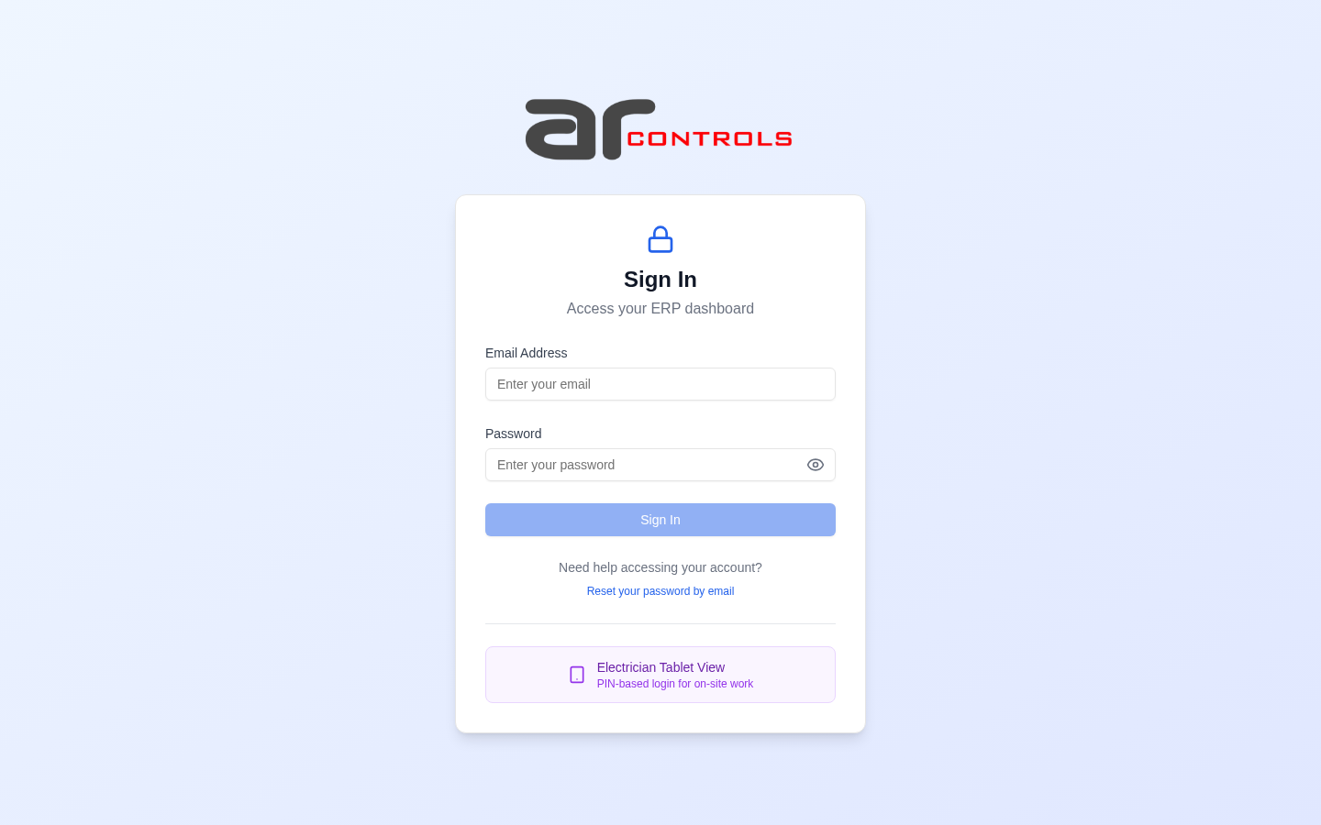
02-post-login.png
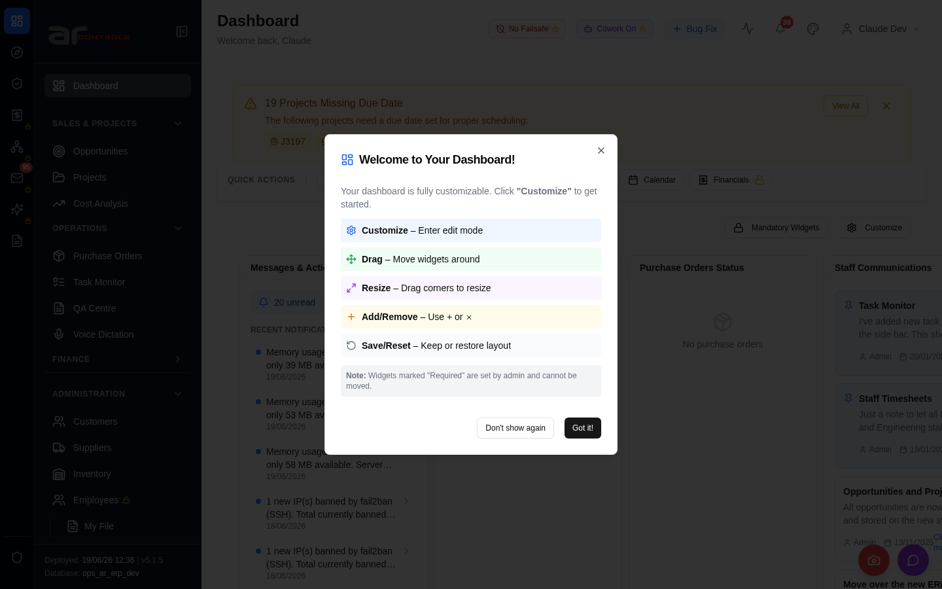
03-project-planning-grid-shows-all-active-projects-in-filter-2026-06-18-00-journey-start.png
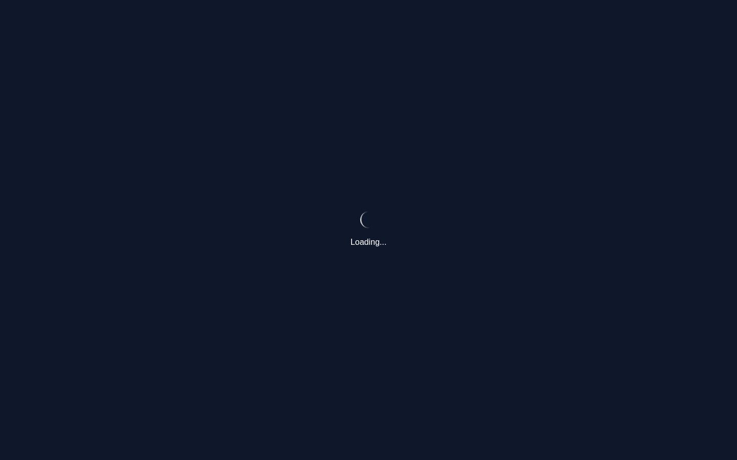
03-project-planning-grid-shows-all-active-projects-in-filter-2026-06-18-01-navigate.png
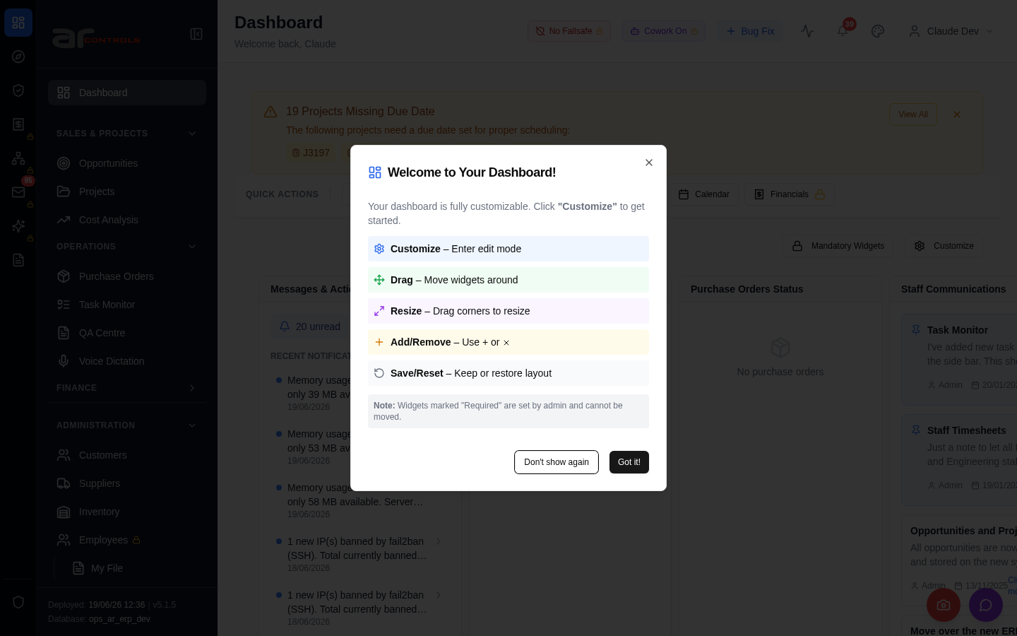
03-project-planning-grid-shows-all-active-projects-in-filter-2026-06-18-failed.png
04-popout-preserves-selected-project-2026-06-18-00-journey-start.png
04-popout-preserves-selected-project-2026-06-18-01-navigate.png
04-popout-preserves-selected-project-2026-06-18-failed.png

Console Errors
- [error] Error fetching pending QA checks: TypeError: Failed to fetch
at g (http://100.121.252.85:3180/static/js/9627.6c769993.chunk.js:1:17127)
- [error] Failed to check for nudges: TypeError: Failed to fetch
at d (http://100.121.252.85:3180/static/js/9627.6c769993.chunk.js:1:20111)
- [error] Failed to check projects due date: TypeError: Failed to fetch
at http://100.121.252.85:3180/static/js/872.89f56c8c.chunk.js:1:89576
- [error] Error fetching dashboard config: TypeError: Failed to fetch
at O (http://100.121.252.85:3180/static/js/872.89f56c8c.chunk.js:1:66364)
- [error] Failed to fetch version info: TypeError: Failed to fetch
at http://100.121.252.85:3180/static/js/9627.6c769993.chunk.js:1:1290
at http://100.121.252.85:3180/static/js/9627.6c769993.chunk.js:1:1425
at vs (http://100.121.252.85:3180/static/js/main.64a8e2ca.js:2:177100)
at tc (http://10
- [error] Error fetching widget types: TypeError: Failed to fetch
at F (http://100.121.252.85:3180/static/js/872.89f56c8c.chunk.js:1:66718)
- [error] Error fetching checklist settings: TypeError: Failed to fetch
at h (http://100.121.252.85:3180/static/js/9627.6c769993.chunk.js:1:16839)
- [error] Failed to check weekend availability: TypeError: Failed to fetch
at http://100.121.252.85:3180/static/js/872.89f56c8c.chunk.js:1:88958
- [error] Failed to fetch HR settings: TypeError: Failed to fetch
at http://100.121.252.85:3180/static/js/9627.6c769993.chunk.js:1:1868
- [error] Failed to check timesheet compliance: TypeError: Failed to fetch
at u (http://100.121.252.85:3180/static/js/9627.6c769993.chunk.js:1:14135)
- [error] Failed to fetch HR settings: TypeError: Failed to fetch
at http://100.121.252.85:3180/static/js/9627.6c769993.chunk.js:1:1868
- [error] Failed to fetch new task count: TypeError: Failed to fetch
at e (http://100.121.252.85:3180/static/js/9627.6c769993.chunk.js:1:1521)
- [error] Failed to fetch new task count: TypeError: Failed to fetch
at e (http://100.121.252.85:3180/static/js/9627.6c769993.chunk.js:1:1521)
- [error] 🔔 NotificationsDropdown: Error fetching notification summary: TypeError: Failed to fetch
at T (http://100.121.252.85:3180/static/js/505.03a7c875.chunk.js:1:76319)
- [error] 🔔 NotificationsDropdown: Error fetching notification summary: TypeError: Failed to fetch
at T (http://100.121.252.85:3180/static/js/505.03a7c875.chunk.js:1:76319)
- [error] Error fetching dashboard config: TypeError: Failed to fetch
at O (http://100.121.252.85:3180/static/js/872.89f56c8c.chunk.js:1:66364)
- [error] Failed to check projects due date: TypeError: Failed to fetch
at http://100.121.252.85:3180/static/js/872.89f56c8c.chunk.js:1:89576
- [error] Error fetching pending QA checks: TypeError: Failed to fetch
at g (http://100.121.252.85:3180/static/js/9627.6c769993.chunk.js:1:17127)
- [error] Failed to fetch new task count: TypeError: Failed to fetch
at e (http://100.121.252.85:3180/static/js/9627.6c769993.chunk.js:1:1521)
- [error] Error fetching widget types: TypeError: Failed to fetch
at F (http://100.121.252.85:3180/static/js/872.89f56c8c.chunk.js:1:66718)

Network Issues
- GET http://100.121.252.85:3180/api/notifications/stream?access_token=eyJhbGciOiJIUzI1NiIsInR5cCI6IkpXVCJ9.eyJzdWIiOiJjbGF1ZGUtZGV2QGFyY29udHJvbHMuaW50ZXJuYWwiLCJ1c2VyX2lkIjoiN2NlNDFmZjAtZDBmNy00NzMxLTkzNG — net::ERR_ABORTED
- GET http://100.121.252.85:3180/api/notifications/stream?access_token=eyJhbGciOiJIUzI1NiIsInR5cCI6IkpXVCJ9.eyJzdWIiOiJjbGF1ZGUtZGV2QGFyY29udHJvbHMuaW50ZXJuYWwiLCJ1c2VyX2lkIjoiN2NlNDFmZjAtZDBmNy00NzMxLTkzNG — net::ERR_ABORTED
- GET http://100.121.252.85:3180/api/qa/my-pending-checks — net::ERR_ABORTED
- GET http://100.121.252.85:3180/api/resources/nudge/active — net::ERR_ABORTED
- GET http://100.121.252.85:3180/api/projects/without-due-date — net::ERR_ABORTED
- GET http://100.121.252.85:3180/api/dashboard/config — net::ERR_ABORTED
- GET http://100.121.252.85:3180/api/version — net::ERR_ABORTED
- GET http://100.121.252.85:3180/api/dashboard/widget-types — net::ERR_ABORTED
- GET http://100.121.252.85:3180/api/system-settings/ — net::ERR_ABORTED
- GET http://100.121.252.85:3180/api/system-settings/ — net::ERR_ABORTED
- GET http://100.121.252.85:3180/api/notifications/stream?access_token=eyJhbGciOiJIUzI1NiIsInR5cCI6IkpXVCJ9.eyJzdWIiOiJjbGF1ZGUtZGV2QGFyY29udHJvbHMuaW50ZXJuYWwiLCJ1c2VyX2lkIjoiN2NlNDFmZjAtZDBmNy00NzMxLTkzNG — net::ERR_ABORTED
- GET http://100.121.252.85:3180/api/resources/check-weekend-availability — net::ERR_ABORTED
- GET http://100.121.252.85:3180/api/email-inbox/stats — net::ERR_ABORTED
- GET http://100.121.252.85:3180/api/employees/my-file — net::ERR_ABORTED
- GET http://100.121.252.85:3180/api/resources/timesheets/compliance-check — net::ERR_ABORTED
- GET http://100.121.252.85:3180/api/employees/my-file — net::ERR_ABORTED
- GET http://100.121.252.85:3180/api/system-settings/cowork-agent-enabled — net::ERR_ABORTED
- GET http://100.121.252.85:3180/api/email-inbox/stats — net::ERR_ABORTED
- GET http://100.121.252.85:3180/api/resources/timesheets/compliance-check — net::ERR_ABORTED
- GET http://100.121.252.85:3180/api/system-settings/ — net::ERR_ABORTED

