ERP Verification Evidence Pack — [ERP bug-fix] Bug from /resource-manager
Result: FAIL — FAIL — 2 browser check(s) failed
When: 20260619T132417Z
Verified URL: http://100.121.252.85:3180/

Runtime Start Checks
No runtime checks were configured.

Notes
- Verification level 2
- ✓ task proof plan L2: 2 task browser check(s), 0 API check(s)
- Task-proof-only mode: Level 1 launch smoke already passed; skipping baseline browser checks.
- Playwright MCP required for level 2+ UI proof; validating worker-declared MCP-backed checks.
- ✓ readiness gate: app ready after 1 probe(s) (status 200)
- networkidle not reached after login (app polls continuously) — non-fatal; confirming login via login-form disappearance instead.
- Logged in as claude-dev@arcontrols.internal
- Browser flow 'project-planning-grid-shows-all-active-projects-in-filter-2026-06-18' started at /; target is /resource-manager. Navigation must use visible UI actions from here.
- ✓ project-planning-grid-shows-all-active-projects-in-filter-2026-06-18: step 1 navigate
- ✓ project-planning-grid-shows-all-active-projects-in-filter-2026-06-18: step 2 a[href="/resource-manager"]
- ✓ project-planning-grid-shows-all-active-projects-in-filter-2026-06-18: step 3 a[href="/resource-manager"]
- ✗ browser check 'project-planning-grid-shows-all-active-projects-in-filter-2026-06-18' failed: Page.wait_for_selector: Timeout 30000ms exceeded.
Call log:
- waiting for locator("[data-testid=\"tab-navigation-set-active-tab-button-planning\"]") to be visible
- Browser flow 'popout-preserves-selected-project-2026-06-18' started at /; target is /resource-manager. Navigation must use visible UI actions from here.
- ✓ popout-preserves-selected-project-2026-06-18: step 1 navigate
- ✓ popout-preserves-selected-project-2026-06-18: step 2 a[href="/resource-manager"]
- ✓ popout-preserves-selected-project-2026-06-18: step 3 a[href="/resource-manager"]
- ✗ browser check 'popout-preserves-selected-project-2026-06-18' failed: Page.wait_for_selector: Timeout 30000ms exceeded.
Call log:
- waiting for locator("[data-testid=\"tab-navigation-set-active-tab-button-planning\"]") to be visible
- Ignored 11 aborted background fetch console error(s); task browser checks, API checks, and runtime checks decide this proof.

Screenshots
01-landing.png
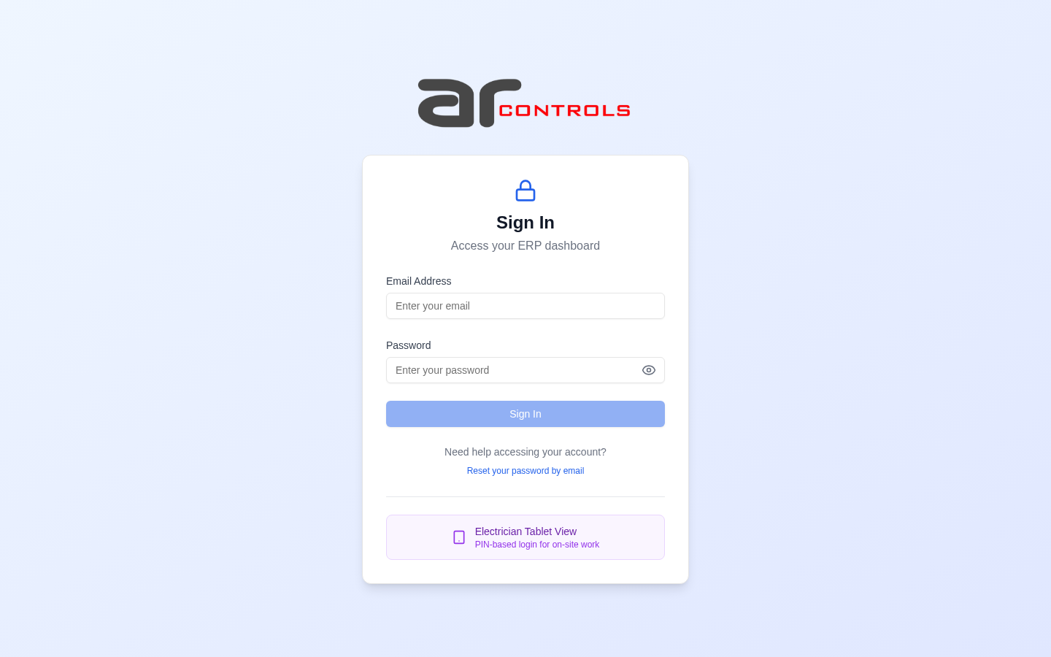
02-post-login.png
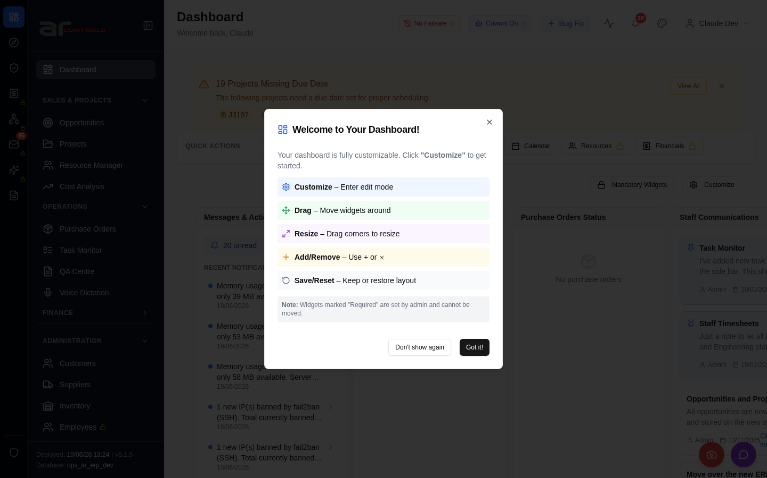
03-project-planning-grid-shows-all-active-projects-in-filter-2026-06-18-00-journey-start.png
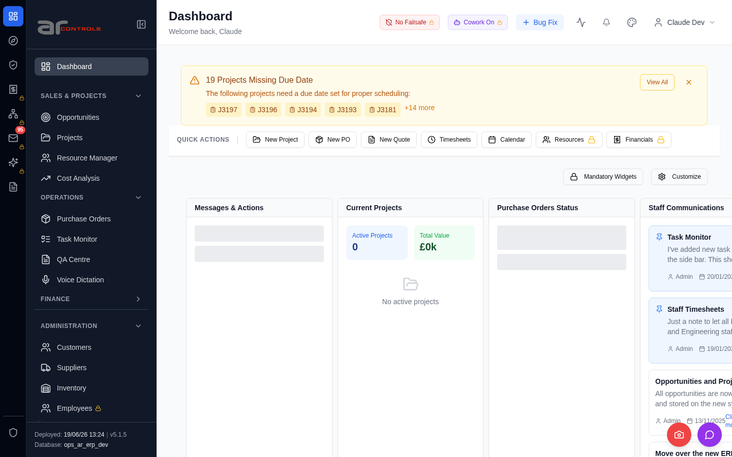
03-project-planning-grid-shows-all-active-projects-in-filter-2026-06-18-01-navigate.png
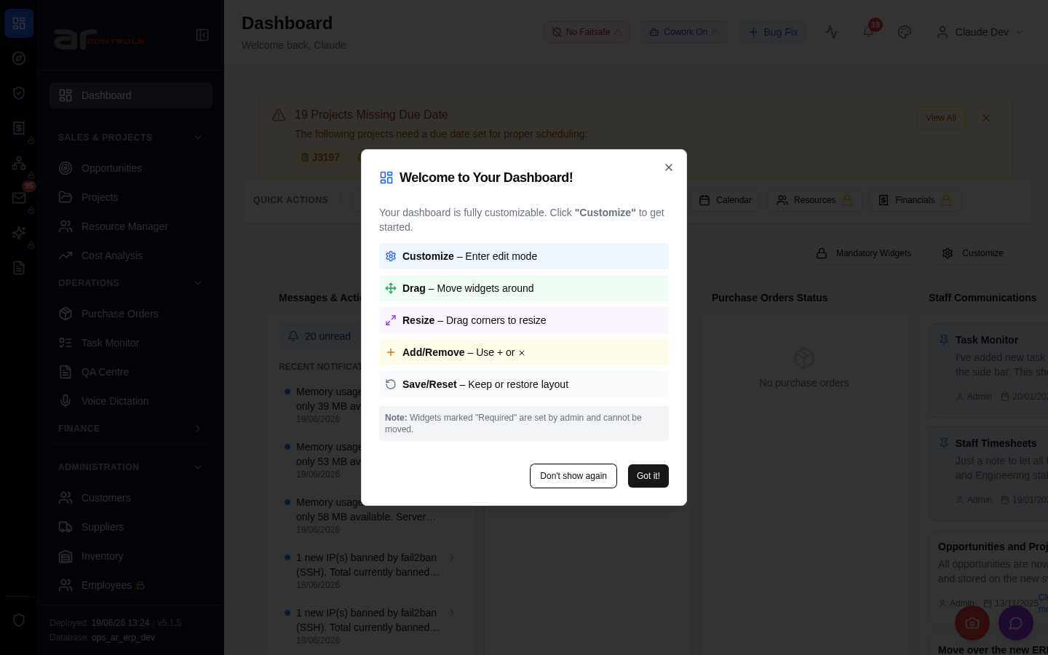
03-project-planning-grid-shows-all-active-projects-in-filter-2026-06-18-02-a-href-resource-manager.png
03-project-planning-grid-shows-all-active-projects-in-filter-2026-06-18-02-a-href-resource-manager-element.png

03-project-planning-grid-shows-all-active-projects-in-filter-2026-06-18-03-a-href-resource-manager.png
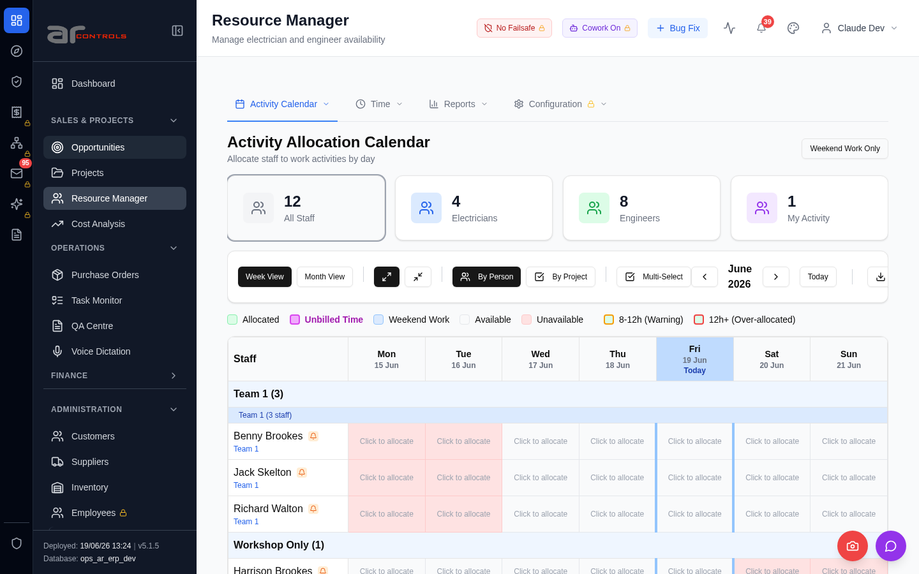
03-project-planning-grid-shows-all-active-projects-in-filter-2026-06-18-03-a-href-resource-manager-element.png

03-project-planning-grid-shows-all-active-projects-in-filter-2026-06-18-failed.png
04-popout-preserves-selected-project-2026-06-18-00-journey-start.png
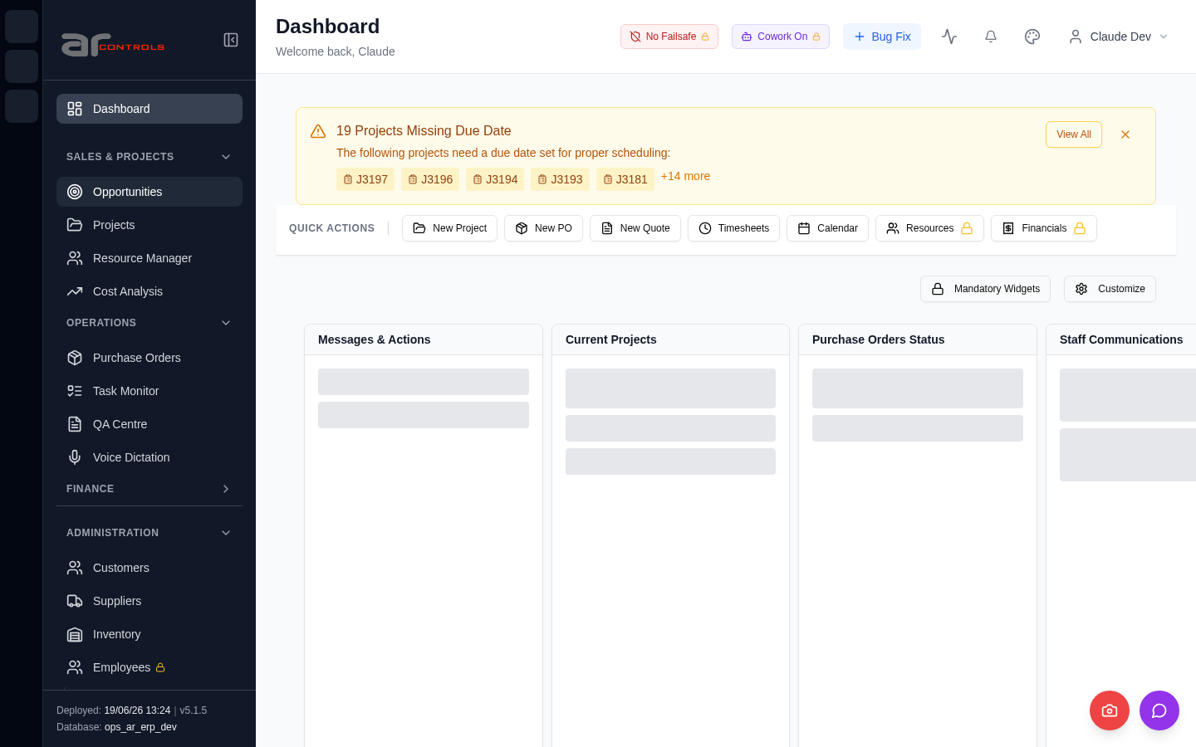
04-popout-preserves-selected-project-2026-06-18-01-navigate.png
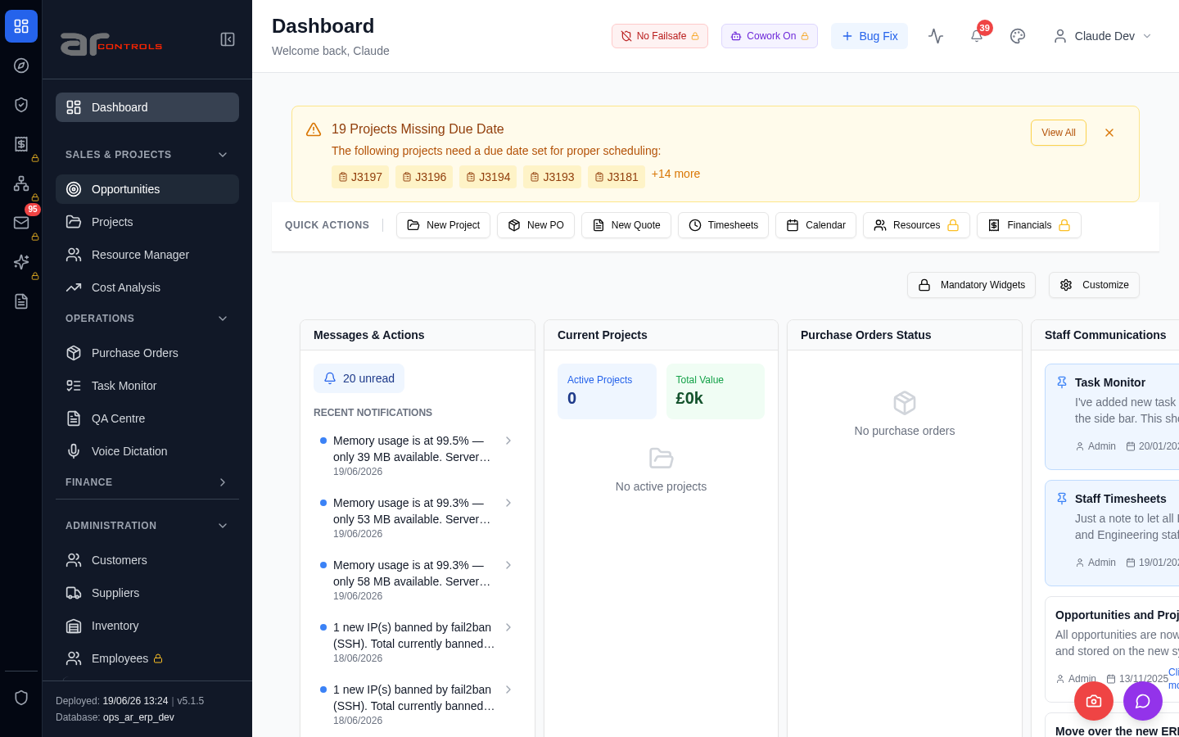
04-popout-preserves-selected-project-2026-06-18-02-a-href-resource-manager.png
04-popout-preserves-selected-project-2026-06-18-02-a-href-resource-manager-element.png

04-popout-preserves-selected-project-2026-06-18-03-a-href-resource-manager.png
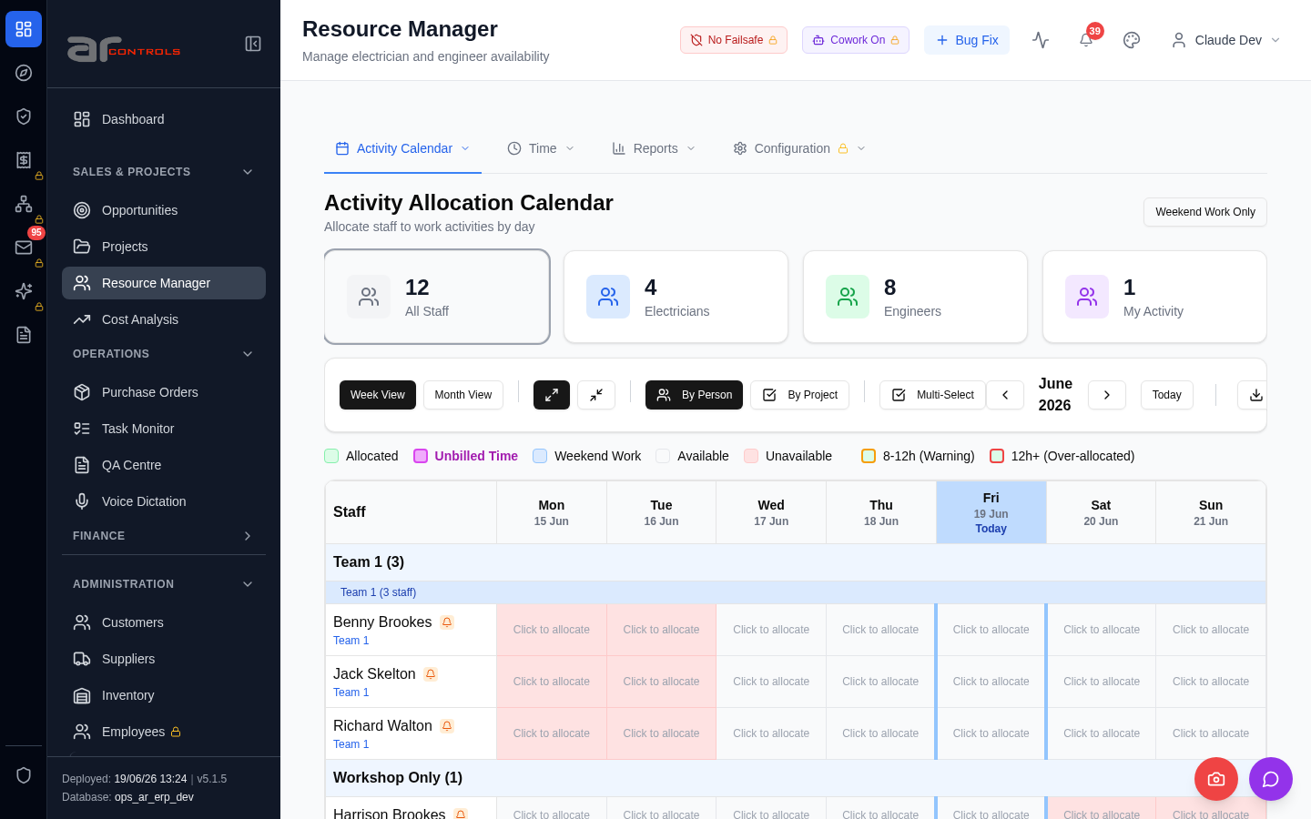
04-popout-preserves-selected-project-2026-06-18-03-a-href-resource-manager-element.png
04-popout-preserves-selected-project-2026-06-18-failed.png

Console Errors
- [error] Error fetching batch widget data: TypeError: Failed to fetch
at P (http://100.121.252.85:3180/static/js/872.89f56c8c.chunk.js:1:67040)
- [error] Error fetching checklist settings: TypeError: Failed to fetch
at h (http://100.121.252.85:3180/static/js/9627.a1760778.chunk.js:1:16800)
- [error] Error fetching PO requests: TypeError: Failed to fetch
at d (http://100.121.252.85:3180/static/js/872.89f56c8c.chunk.js:1:45670)
- [error] Error fetching POs: TypeError: Failed to fetch
at d (http://100.121.252.85:3180/static/js/872.89f56c8c.chunk.js:1:18190)
- [error] Error fetching budget warnings: TypeError: Failed to fetch
at x (http://100.121.252.85:3180/static/js/872.89f56c8c.chunk.js:1:23348)
- [error] Error fetching approval requests: TypeError: Failed to fetch
at x (http://100.121.252.85:3180/static/js/872.89f56c8c.chunk.js:1:48850)
- [error] 🔔 NotificationsDropdown: Error fetching notification summary: TypeError: Failed to fetch
at T (http://100.121.252.85:3180/static/js/505.03a7c875.chunk.js:1:76319)
- [error] Error fetching checklist settings: TypeError: Failed to fetch
at h (http://100.121.252.85:3180/static/js/9627.a1760778.chunk.js:1:16800)
- [error] Error fetching batch widget data: TypeError: Failed to fetch
at P (http://100.121.252.85:3180/static/js/872.89f56c8c.chunk.js:1:67040)
- [error] Failed to fetch HR settings: TypeError: Failed to fetch
at http://100.121.252.85:3180/static/js/9627.a1760778.chunk.js:1:1841
- [error] 🔔 NotificationsDropdown: Error fetching notification summary: TypeError: Failed to fetch
at T (http://100.121.252.85:3180/static/js/505.03a7c875.chunk.js:1:76319)

Network Issues
- GET http://100.121.252.85:3180/api/notifications/stream?access_token=eyJhbGciOiJIUzI1NiIsInR5cCI6IkpXVCJ9.eyJzdWIiOiJjbGF1ZGUtZGV2QGFyY29udHJvbHMuaW50ZXJuYWwiLCJ1c2VyX2lkIjoiN2NlNDFmZjAtZDBmNy00NzMxLTkzNG — net::ERR_ABORTED
- GET http://100.121.252.85:3180/api/notifications/stream?access_token=eyJhbGciOiJIUzI1NiIsInR5cCI6IkpXVCJ9.eyJzdWIiOiJjbGF1ZGUtZGV2QGFyY29udHJvbHMuaW50ZXJuYWwiLCJ1c2VyX2lkIjoiN2NlNDFmZjAtZDBmNy00NzMxLTkzNG — net::ERR_ABORTED
- GET http://100.121.252.85:3180/api/notifications/stream?access_token=eyJhbGciOiJIUzI1NiIsInR5cCI6IkpXVCJ9.eyJzdWIiOiJjbGF1ZGUtZGV2QGFyY29udHJvbHMuaW50ZXJuYWwiLCJ1c2VyX2lkIjoiN2NlNDFmZjAtZDBmNy00NzMxLTkzNG — net::ERR_ABORTED
- POST http://100.121.252.85:3180/api/dashboard/widgets/batch — net::ERR_ABORTED
- GET http://100.121.252.85:3180/api/notifications/stream?access_token=eyJhbGciOiJIUzI1NiIsInR5cCI6IkpXVCJ9.eyJzdWIiOiJjbGF1ZGUtZGV2QGFyY29udHJvbHMuaW50ZXJuYWwiLCJ1c2VyX2lkIjoiN2NlNDFmZjAtZDBmNy00NzMxLTkzNG — net::ERR_ABORTED
- GET http://100.121.252.85:3180/api/system-settings/ — net::ERR_ABORTED
- GET http://100.121.252.85:3180/api/dashboard/widgets/po-requests — net::ERR_ABORTED
- GET http://100.121.252.85:3180/api/resources/timesheets/unsubmitted-check — net::ERR_ABORTED
- GET http://100.121.252.85:3180/api/dashboard/widgets/purchase-orders — net::ERR_ABORTED
- GET http://100.121.252.85:3180/api/dashboard/widgets/budget-warnings — net::ERR_ABORTED
- GET http://100.121.252.85:3180/api/dashboard/widgets/approval-requests — net::ERR_ABORTED
- GET http://100.121.252.85:3180/api/notifications/summary — net::ERR_ABORTED
- GET http://100.121.252.85:3180/api/notifications/stream?access_token=eyJhbGciOiJIUzI1NiIsInR5cCI6IkpXVCJ9.eyJzdWIiOiJjbGF1ZGUtZGV2QGFyY29udHJvbHMuaW50ZXJuYWwiLCJ1c2VyX2lkIjoiN2NlNDFmZjAtZDBmNy00NzMxLTkzNG — net::ERR_ABORTED
- GET http://100.121.252.85:3180/api/notifications/stream?access_token=eyJhbGciOiJIUzI1NiIsInR5cCI6IkpXVCJ9.eyJzdWIiOiJjbGF1ZGUtZGV2QGFyY29udHJvbHMuaW50ZXJuYWwiLCJ1c2VyX2lkIjoiN2NlNDFmZjAtZDBmNy00NzMxLTkzNG — net::ERR_ABORTED
- GET http://100.121.252.85:3180/api/notifications/stream?access_token=eyJhbGciOiJIUzI1NiIsInR5cCI6IkpXVCJ9.eyJzdWIiOiJjbGF1ZGUtZGV2QGFyY29udHJvbHMuaW50ZXJuYWwiLCJ1c2VyX2lkIjoiN2NlNDFmZjAtZDBmNy00NzMxLTkzNG — net::ERR_ABORTED
- GET http://100.121.252.85:3180/api/notifications/stream?access_token=eyJhbGciOiJIUzI1NiIsInR5cCI6IkpXVCJ9.eyJzdWIiOiJjbGF1ZGUtZGV2QGFyY29udHJvbHMuaW50ZXJuYWwiLCJ1c2VyX2lkIjoiN2NlNDFmZjAtZDBmNy00NzMxLTkzNG — net::ERR_ABORTED
- GET http://100.121.252.85:3180/api/system-settings/ — net::ERR_ABORTED
- POST http://100.121.252.85:3180/api/dashboard/widgets/batch — net::ERR_ABORTED
- GET http://100.121.252.85:3180/api/employees/my-file — net::ERR_ABORTED
- GET http://100.121.252.85:3180/api/notifications/stream?access_token=eyJhbGciOiJIUzI1NiIsInR5cCI6IkpXVCJ9.eyJzdWIiOiJjbGF1ZGUtZGV2QGFyY29udHJvbHMuaW50ZXJuYWwiLCJ1c2VyX2lkIjoiN2NlNDFmZjAtZDBmNy00NzMxLTkzNG — net::ERR_ABORTED

