ERP Verification Evidence Pack — [ERP bug-fix] Bug from /resource-manager
Result: FAIL — FAIL — 1 browser check(s) failed
When: 20260619T141352Z
Verified URL: http://100.121.252.85:3180/

Runtime Start Checks
No runtime checks were configured.

Notes
- Verification level 2
- ✓ task proof plan L2: 2 task browser check(s), 0 API check(s)
- Task-proof-only mode: Level 1 launch smoke already passed; skipping baseline browser checks.
- Playwright MCP required for level 2+ UI proof; validating worker-declared MCP-backed checks.
- ✓ readiness gate: app ready after 1 probe(s) (status 200)
- networkidle not reached after login (app polls continuously) — non-fatal; confirming login via login-form disappearance instead.
- Logged in as claude-dev@arcontrols.internal
- Browser flow 'project-planning-grid-shows-all-active-projects-in-filter-2026-06-18' started at /; target is /resource-manager. Navigation must use visible UI actions from here.
- ✓ project-planning-grid-shows-all-active-projects-in-filter-2026-06-18: step 1 navigate
- ✓ project-planning-grid-shows-all-active-projects-in-filter-2026-06-18: step 2 [data-testid="project-planning-grid-project-filter-trigger"]
- ✓ project-planning-grid-shows-all-active-projects-in-filter-2026-06-18: step 3 [data-testid="project-planning-grid-project-filter-trigger"]
- ✓ project-planning-grid-shows-all-active-projects-in-filter-2026-06-18: step 4 [data-testid="project-planning-grid-project-id-option"]
- ✓ project-planning-grid-shows-all-active-projects-in-filter-2026-06-18: step 5 [data-testid="project-planning-grid-project-id-option"]
- ✓ project-planning-grid-shows-all-active-projects-in-filter-2026-06-18: step 6 Filter by Project
- ✓ project-planning-grid-shows-all-active-projects-in-filter-2026-06-18: step 7 Manage electrician and engineer availability
- ✓ project-planning-grid-shows-all-active-projects-in-filter-2026-06-18: browser flow reached target path /resource-manager
- ✓ project-planning-grid-shows-all-active-projects-in-filter-2026-06-18: text present: Manage electrician and engineer availability
- Browser flow 'popout-preserves-selected-project-2026-06-18' started at /; target is /resource-manager. Navigation must use visible UI actions from here.
- ✓ popout-preserves-selected-project-2026-06-18: step 1 navigate
- ✓ popout-preserves-selected-project-2026-06-18: step 2 [data-testid="project-planning-grid-project-filter-trigger"]
- ✓ popout-preserves-selected-project-2026-06-18: step 3 [data-testid="project-planning-grid-project-filter-trigger"]
- ✓ popout-preserves-selected-project-2026-06-18: step 4 [data-testid="project-planning-grid-project-id-option"]
- ✓ popout-preserves-selected-project-2026-06-18: step 5 [data-testid="project-planning-grid-project-id-option"]:nth-of-type(2)
- ✓ popout-preserves-selected-project-2026-06-18: step 6 [data-testid="project-planning-grid-popout-button"]
- ✗ popout-preserves-selected-project-2026-06-18: step 7 Manage electrician and engineer availability: text missing: Manage electrician and engineer availability
- ✗ popout-preserves-selected-project-2026-06-18: browser flow target path /resource-manager not reached; current path /popup/planner/J9999-M
- ✗ popout-preserves-selected-project-2026-06-18: text missing: Manage electrician and engineer availability
- Ignored 14 aborted background fetch console error(s); task browser checks, API checks, and runtime checks decide this proof.

Screenshots
01-landing.png
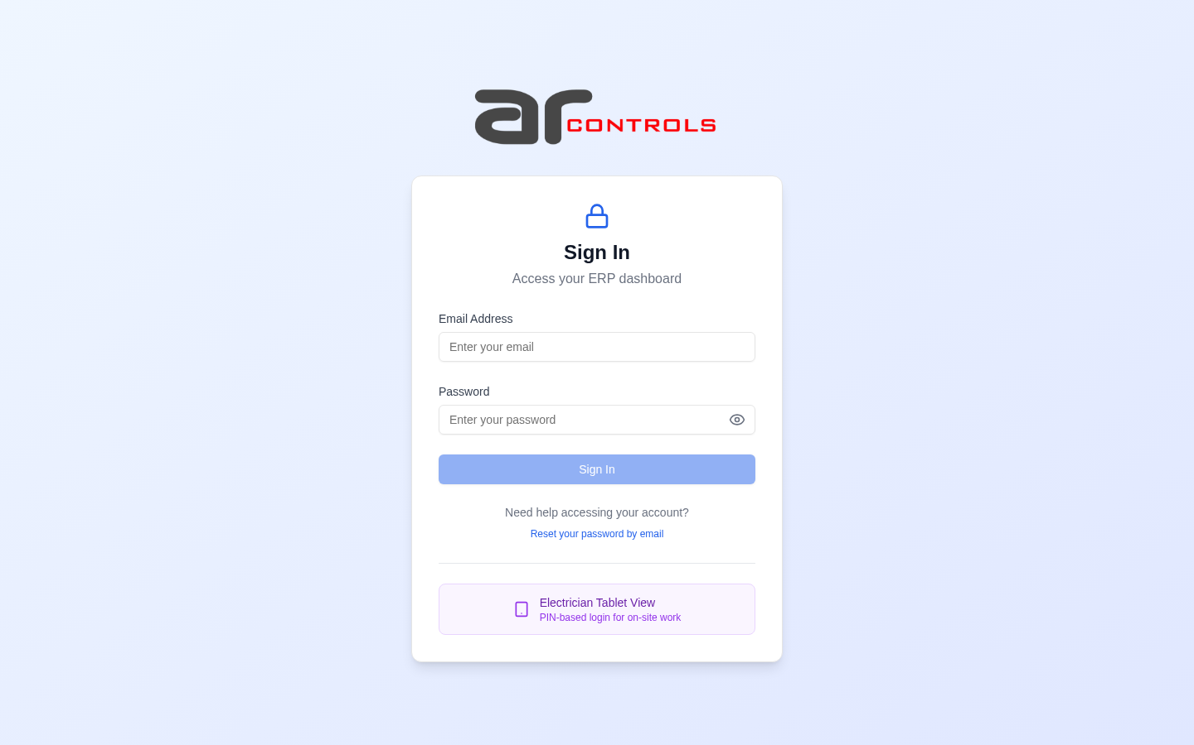
02-post-login.png
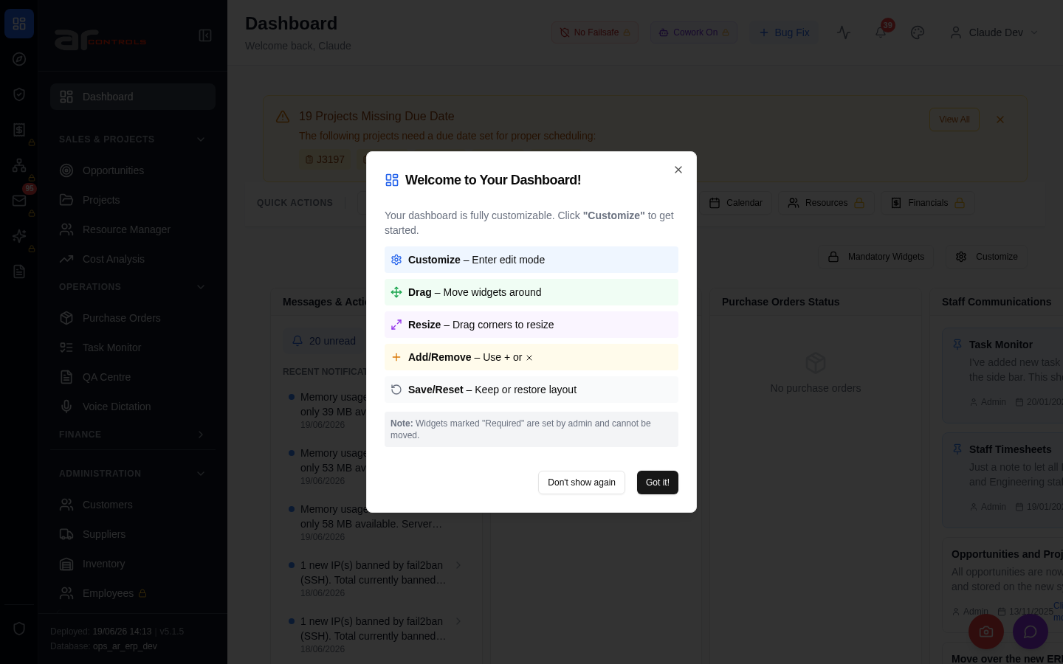
03-project-planning-grid-shows-all-active-projects-in-filter-2026-06-18-00-journey-start.png
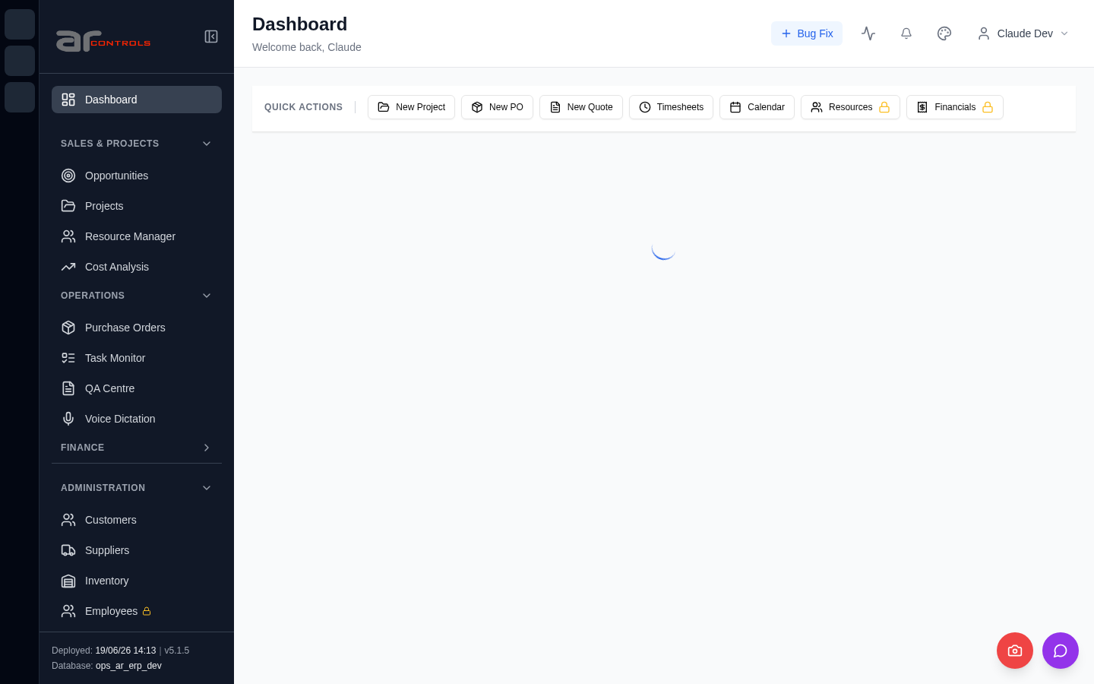
03-project-planning-grid-shows-all-active-projects-in-filter-2026-06-18-01-navigate.png
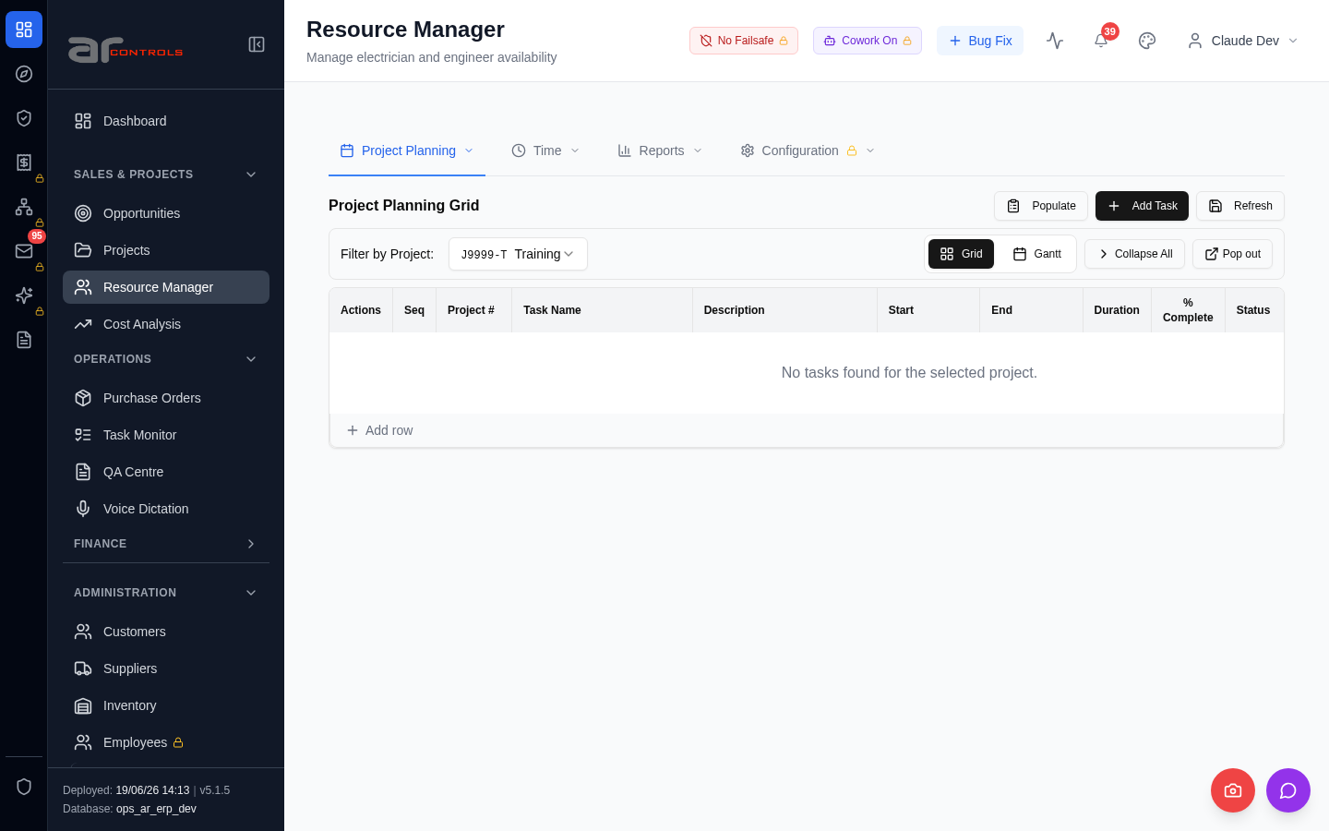
03-project-planning-grid-shows-all-active-projects-in-filter-2026-06-18-02-data-testid-project-planning-grid-project-filter-trigger.png
03-project-planning-grid-shows-all-active-projects-in-filter-2026-06-18-02-data-testid-project-planning-grid-project-filter-trigger-element.png
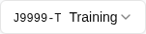
03-project-planning-grid-shows-all-active-projects-in-filter-2026-06-18-03-data-testid-project-planning-grid-project-filter-trigger.png
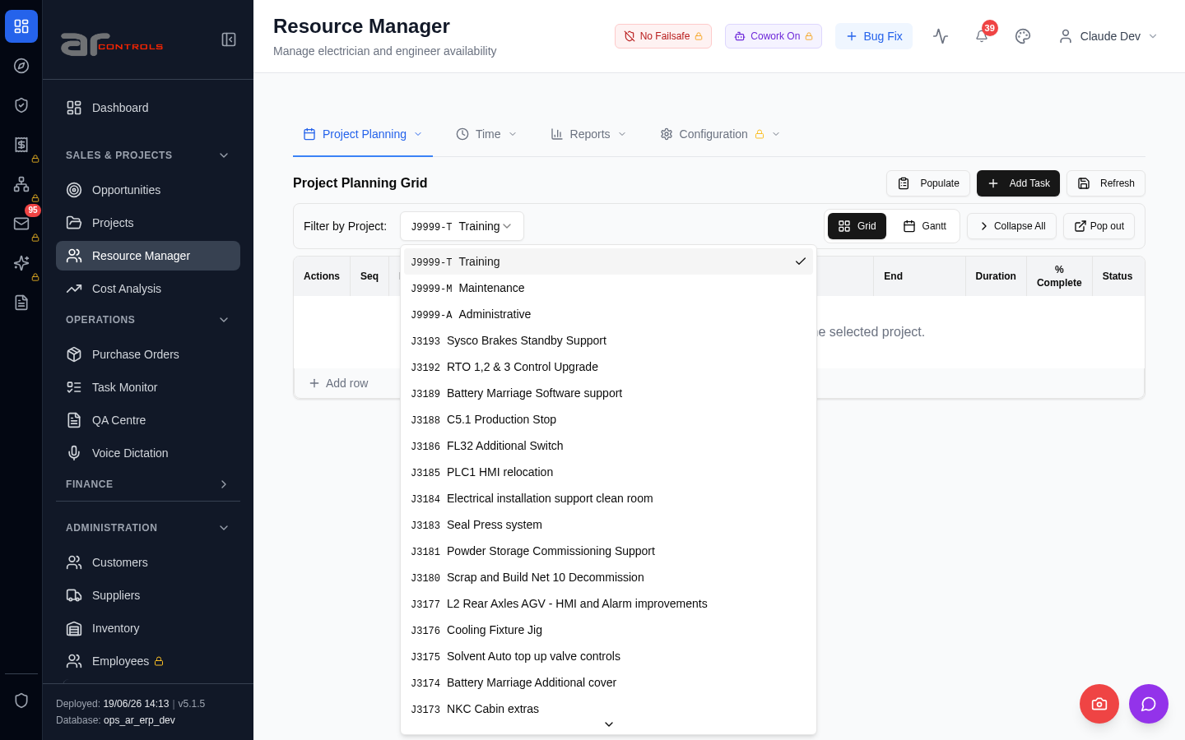
03-project-planning-grid-shows-all-active-projects-in-filter-2026-06-18-03-data-testid-project-planning-grid-project-filter-trigger-element.png
03-project-planning-grid-shows-all-active-projects-in-filter-2026-06-18-04-data-testid-project-planning-grid-project-id-option.png
03-project-planning-grid-shows-all-active-projects-in-filter-2026-06-18-04-data-testid-project-planning-grid-project-id-option-element.png
03-project-planning-grid-shows-all-active-projects-in-filter-2026-06-18-05-data-testid-project-planning-grid-project-id-option.png
03-project-planning-grid-shows-all-active-projects-in-filter-2026-06-18-05-data-testid-project-planning-grid-project-id-option-element.png
03-project-planning-grid-shows-all-active-projects-in-filter-2026-06-18-06-filter-by-project.png
03-project-planning-grid-shows-all-active-projects-in-filter-2026-06-18-07-manage-electrician-and-engineer-availability.png
03-project-planning-grid-shows-all-active-projects-in-filter-2026-06-18.png
04-popout-preserves-selected-project-2026-06-18-00-journey-start.png
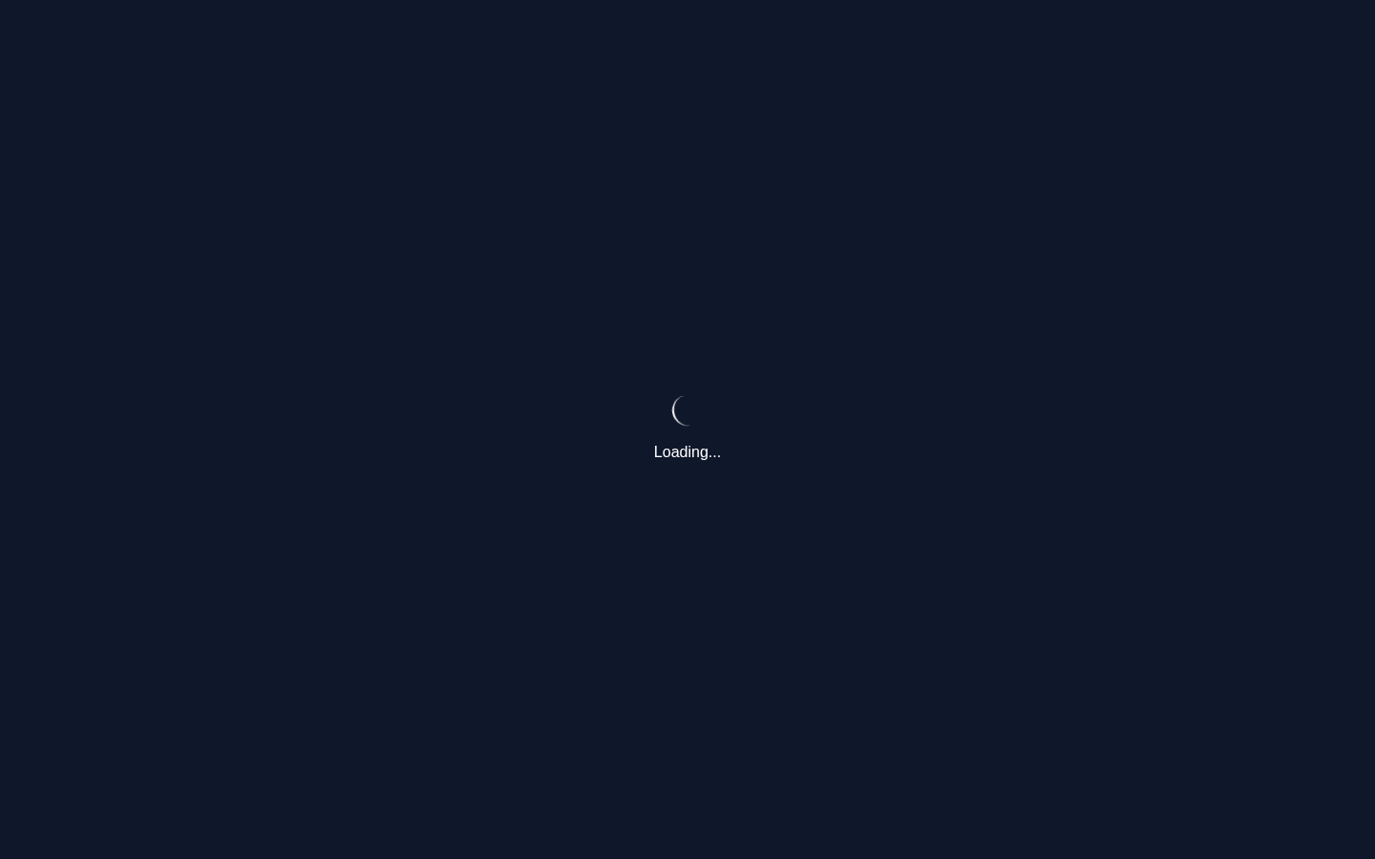
04-popout-preserves-selected-project-2026-06-18-01-navigate.png
04-popout-preserves-selected-project-2026-06-18-02-data-testid-project-planning-grid-project-filter-trigger.png
04-popout-preserves-selected-project-2026-06-18-02-data-testid-project-planning-grid-project-filter-trigger-element.png
04-popout-preserves-selected-project-2026-06-18-03-data-testid-project-planning-grid-project-filter-trigger.png
04-popout-preserves-selected-project-2026-06-18-03-data-testid-project-planning-grid-project-filter-trigger-element.png
04-popout-preserves-selected-project-2026-06-18-04-data-testid-project-planning-grid-project-id-option.png
04-popout-preserves-selected-project-2026-06-18-04-data-testid-project-planning-grid-project-id-option-element.png
04-popout-preserves-selected-project-2026-06-18-05-data-testid-project-planning-grid-project-id-option-nth-of-type-2.png
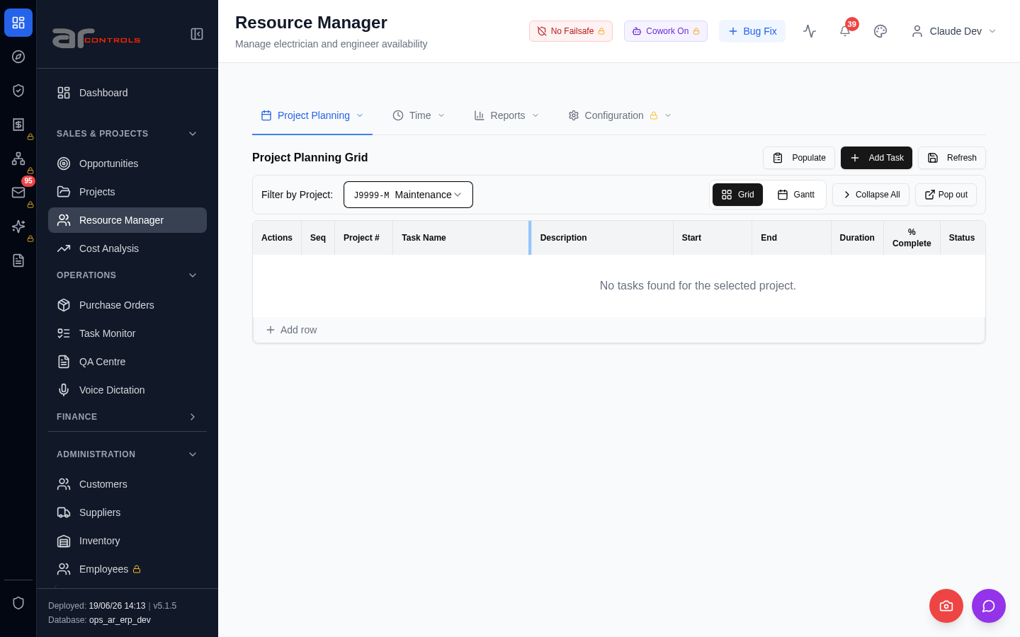
04-popout-preserves-selected-project-2026-06-18-06-data-testid-project-planning-grid-popout-button.png
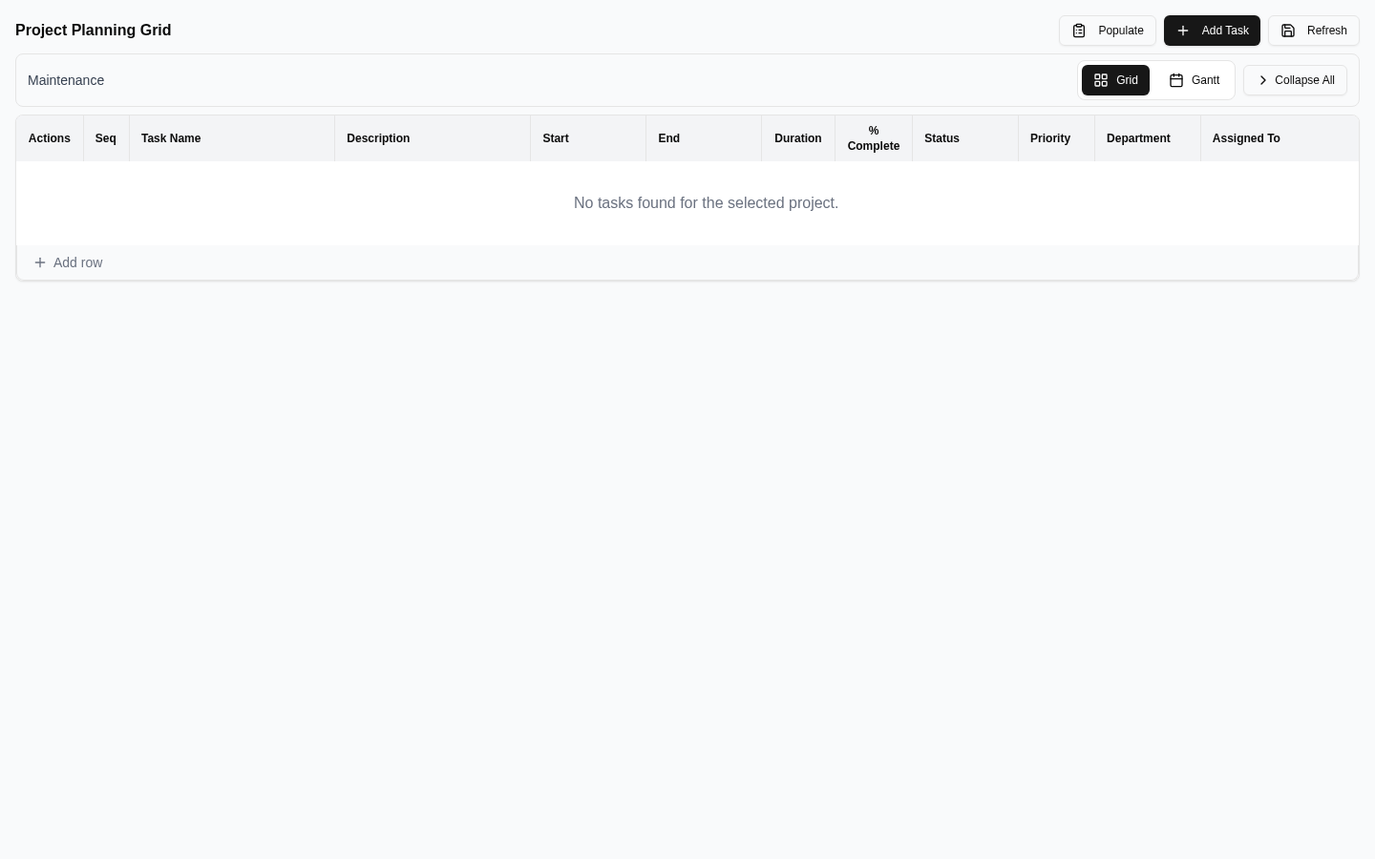
04-popout-preserves-selected-project-2026-06-18-07-manage-electrician-and-engineer-availability.png
04-popout-preserves-selected-project-2026-06-18.png

Console Errors
- [error] Failed to check weekend availability: TypeError: Failed to fetch
at http://100.121.252.85:3180/static/js/872.89f56c8c.chunk.js:1:88958
- [error] Failed to fetch HR settings: TypeError: Failed to fetch
at http://100.121.252.85:3180/static/js/9627.a1760778.chunk.js:1:1841
- [error] Failed to fetch version info: TypeError: Failed to fetch
at http://100.121.252.85:3180/static/js/9627.a1760778.chunk.js:1:1263
at http://100.121.252.85:3180/static/js/9627.a1760778.chunk.js:1:1398
at vs (http://100.121.252.85:3180/static/js/main.9f14fdb6.js:2:177166)
at tc (http://10
- [error] 🔔 NotificationsDropdown: Error fetching notification summary: TypeError: Failed to fetch
at T (http://100.121.252.85:3180/static/js/505.03a7c875.chunk.js:1:76319)
- [error] Failed to check projects due date: TypeError: Failed to fetch
at http://100.121.252.85:3180/static/js/872.89f56c8c.chunk.js:1:89576
- [error] Error fetching pending QA checks: TypeError: Failed to fetch
at g (http://100.121.252.85:3180/static/js/9627.a1760778.chunk.js:1:17088)
- [error] Failed to check timesheet compliance: TypeError: Failed to fetch
at u (http://100.121.252.85:3180/static/js/9627.a1760778.chunk.js:1:14096)
- [error] Error fetching dashboard config: TypeError: Failed to fetch
at O (http://100.121.252.85:3180/static/js/872.89f56c8c.chunk.js:1:66364)
- [error] Failed to fetch HR settings: TypeError: Failed to fetch
at http://100.121.252.85:3180/static/js/9627.a1760778.chunk.js:1:1841
- [error] 🔔 NotificationsDropdown: Error fetching notification summary: TypeError: Failed to fetch
at T (http://100.121.252.85:3180/static/js/505.03a7c875.chunk.js:1:76319)
- [error] Failed to fetch new task count: TypeError: Failed to fetch
at e (http://100.121.252.85:3180/static/js/9627.a1760778.chunk.js:1:1494)
- [error] Failed to check for nudges: TypeError: Failed to fetch
at d (http://100.121.252.85:3180/static/js/9627.a1760778.chunk.js:1:20072)
- [error] Error fetching widget types: TypeError: Failed to fetch
at F (http://100.121.252.85:3180/static/js/872.89f56c8c.chunk.js:1:66718)
- [error] Error fetching checklist settings: TypeError: Failed to fetch
at h (http://100.121.252.85:3180/static/js/9627.a1760778.chunk.js:1:16800)

Network Issues
- GET http://100.121.252.85:3180/api/notifications/stream?access_token=eyJhbGciOiJIUzI1NiIsInR5cCI6IkpXVCJ9.eyJzdWIiOiJjbGF1ZGUtZGV2QGFyY29udHJvbHMuaW50ZXJuYWwiLCJ1c2VyX2lkIjoiN2NlNDFmZjAtZDBmNy00NzMxLTkzNG — net::ERR_ABORTED
- GET http://100.121.252.85:3180/api/notifications/stream?access_token=eyJhbGciOiJIUzI1NiIsInR5cCI6IkpXVCJ9.eyJzdWIiOiJjbGF1ZGUtZGV2QGFyY29udHJvbHMuaW50ZXJuYWwiLCJ1c2VyX2lkIjoiN2NlNDFmZjAtZDBmNy00NzMxLTkzNG — net::ERR_ABORTED
- GET http://100.121.252.85:3180/api/resources/check-weekend-availability — net::ERR_ABORTED
- GET http://100.121.252.85:3180/api/employees/my-file — net::ERR_ABORTED
- GET http://100.121.252.85:3180/api/version — net::ERR_ABORTED
- GET http://100.121.252.85:3180/api/notifications/summary — net::ERR_ABORTED
- GET http://100.121.252.85:3180/api/projects/without-due-date — net::ERR_ABORTED
- GET http://100.121.252.85:3180/api/qa/my-pending-checks — net::ERR_ABORTED
- GET http://100.121.252.85:3180/api/resources/timesheets/compliance-check — net::ERR_ABORTED
- GET http://100.121.252.85:3180/api/email-inbox/stats — net::ERR_ABORTED
- GET http://100.121.252.85:3180/api/email-inbox/stats — net::ERR_ABORTED
- GET http://100.121.252.85:3180/api/dashboard/config — net::ERR_ABORTED
- GET http://100.121.252.85:3180/api/system-settings/ — net::ERR_ABORTED
- GET http://100.121.252.85:3180/api/notifications/stream?access_token=eyJhbGciOiJIUzI1NiIsInR5cCI6IkpXVCJ9.eyJzdWIiOiJjbGF1ZGUtZGV2QGFyY29udHJvbHMuaW50ZXJuYWwiLCJ1c2VyX2lkIjoiN2NlNDFmZjAtZDBmNy00NzMxLTkzNG — net::ERR_ABORTED
- GET http://100.121.252.85:3180/api/employees/my-file — net::ERR_ABORTED
- GET http://100.121.252.85:3180/api/notifications/summary — net::ERR_ABORTED
- GET http://100.121.252.85:3180/api/tasks/new-count — net::ERR_ABORTED
- GET http://100.121.252.85:3180/api/resources/nudge/active — net::ERR_ABORTED
- GET http://100.121.252.85:3180/api/notifications/stream?access_token=eyJhbGciOiJIUzI1NiIsInR5cCI6IkpXVCJ9.eyJzdWIiOiJjbGF1ZGUtZGV2QGFyY29udHJvbHMuaW50ZXJuYWwiLCJ1c2VyX2lkIjoiN2NlNDFmZjAtZDBmNy00NzMxLTkzNG — net::ERR_ABORTED
- GET http://100.121.252.85:3180/api/dashboard/widget-types — net::ERR_ABORTED

