ERP Verification Evidence Pack — [ERP bug-fix] Bug from /resource-manager
Result: FAIL — FAIL — 1 browser check(s) failed
When: 20260619T145833Z
Verified URL: http://100.121.252.85:3180/

Runtime Start Checks
No runtime checks were configured.

Notes
- Verification level 2
- ✓ task proof plan L2: 2 task browser check(s), 0 API check(s)
- Task-proof-only mode: Level 1 launch smoke already passed; skipping baseline browser checks.
- Playwright MCP required for level 2+ UI proof; validating worker-declared MCP-backed checks.
- ✓ readiness gate: app ready after 1 probe(s) (status 200)
- networkidle not reached after login (app polls continuously) — non-fatal; confirming login via login-form disappearance instead.
- Logged in as claude-dev@arcontrols.internal
- Browser flow 'project-planning-grid-shows-all-active-projects-in-filter-2026-06-18' started at /; target is /resource-manager. Navigation must use visible UI actions from here.
- ✓ project-planning-grid-shows-all-active-projects-in-filter-2026-06-18: step 1 navigate
- ✓ project-planning-grid-shows-all-active-projects-in-filter-2026-06-18: step 2 [data-testid="project-planning-grid-project-filter-trigger"]
- ✓ project-planning-grid-shows-all-active-projects-in-filter-2026-06-18: step 3 [data-testid="project-planning-grid-project-filter-trigger"]
- ✓ project-planning-grid-shows-all-active-projects-in-filter-2026-06-18: step 4 [data-testid="project-planning-grid-project-id-option"]
- ✓ project-planning-grid-shows-all-active-projects-in-filter-2026-06-18: step 5 [data-testid="project-planning-grid-project-id-option"]
- ✓ project-planning-grid-shows-all-active-projects-in-filter-2026-06-18: step 6 Filter by Project
- ✓ project-planning-grid-shows-all-active-projects-in-filter-2026-06-18: step 7 Manage electrician and engineer availability
- ✓ project-planning-grid-shows-all-active-projects-in-filter-2026-06-18: browser flow reached target path /resource-manager
- ✓ project-planning-grid-shows-all-active-projects-in-filter-2026-06-18: text present: Manage electrician and engineer availability
- Browser flow 'popout-preserves-selected-project-2026-06-18' started at /; target is /resource-manager. Navigation must use visible UI actions from here.
- ✓ popout-preserves-selected-project-2026-06-18: step 1 navigate
- ✓ popout-preserves-selected-project-2026-06-18: step 2 [data-testid="project-planning-grid-project-filter-trigger"]
- ✓ popout-preserves-selected-project-2026-06-18: step 3 [data-testid="project-planning-grid-project-filter-trigger"]
- ✓ popout-preserves-selected-project-2026-06-18: step 4 [data-testid="project-planning-grid-project-id-option"]
- ✗ popout-preserves-selected-project-2026-06-18: step 5 [data-testid="project-planning-grid-popout-button"]: popup action failed: Locator.click: Timeout 30000ms exceeded.
Call log:
- waiting for locator("[data-testid=\"project-planning-grid-popout-button\"]")
- locator resolved to <button data-testid="project-planning-grid-popout-button" title="Open the planner full-screen in a new tab" class="inline-flex items-center justify-center whitespace-nowrap font-medium transition-colors focus-visible:outline-none focus-visible:ring-1 focus-visible:ring-ring disabled:pointer-events-none disabled:opacity-50 [&_svg]:pointer-events-none [&_svg]:size-4 [&_svg]:shrink-0 border border-input shadow-sm hover:bg-accent hover:text-accent-foreground h-8 rounded-md px-3 text-xs gap-1">…</button>
- attempting click action
2 × waiting for element to be visible, enabled and stable
- element is visible, enabled and stable
- scrolling into view if needed
- done scrolling
- <html lang="en">…</html> intercepts pointer events
- retrying click action
- waiting 20ms
2 × waiting for element to be visible, enabled and stable
- element is visible, enabled and stable
- scrolling into view if needed
- done scrolling
- <html lang="en">…</html> intercepts pointer events
- retrying click action
- waiting 100ms
58 × waiting for element to be visible, enabled and stable
- element is visible, enabled and stable
- scrolling into view if needed
- done scrolling
- <html lang="en">…</html> intercepts pointer events
- retrying click action
- waiting 500ms
- ✓ popout-preserves-selected-project-2026-06-18: step 6 Manage electrician and engineer availability
- ✓ popout-preserves-selected-project-2026-06-18: browser flow reached target path /resource-manager
- ✓ popout-preserves-selected-project-2026-06-18: text present: Manage electrician and engineer availability
- Ignored 22 aborted background fetch console error(s); task browser checks, API checks, and runtime checks decide this proof.

Screenshots
01-landing.png
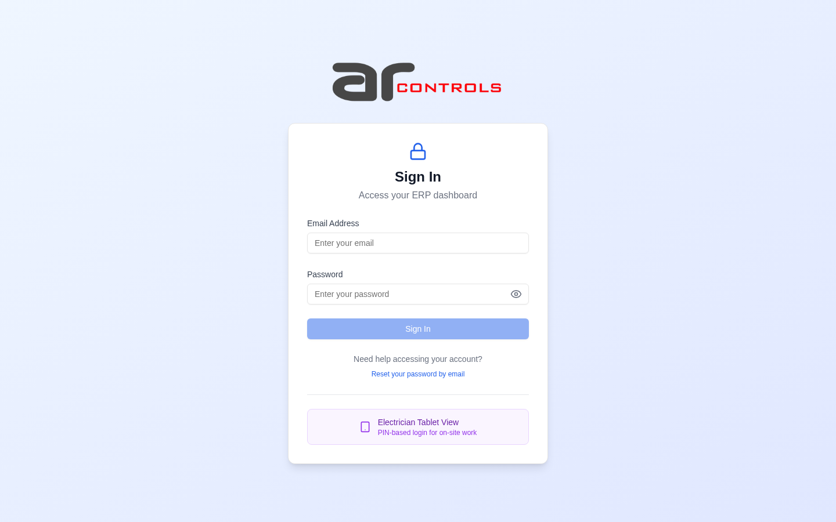
02-post-login.png
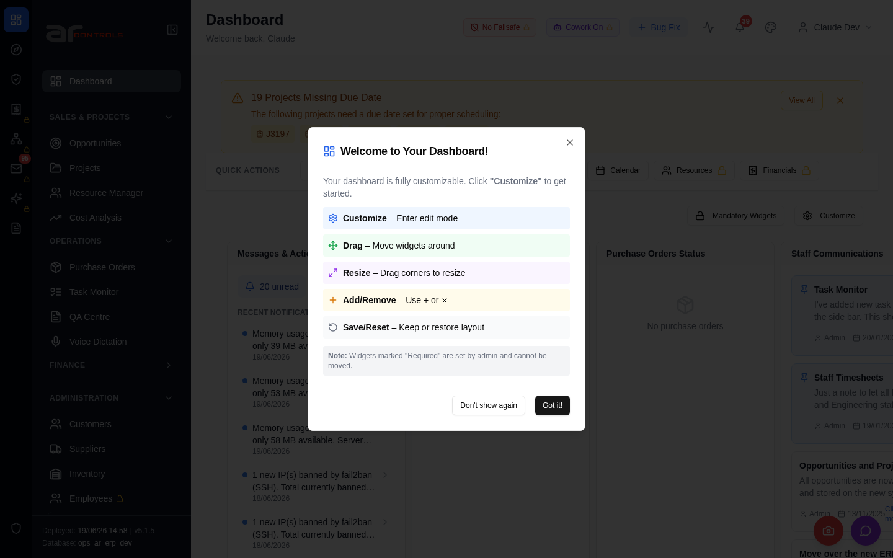
03-project-planning-grid-shows-all-active-projects-in-filter-2026-06-18-00-journey-start.png
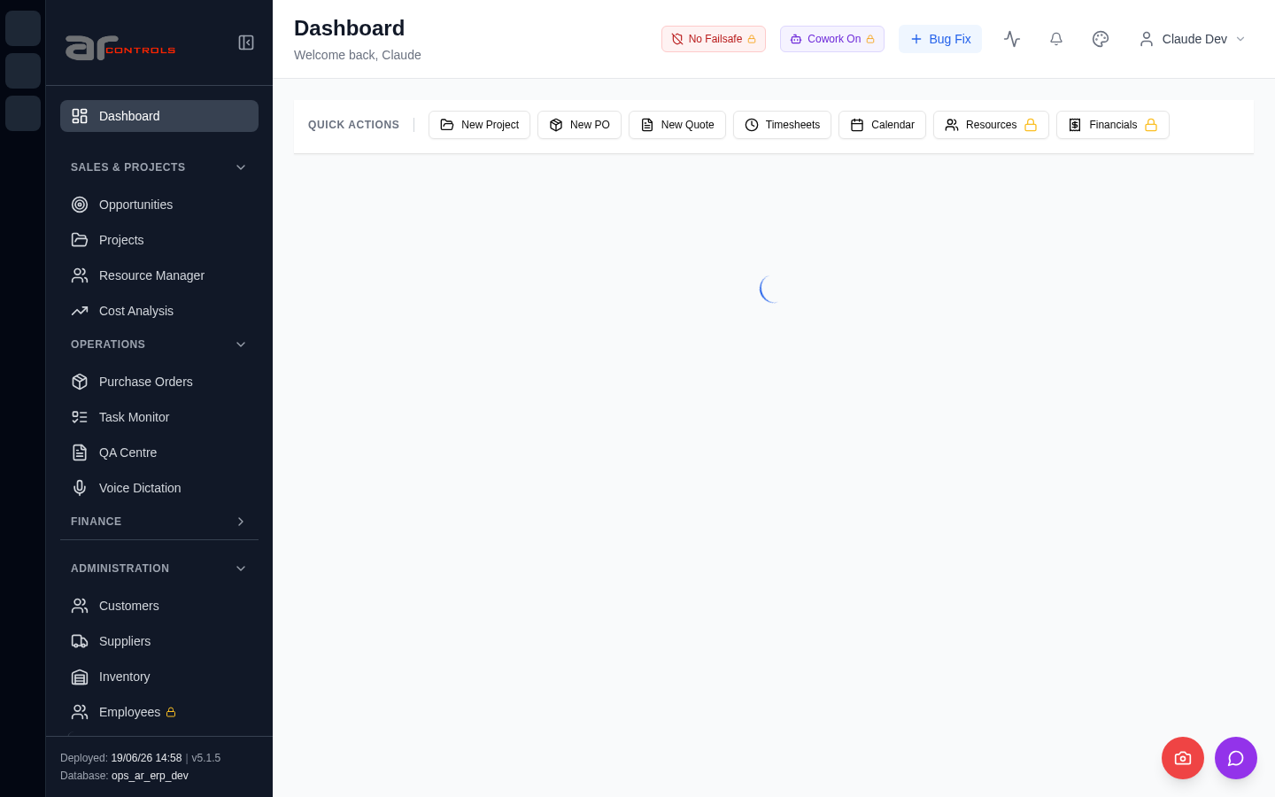
03-project-planning-grid-shows-all-active-projects-in-filter-2026-06-18-01-navigate.png
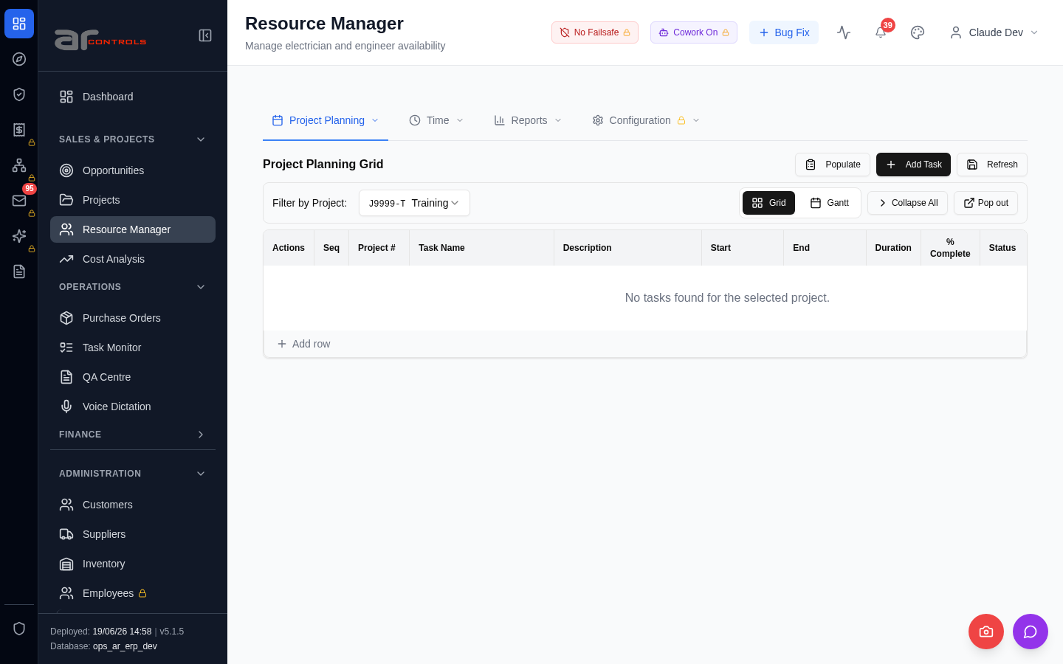
03-project-planning-grid-shows-all-active-projects-in-filter-2026-06-18-02-data-testid-project-planning-grid-project-filter-trigger.png
03-project-planning-grid-shows-all-active-projects-in-filter-2026-06-18-02-data-testid-project-planning-grid-project-filter-trigger-element.png
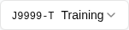
03-project-planning-grid-shows-all-active-projects-in-filter-2026-06-18-03-data-testid-project-planning-grid-project-filter-trigger.png
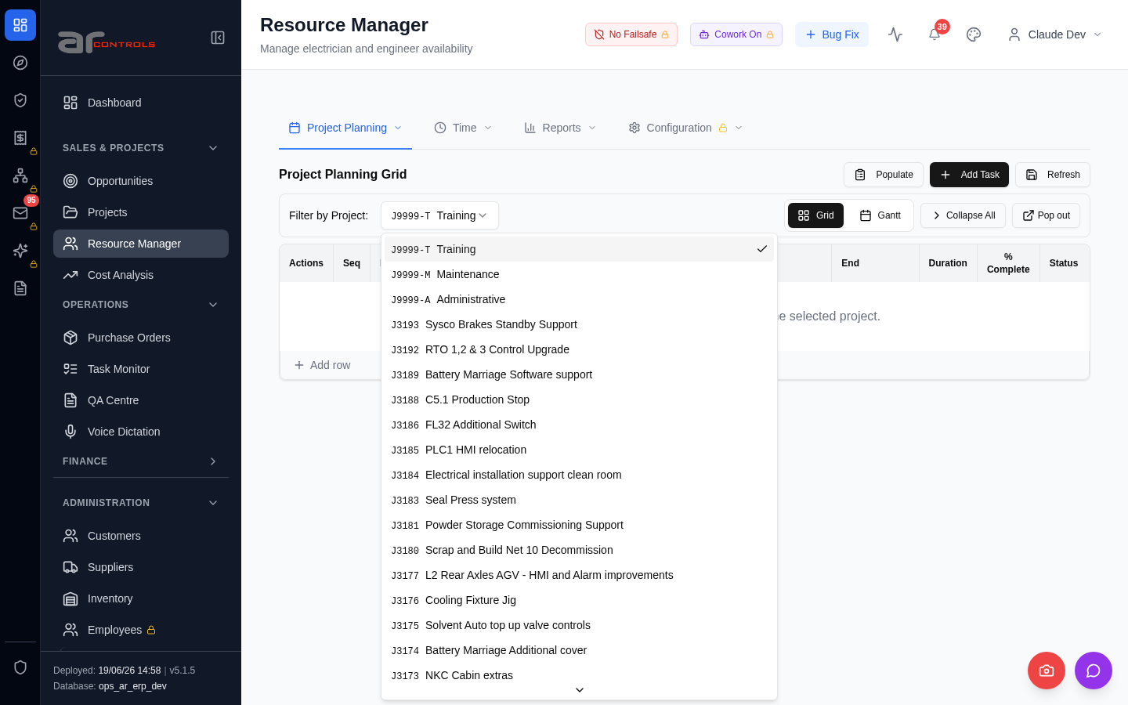
03-project-planning-grid-shows-all-active-projects-in-filter-2026-06-18-03-data-testid-project-planning-grid-project-filter-trigger-element.png
03-project-planning-grid-shows-all-active-projects-in-filter-2026-06-18-04-data-testid-project-planning-grid-project-id-option.png
03-project-planning-grid-shows-all-active-projects-in-filter-2026-06-18-04-data-testid-project-planning-grid-project-id-option-element.png
03-project-planning-grid-shows-all-active-projects-in-filter-2026-06-18-05-data-testid-project-planning-grid-project-id-option.png
03-project-planning-grid-shows-all-active-projects-in-filter-2026-06-18-05-data-testid-project-planning-grid-project-id-option-element.png
03-project-planning-grid-shows-all-active-projects-in-filter-2026-06-18-06-filter-by-project.png
03-project-planning-grid-shows-all-active-projects-in-filter-2026-06-18-07-manage-electrician-and-engineer-availability.png
03-project-planning-grid-shows-all-active-projects-in-filter-2026-06-18.png
04-popout-preserves-selected-project-2026-06-18-00-journey-start.png
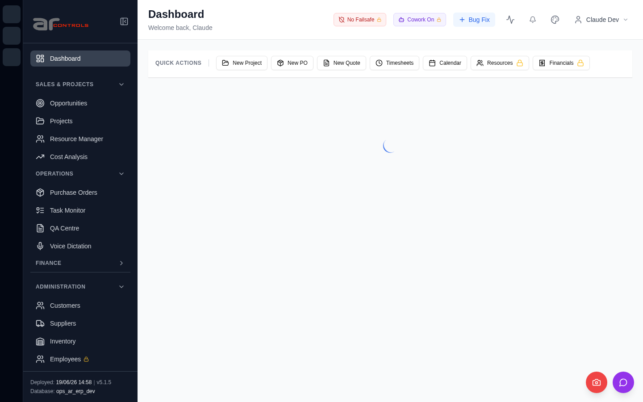
04-popout-preserves-selected-project-2026-06-18-01-navigate.png
04-popout-preserves-selected-project-2026-06-18-02-data-testid-project-planning-grid-project-filter-trigger.png
04-popout-preserves-selected-project-2026-06-18-02-data-testid-project-planning-grid-project-filter-trigger-element.png
04-popout-preserves-selected-project-2026-06-18-03-data-testid-project-planning-grid-project-filter-trigger.png
04-popout-preserves-selected-project-2026-06-18-03-data-testid-project-planning-grid-project-filter-trigger-element.png
04-popout-preserves-selected-project-2026-06-18-04-data-testid-project-planning-grid-project-id-option.png
04-popout-preserves-selected-project-2026-06-18-04-data-testid-project-planning-grid-project-id-option-element.png
04-popout-preserves-selected-project-2026-06-18-05-data-testid-project-planning-grid-popout-button.png
04-popout-preserves-selected-project-2026-06-18-05-data-testid-project-planning-grid-popout-button-element.png
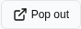
04-popout-preserves-selected-project-2026-06-18-06-manage-electrician-and-engineer-availability.png
04-popout-preserves-selected-project-2026-06-18.png

Console Errors
- [error] Error fetching projects: TypeError: Failed to fetch
- [error] Error fetching POs: TypeError: Failed to fetch
at d (http://100.121.252.85:3180/static/js/872.89f56c8c.chunk.js:1:18190)
- [error] Error fetching tasks: TypeError: Failed to fetch
at o (http://100.121.252.85:3180/static/js/872.89f56c8c.chunk.js:1:20462)
- [error] Error fetching approval requests: TypeError: Failed to fetch
at x (http://100.121.252.85:3180/static/js/872.89f56c8c.chunk.js:1:48850)
- [error] Error fetching checklist settings: TypeError: Failed to fetch
at h (http://100.121.252.85:3180/static/js/9627.a1760778.chunk.js:1:16800)
- [error] Error fetching budget warnings: TypeError: Failed to fetch
at x (http://100.121.252.85:3180/static/js/872.89f56c8c.chunk.js:1:23348)
- [error] Error fetching PO requests: TypeError: Failed to fetch
at d (http://100.121.252.85:3180/static/js/872.89f56c8c.chunk.js:1:45670)
- [error] Failed to fetch HR settings: TypeError: Failed to fetch
at http://100.121.252.85:3180/static/js/9627.a1760778.chunk.js:1:1841
- [error] Error fetching batch widget data: TypeError: Failed to fetch
at P (http://100.121.252.85:3180/static/js/872.89f56c8c.chunk.js:1:67040)
- [error] 🔔 NotificationsDropdown: Error fetching notification summary: TypeError: Failed to fetch
at T (http://100.121.252.85:3180/static/js/505.03a7c875.chunk.js:1:76319)
- [error] Error fetching staff comms: TypeError: Failed to fetch
at g (http://100.121.252.85:3180/static/js/872.89f56c8c.chunk.js:1:36764)
- [error] Error fetching approval requests: TypeError: Failed to fetch
at x (http://100.121.252.85:3180/static/js/872.89f56c8c.chunk.js:1:48850)
- [error] Error fetching budget warnings: TypeError: Failed to fetch
at x (http://100.121.252.85:3180/static/js/872.89f56c8c.chunk.js:1:23348)
- [error] Error fetching POs: TypeError: Failed to fetch
at d (http://100.121.252.85:3180/static/js/872.89f56c8c.chunk.js:1:18190)
- [error] 🔔 NotificationsDropdown: Error fetching notification summary: TypeError: Failed to fetch
at T (http://100.121.252.85:3180/static/js/505.03a7c875.chunk.js:1:76319)
- [error] Error fetching projects: TypeError: Failed to fetch
at x (http://100.121.252.85:3180/static/js/872.89f56c8c.chunk.js:1:15247)
- [error] Error fetching PO requests: TypeError: Failed to fetch
at d (http://100.121.252.85:3180/static/js/872.89f56c8c.chunk.js:1:45670)
- [error] Error fetching batch widget data: TypeError: Failed to fetch
at P (http://100.121.252.85:3180/static/js/872.89f56c8c.chunk.js:1:67040)
- [error] Error fetching staff comms: TypeError: Failed to fetch
at g (http://100.121.252.85:3180/static/js/872.89f56c8c.chunk.js:1:36764)
- [error] Failed to fetch HR settings: TypeError: Failed to fetch
at http://100.121.252.85:3180/static/js/9627.a1760778.chunk.js:1:1841

Network Issues
- GET http://100.121.252.85:3180/api/notifications/stream?access_token=eyJhbGciOiJIUzI1NiIsInR5cCI6IkpXVCJ9.eyJzdWIiOiJjbGF1ZGUtZGV2QGFyY29udHJvbHMuaW50ZXJuYWwiLCJ1c2VyX2lkIjoiN2NlNDFmZjAtZDBmNy00NzMxLTkzNG — net::ERR_ABORTED
- GET http://100.121.252.85:3180/api/notifications/stream?access_token=eyJhbGciOiJIUzI1NiIsInR5cCI6IkpXVCJ9.eyJzdWIiOiJjbGF1ZGUtZGV2QGFyY29udHJvbHMuaW50ZXJuYWwiLCJ1c2VyX2lkIjoiN2NlNDFmZjAtZDBmNy00NzMxLTkzNG — net::ERR_ABORTED
- GET http://100.121.252.85:3180/api/dashboard/widgets/current-projects — net::ERR_ABORTED
- GET http://100.121.252.85:3180/api/dashboard/widgets/purchase-orders — net::ERR_ABORTED
- GET http://100.121.252.85:3180/api/dashboard/widgets/task-allocations — net::ERR_ABORTED
- GET http://100.121.252.85:3180/api/dashboard/widgets/approval-requests — net::ERR_ABORTED
- GET http://100.121.252.85:3180/api/notifications/stream?access_token=eyJhbGciOiJIUzI1NiIsInR5cCI6IkpXVCJ9.eyJzdWIiOiJjbGF1ZGUtZGV2QGFyY29udHJvbHMuaW50ZXJuYWwiLCJ1c2VyX2lkIjoiN2NlNDFmZjAtZDBmNy00NzMxLTkzNG — net::ERR_ABORTED
- GET http://100.121.252.85:3180/api/system-settings/ — net::ERR_ABORTED
- GET http://100.121.252.85:3180/api/dashboard/widgets/budget-warnings — net::ERR_ABORTED
- GET http://100.121.252.85:3180/api/dashboard/widgets/po-requests — net::ERR_ABORTED
- GET http://100.121.252.85:3180/api/employees/my-file — net::ERR_ABORTED
- POST http://100.121.252.85:3180/api/dashboard/widgets/batch — net::ERR_ABORTED
- GET http://100.121.252.85:3180/api/notifications/stream?access_token=eyJhbGciOiJIUzI1NiIsInR5cCI6IkpXVCJ9.eyJzdWIiOiJjbGF1ZGUtZGV2QGFyY29udHJvbHMuaW50ZXJuYWwiLCJ1c2VyX2lkIjoiN2NlNDFmZjAtZDBmNy00NzMxLTkzNG — net::ERR_ABORTED
- GET http://100.121.252.85:3180/api/notifications/summary — net::ERR_ABORTED
- GET http://100.121.252.85:3180/api/dashboard/widgets/staff-comms — net::ERR_ABORTED
- GET http://100.121.252.85:3180/api/notifications/stream?access_token=eyJhbGciOiJIUzI1NiIsInR5cCI6IkpXVCJ9.eyJzdWIiOiJjbGF1ZGUtZGV2QGFyY29udHJvbHMuaW50ZXJuYWwiLCJ1c2VyX2lkIjoiN2NlNDFmZjAtZDBmNy00NzMxLTkzNG — net::ERR_ABORTED
- GET http://100.121.252.85:3180/api/notifications/stream?access_token=eyJhbGciOiJIUzI1NiIsInR5cCI6IkpXVCJ9.eyJzdWIiOiJjbGF1ZGUtZGV2QGFyY29udHJvbHMuaW50ZXJuYWwiLCJ1c2VyX2lkIjoiN2NlNDFmZjAtZDBmNy00NzMxLTkzNG — net::ERR_ABORTED
- GET http://100.121.252.85:3180/api/dashboard/widgets/approval-requests — net::ERR_ABORTED
- GET http://100.121.252.85:3180/api/dashboard/widgets/budget-warnings — net::ERR_ABORTED
- GET http://100.121.252.85:3180/api/dashboard/widgets/purchase-orders — net::ERR_ABORTED

