ERP Verification Evidence Pack — [ERP bug-fix] Bug from /invoicing
Result: FAIL — FAIL — 1 browser check(s) failed
When: 20260615T001822Z
Verified URL: http://100.68.36.49:3080/

Runtime Start Checks
No runtime checks were configured.

Notes
- Verification level 2
- ✓ task proof plan L2: 1 task browser check(s), 0 API check(s)
- Task-proof-only mode: Level 1 launch smoke already passed; skipping baseline browser checks.
- Playwright MCP required for level 2+ UI proof; validating worker-declared MCP-backed checks.
- ✓ readiness gate: app ready after 1 probe(s) (status 200)
- networkidle not reached after login (app polls continuously) — non-fatal; confirming login via login-form disappearance instead.
- Logged in as claude-dev@arcontrols.internal
- Browser flow 'pn-no-nan-totals' started at /; target is /pn. Navigation must use visible UI actions from here.
- ✓ pn-no-nan-totals: step 1 navigate
- ✗ browser check 'pn-no-nan-totals' failed: Page.wait_for_selector: Timeout 30000ms exceeded.
Call log:
- waiting for locator("[aria-label=\"Project Navigator\"]") to be visible
63 × locator resolved to 2 elements. Proceeding with the first one: <button title="Project Navigator" aria-label="Project Navigator" data-testid="app-switcher-binary-expression-button" class="flex shrink-0 items-center whitespace-nowrap px-3 py-1.5 rounded-lg transition-colors text-sm text-gray-600 hover:text-gray-900 hover:bg-gray-100 relative">…</button>

Screenshots
01-landing.png
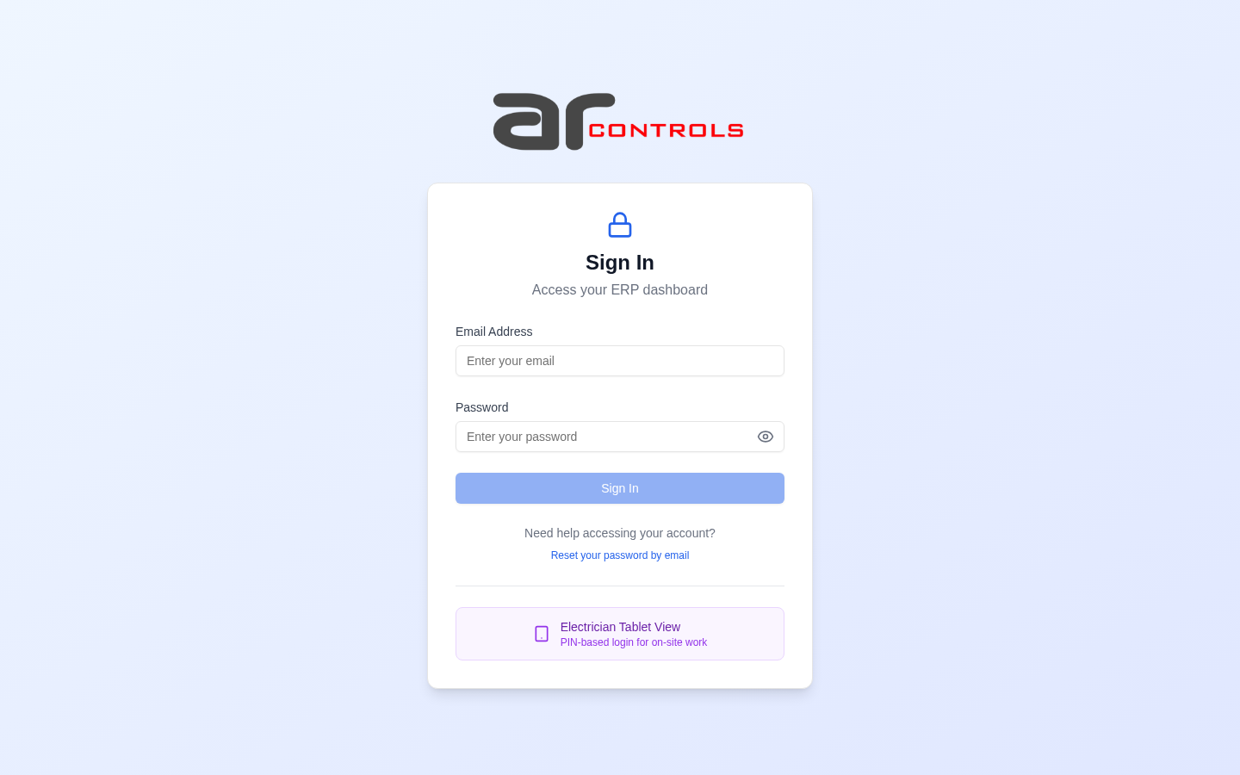
02-post-login.png
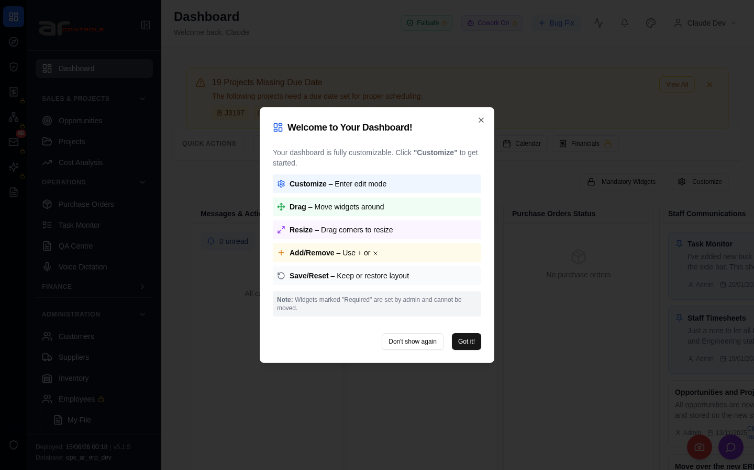
03-pn-no-nan-totals-00-journey-start.png

03-pn-no-nan-totals-01-navigate.png
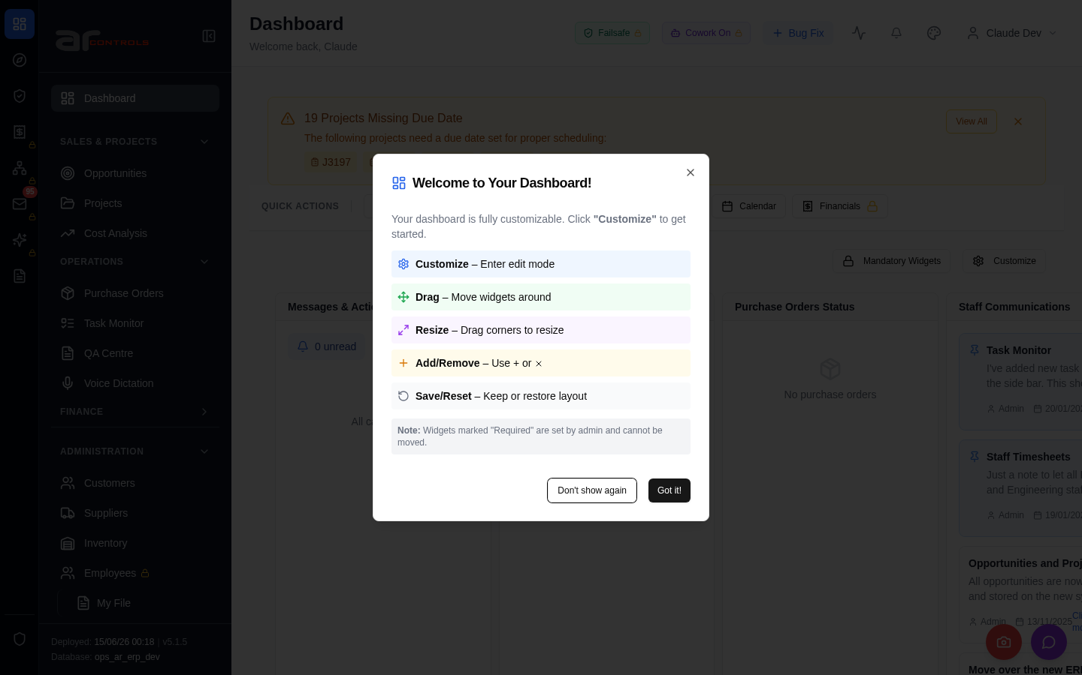
03-pn-no-nan-totals-failed.png

Network Issues
- GET http://100.68.36.49:3080/api/notifications/stream?access_token=eyJhbGciOiJIUzI1NiIsInR5cCI6IkpXVCJ9.eyJzdWIiOiJjbGF1ZGUtZGV2QGFyY29udHJvbHMuaW50ZXJuYWwiLCJ1c2VyX2lkIjoiN2NlNDFmZjAtZDBmNy00NzMxLTkzNGIt — net::ERR_ABORTED
- GET http://100.68.36.49:3080/api/notifications/stream?access_token=eyJhbGciOiJIUzI1NiIsInR5cCI6IkpXVCJ9.eyJzdWIiOiJjbGF1ZGUtZGV2QGFyY29udHJvbHMuaW50ZXJuYWwiLCJ1c2VyX2lkIjoiN2NlNDFmZjAtZDBmNy00NzMxLTkzNGIt — net::ERR_ABORTED

